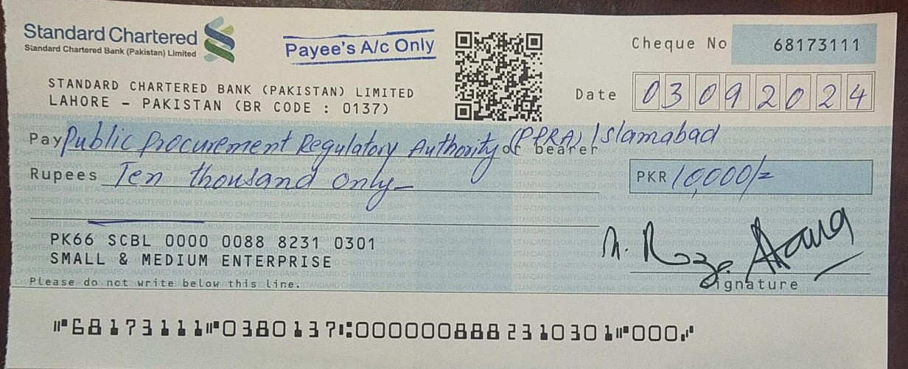

EVALUATION REPORT
As Per Rule 35 of PP Rules, 2004

1. Name of Procuring Agency Research, Regulatory Insight & Advocacy Assistance
for SMEs (RRI&A), SMEDA
2. Method of Procurement: PPRA Clause Reference No. 36(a)
3. Title of Procurement: Provision of Janitorial Services
4. PPRA Ref. No (TSE): TS544800
5. Date & Time of Bid Closing: 19/08/2024, 11:00 AM
- Date & Time of Bid Opening: Technical 19/08/2024, 11:30 AM
Financial 19/08/2024, 11:45 AM
- No. of Bids Received: 02
- Criteria for Bid Evaluation: 20% Technical and 80% Financial as given in Tender document
- Detail of Bid(s) Evaluation: As mentioned below

Technically Qualified Bidders | Technical Score | Combined Evaluation |  | Total Score | Most Advantageous Bid
Technically Qualified Bidders | Technical Score | Technical  20% | Financial  80% | Total Score | Most Advantageous Bid
Sahab Gee Enterprises | 20 | 20 | 75.49 | 95.49
Cleanol Services | 20 | 20 | 80 | 100 | Cleanol Services

