TECHNICAL EVALUATION REPORT
(As per Rule 35 of PP Rules. 2004)

  - Name of Procuring Agency: Pakistan Railways Police
  - Method of Procurement : Tender
  - Title of Procurement: Installation of IP-Cameras
  - Tender Inquiry No: 1738/IP-Cameras/PRP/PSC Dated 16.06.2023
  - PPRA Ref. No. (TSE): TS.513830 E
  - Date & Time of Bid Closing: 18.07.2023 Time 12.00 Hours
  - Date & Time of Bid Opening: 18.07.2023 Time 12.30 Hours
  - No of Bids received: 03 (Three)
  - Criteria for Bid Evaluation: Two Stage Two Envelops
  - Details of Bid(s) Evaluation: Technical Bids
Name of Bidder | Technical Marks  (if Applicable) | Rule/Regulation/SBD/Policy/Basis for Technical Rejection/Acceptance as per Rule 35 of PP Rules 2004.
M/S National Radio And Telecommunication,  Corporation, | 70 | Accepted as per Eligibility Criteria
TALHA ARSHAD GOVT: CONTRACTORS | 40 | Rejected
M/S Hafeez Enterprises, | 20 | Rejected

  - Any other additional/supporting information, the procuring agency may like to share.

Signature: 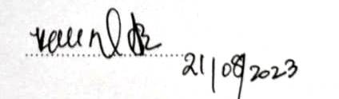

Official Stamp: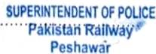

Standard Bidding Documents (SBD).

