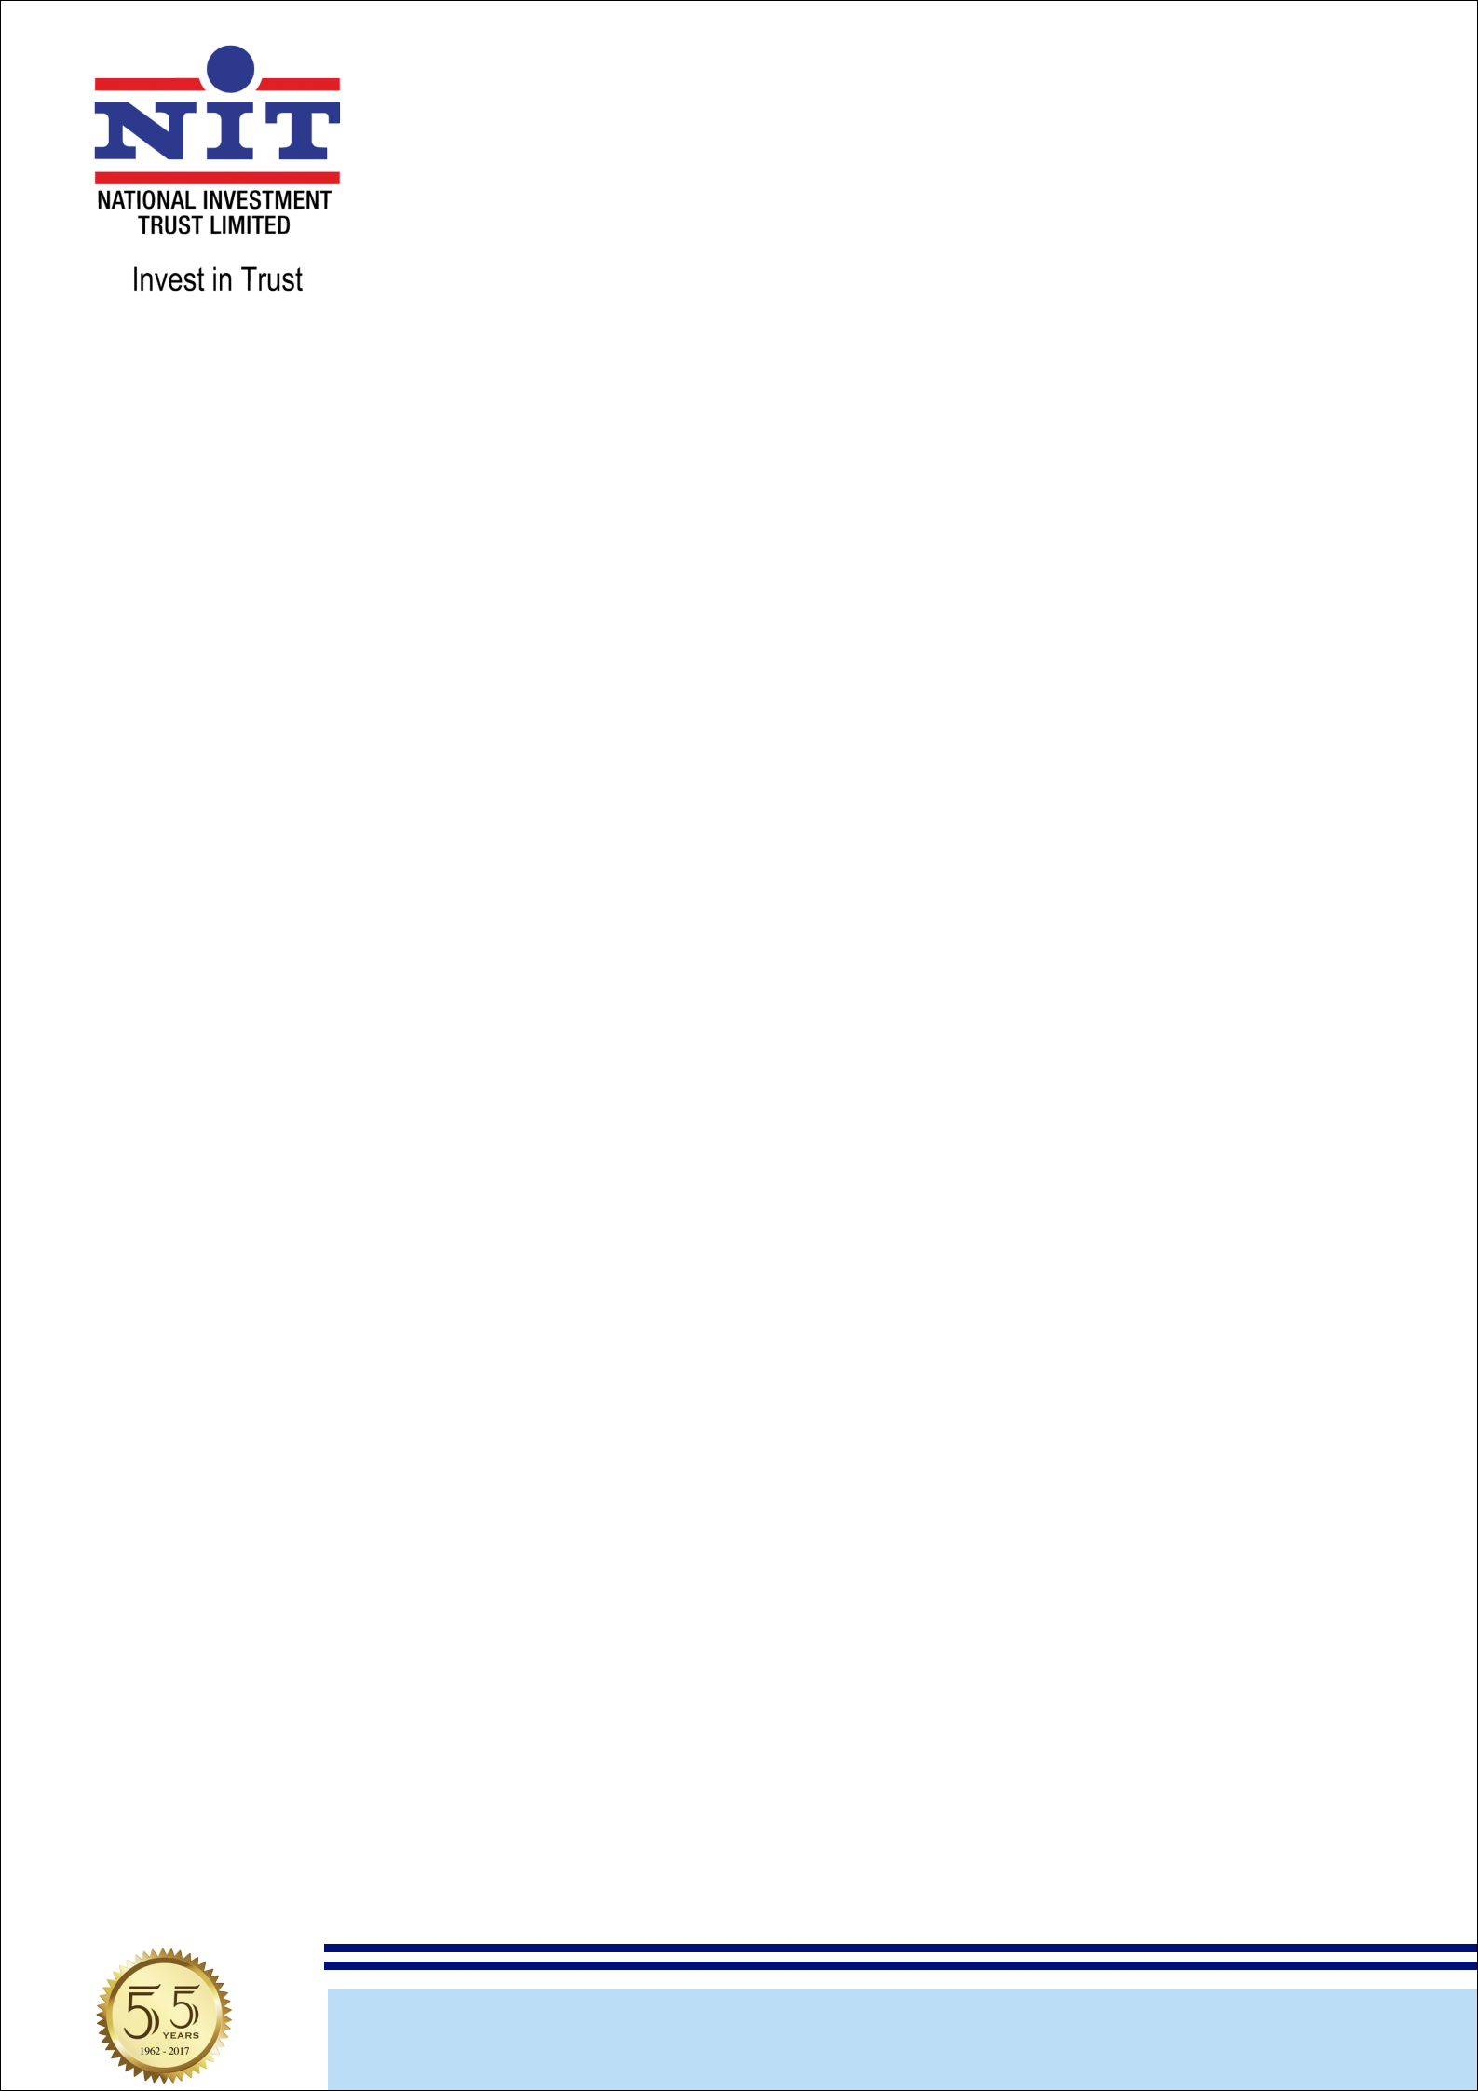
NATIONAL INVESTMENT TRUST LIMITED

BID EVALUATION REPORT

Tender No: | TS541011E
Tender Date: | 3/6/2024
Tender Title & Scope of Work: | Supply of general and computer stationary items
Bidding Procedure: | Single Stage Single Envelope Procedure
No. of Bids Received | 06 positive bids
Tender Opening Date : | 24/6/2024
Details of Bid Evaluation:
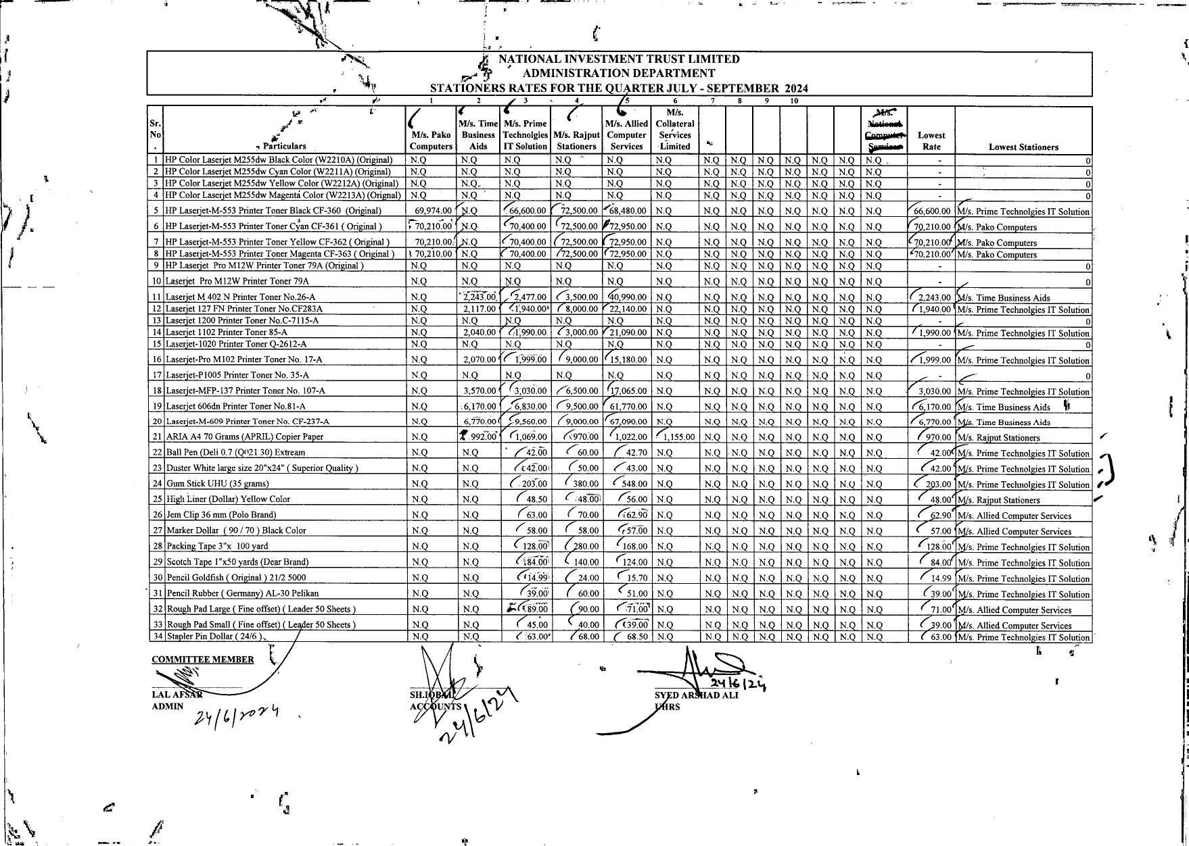

Lowest Evaluated Bidders.
M/s. Pako Computers
M/s.Time buisiness Aids
m/s. prime technologies
m/s.rajput stationers
m/s.allied computer services

NBP Building, 6th Floor, I.I. Chundrigar Road, P.O. Box 5671, Karachi-74000, Pakistan.
UAN: 111-648-648 Tel: 32412056-9 (4 Lines) Fax: 32422719, 32417827 Email: info@nit.com.pk Website: www.nit.com.pk

