FINAL EVALUATION REPORT
(As Per Rule 35 of PP Rules, 2004)

1. Name of Procuring Agency: | Trading Corporation of Pakistan (Pvt) Limited
2. Method of Procurement: | Single Stage-Two Envelop Procedure as per rule 36(b)
3. Title of Procurement: | Document Digitization/Scanning of old record
4. Tender Inquiry No.: | TCP/IT/Digitize/2022
5. PPRA Ref. No. (TSE): | TS505282E
6. Date & Time of Bid Closing: | 27-03-2023 11:00 AM
7. Date & Time of Bid Opening: | 27-03-2023 11:30 AM
8. No of Bids Received: | Four (4)
9. Criteria for Bid Evaluation: | As per tender terms and conditions
10. Details of Bid(s) Evaluation:

Name of Bidder | Marks | Evaluated Cost | Rule/Regulation/SBD*/Policy/ Basis for Rejection / Acceptance as per Rule 35  of PP Rules, 2004.
Name of Bidder | Technical  (if applicable) | Evaluated Cost
M/s ASC First Solution (Pvt) Limited | 95 | Rs.5.23 per page  Rs.500,000 software cost.  Rs.50,000 yearly maintenance. | Responsive
M/s A.Hamson | 78 | Rs.2.53 per page | Responsive
M/s XP Enterprises | 40 | - | Non-Responsive due to non-provision of required documents
M/s Archive Services |  | - | The bidder was not holding incorporation and NTN/STRN certificates at the time of opening of tender. Thus, Bid Evaluation Committee has found the bidder ineligible to participate in the tender.

Most Advantageous Bidder:…M/s. A Hamson
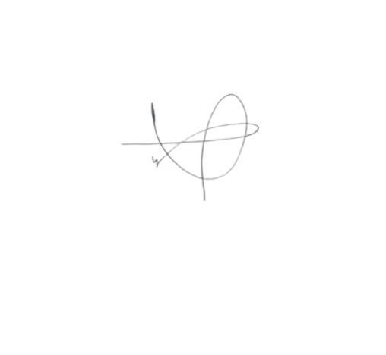

Signature: ………………….

