OFFICE OF THE
SENIOR SUPERINTENDENT OF POLICE
NATIONAL HIGHWAYS AND MOTORWAYS POLICE
M-4 SECTOR-I, TOBA TEK SINGH

No. NH&MP-( )/SSP/M-4/S1/23/163 Jan, 25th, 2023
To The Director
Public Procurement Regulatory Authority,
Islamabad.

Subject: PUBLICATION OF EVALUATION REPORT REGARDING TENDER FOR PURCHASE OF OFFICE STATIONERY FOR M-4 SECTOR-I AND SUB SECTOR.

Kindly find enclosed herewith evaluation report regarding purchase of Office Stationery M-4 Sector-I and Sub Sector for the financial year 2022-23, in reference to tender notice No/PPRA web reference No.TS499053E.
2. The evaluation report regarding Purchase of Office Stationery for M-4 Sector-I and Sub Sector for the financial year 2022-23 has been approved by the Competent Authority and required to be published accordance with instructions issued by Director General (DG M&E) PPRA vide letter No: 1(5)/M&E/PPRA/2018/263 dated 01-07-2021.
3. Submitted for necessary action, please.
(Encls.a.a.)
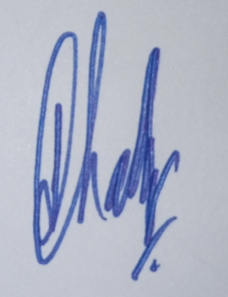
(Javed Iqbal Chadhar)
SP/Sector Commander
M-4 Sector-I, Toba Tek Singh
Chairman Purchase Committee

EVALUATION REPORT
(As per rules 35 of PP Rules, 2004)

- Name of Procuring Agency NHMP M-4 Sector-I Toba Tek Singh
- Method of Procurement Single Stage - Two Envelopes procedure
- Title of Procurement Purchase of Office Stationery
- Tender Inquiry No. Tender No.03/NHMP/STORE/M-4/SI/2022
- PPRA Ref. No. TS499053E
- Date & Time of Technical Bid opening 12-01-2023 11:30 A.M
- Date & Time of Financial Bid opening 12-01-2023 11:30 A.M
- No. of Bids Received 04
- Criteria for Bid Evaluation As per NHMP requirements/ specification & lowest in rate
- Details of Bid(s) Evaluation As under
Sr.# | Name of Bidder | Evaluation |  | Most Advantageous Bids offered | Rule/Regulation/SBD/policy/  Basis for Rejection/Acceptance as per Rule 35 of PP Rules, 2004
Sr.# | Name of Bidder | Technical | Financial | Most Advantageous Bids offered
1 | M/S Malik Enterprises Toba Tek Singh | Qualified by Committee in all items of Office Stationery. | Single Item approved being the most advantageous bidder by the committee | Rs.7,425/- | Purchase Committee has accepted the bid submitted by M/S Malik Enterprises Toba Tek Singh being the most advantageous bidder in Single item.
2 | M/S Mian Abdul Shakoor, Traders Toba Tek Singh | Qualified by Committee in all items of Office Stationery. | 36 Items approved being the most advantageous bidder by the committee | Rs.284,802/- | Purchase Committee has accepted the bids submitted by M/S Mian Abdul Shakoor, Traders Toba Tek Singh being the most advantageous bidder in 36 items.
3 | M/S Chinar Enterprises, Gujranwala | Qualified by Committee in all items of Office Stationery except Stapler steel. | 10 Items approved being the most advantageous bidder by the committee | Rs.347,446/- | Purchase Committee has accepted the bids submitted by M/S Chinar Enterprises, Gujranwala being the most advantageous bidder in 10 items.
4 | M/S Adan Enterprises, Nowshera | Disqualified | - | - | Technical Committee rejected the M/S Adan Enterprises Gujranwala due to non-provision of samples.

Most Advantageous Evaluated Bidders M/S Malik Enterprises Toba Tek Singh in Single item.
M/S Mian Abdul Shakoor, Toba Tek Singh in 36 items.
M/S Chinar Enterprises, Gujranwala in 10 items.

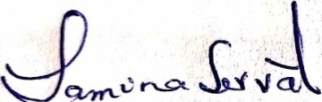
SAMINA SERVAT
DSP/CPO Line (HQs), NHMP
M-4 Sector-I, Toba Tek Singh

