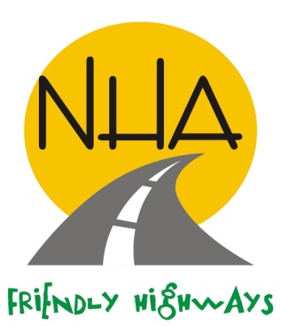
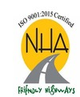
“SAY NO TO CORRUPTION”
GOVERNMENT OF PAKISTAN
MINISTRY OF COMMUNICATIONS
NATIONAL HIGHWAY AUTHORITY
(BALOCHISTAN NORTH REGION)

INVITATION TO BIDS
1x Special Maintenance & 1x Corridor Management works

1. National Highway Authority (NHA), invites bids from the constructor, registered with Income Tax department and who are on Active Taxpayers List of the Federal Board of Revenue having valid registration with Pakistan Engineering Council in Category mentioned in the table with Specialization codes for the works mentioned below:

S# | Contract No. | Description | KM Route | Engineer’s Estimate Rs. | PEC Category/ Specialization
1 | CM-BN-2024-25-01 | Construction of water supply (Tube well) and supply & installation of solar system | 161+000 N-50 | 9,986,000 | C-5  (CE-01, & CE-10)
2 | SM-BN-2024-25-01 | Construction of Retaining wall | 264+200 N-50 | 9,829,398 | C-5  (CE-01, & CE-10)

2. Bidding documents, containing method of procurement (Single Stage - Two Envelope), detailed terms & conditions etc. will be available on the website mentioned below from 10th August,2024 for downloading free of cost. Prospective Bidders are also advised to follow the said website for updates of schedule and addendum(s), if any.
3. The bids, prepared in accordance with the instructions provided in the bidding documents, must reach at the address mentioned below, on or before 21st August, 2024 before 1100 hours. Technical Bids will be opened on the same day at 1130 hours. This advertisement is also available on www.nha.gov.pk & PPRA website at www.ppra.org.pk.

Director (Maintenance)
National Highway Authority, Quetta
NHA, Complex near Wapda Grid Station, Airport Road, Quetta
Phone: 081-9241082
Email: dirmaint-bn@nha.gov.pk

NATIONAL HIGHWAY AUTHORITY
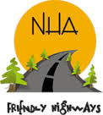
ZONAL HEADQUARTERS, WEST ZONE, QUETTA
Directorate of Balochistan North Region
NHA Complex, Main Airport Road, Quetta
Phone No. 081-9241082, Fax No. 081-9241083
Email:dir.nha.qta@gmail.com
No. DM/NHA/QTA/2024/ July, 2024

Subject: APPROVAL FOR PUBLICATION OF TENDER NOTICE OF MAINTENANCE WORKS OF BALOCHISTAN-NORTH REGION F.Y 2024-25.

The approval has been conveyed for 2x Engineer’s Estimate of maintenance Works for F.Y. 2024-25 & copy of approval are attached at F/A.

2. The NIT for the 02x contracts is submitted for the approval so that it could be forwarded to NHA-HQ for publication in print media.

3. Para 2/N is submitted for approval please.

Enclosure: DFA
(Engr. Raheel Ahmed)
Director (Maintenance)
Balochistan-North, Quetta

General Manager (Balochistan-North) NHA, Quetta.

4.

NATIONAL HIGHWAY AUTHORITY
ZONAL HEADQUARTERS, WEST ZONE, QUETTA
SAY NO TO CORRUPTION
Directorate of Baluchistan North Region
NHA Complex, Main Airport Road, Quetta
Phone No. 081-9241082, Fax No. 081-9241083
Email:dir.nha.qta@gmail.com
No. DM/NHA/QTA/2024/ July, 2024

The Director (PR),
National Highway Authority,
Islamabad.

SUBJECT: PUBLICATION OF TENDER NOTICE OF MAINTENANCE WORK OF BALOCHISTAN-NORTH REGION 2024-25.

Enclosed herewith the tender notice of maintenance works of Balochistan North Region duly approved by the competent authority for publication.

2. Please forward the said advertisement for publication so that it may appear in newspapers on 31st July, 2024.

3. Original newspapers wherein advertisement published may kindly be forwarded to this office for record, please.

(Engr. Raheel Ahmed)
Director (Maintenance)
Balochistan-North, Quetta

Copy alongwith enclosures:
- Member (West Zone) NHA, Quetta.
- General Manager (Bal-North) NHA-Quetta.
- General Manager (P&CA)NHA-HQ
- General Manager (RAMS) NHA, Islamabad.
- Director (MIS) NHA, Islamabad…….for uploading at NHA website, please.
- Dy. Director (Accounts) NHA, Quetta.
- Dy. Director, PPRA, Islamabad……..for uploading at PPRA website, please.

