MOST IMED
Central Ord Dep Sgd
(MAKHZAN-E-FASIL)
Sargodha Cantt
Tel : 36112
3276/IT/Gen Corres/LP-TWBXBT
02 Aug 2024

To: Public Procurement Regulatory Authority

ID: COD SGD - LP

Subj: Requisition for Classified Advertisement - PPRA Website

1. Please arrange to publish attach advertisement on PPRA website on 06 Aug 2024.
2. Your cooperation in this regard will be highly appreciated, please.

TENDER NOTICE

1. Central Ordnance Depot (Kirana) Sargodha invites sealed offers for purchase / supply of Battery Operated Stacker Carrier (MHE Carrier) and General / Miscellaneous items etc (Detail of items is also attached).
2. Last date of submission of tender documents is 26 Aug 2024 by 1000 hours and tender will be opened on same date (i.e. 26 Aug 2024) at 1100 hours in the presence of firm’s representatives.
3. Firm’s Registered with Army installation, Ordnance Depots / units or willing to get themselves registered with Central Ordnance Depot (Kirana) Sargodha may participate in this tender.
4. Commandant Central Ordnance Depot (Kirana) Sargodha reserves the rights to cancel any offer.
5. This Tender Notice is also available on newspapers Pakistan Observer and Daily Dunia Lahore.

Commandant Central Ordnance Depot (Kirana) Sargodha
Telephone: 048-3251124

Central Ordnance Depot
Sargodha (Kirana)
Telephone - 048-3251124
3276/IT/Gen Corres/LP
3276 / IT / Gen Corres/ LP
02 Aug 2024
To: ______________
(Firm Concerned)

Subject: Local Purchase of Ordnance Stores –FY (1st Half – Aug) 2024/25

1. Rates are invited for supply of Ordnance stores as per Annex ‘A’.
2. Your offer / quotation must reach this depot by 26 Aug 2024 up to 1000 hours.
3. Date and time of opening of tender is 26 Aug 2024 at 1100 hours.
4. Following must be read out and keep in mind before quoting of rates:-
a. Store (s) purchased will be delivered in Central Ordnance Depot Sargodha.
b. Terms and conditions as given below will be applicable.
c. Rate must be quoted including packing as per packing regime (Provided).
d. Rate must should be single. Duplicate rates are not allowed and will be considered as “Not Quoted” (N/Q).
TERMS, CONDITIONS AND GENERAL INSTRUCTINS FOR BIDDERS

5. General Instructions. Following are the terms, conditions and general instructions for bidders:-

a. The purchaser reserve the right to accept or reject any offer if any of the condition(s) stipulated in this invitation to tender in violated.
b. All supplies will be subjected to tests and inspection (s) either by a Board of Officers constituted for the purpose or by ASID / IAS&C. Any cost incurred on tests / inspection will be borne by the bidder. Admissible
c. Successful bidders will have to complete the supplies within one month stipulated period as specified in the purchase order (s), failing which appropriate penalty as decided by Commandant Central Ordnance Depot (Kirana) Sargodha will be imposed besides necessary / appropriate disciplinary / punitive action.
d. Store(s) offered must be brand new, as per DGP (Army) approved standard, specifications, drawing.
e. Make / Model / Brand and Country of Origin of store(s) must be mentioned in offer / quotation.
f. Price / rate will be quoted based on delivery at location as mentioned in para 4 above.
g. Price / rate quoted must be inclusive of all applicable taxes / duties.
h. Price / rate quoted must be as per accounting unit.
i. Only one price / rate will be quoted against an item, multi price / rate if quoted will lead to rejection of the offer.
j. Price / rate will be quoted in Pak Currency.
k. Price / rate quoted will be valid up to 30 December 2024.
l. Acceptance of inspection / testing of advance sample will not be taken as acceptance of bulk supply against Purchase Order rather the inspection process will commence on delivery of complete / ordered quantity.
m. Part delivery is not accepted / allowed.
n. 100% payment will be made through CMA on clearance of bills / documents.
o. Firm will provide latest / best quality of store(s).
p. Proof of taxes (Sale Tax Return / Invoice / Income Tax Return / Professional Tax Certificate) will be provided by firm.

6. Special Instructions

a. No changes / amendment in Tender documents provided by Central Ordnance Depot (Kirana) Sargodha will made, doing so will lead to rejection of offer.
b. As far as possible price / rate must be quoted against each item, where price / rate are not being quoted, the space should reflect by words “Not Quoted”.
c. Tender documents will be submitted duly quoted rate with permanent ink, stamped & signed on each page and sealed envelope otherwise offer will be rejected. STRN and NTN number be also endorsed on offer / quotation.
d. Tender documents having quoted rate will be taken as “Offer” instead of soft copy submitted with it.

7. Purchaser’s Rights. Purchaser does not pledge to accept the lowest or any tender and reserves the right of accepting the whole or any part of the offer made.

8. Withdrawal of Offer. Firm may withdraw its offer before opening of tender. If the firm withdraw its offer after opening of tender within validity period i.e. up to 30 December 2024, Commandant Central Ordnance Depot (Kirana) Sargodha may place such bidder / firm under embargo /blacklist.

9. Pre-qualification of Supplier and Contractors. Following documents must be provided alongwith an application for obtaining Tender documents as Pre-qualifications otherwise Tender documents will not be awarded:-
a. Security clearance of General Headquarters, Military Intelligence Directorate or Police Verification.
b. Valid NTN Certificate.
c. Valid Sale Tax Certificate.
d. Valid Professional Tax Certificate.
e. Copy of CNIC of the Proprietor.
f. 2 x photograph of Proprietor.
g. Bank statement for last six months.
h. Application for registration with Central Ordnance Depot (Kirana) Sargodha with complete profile.
i. Firms/ Contractors information may also be provided duly stamp/signed as per given specimen.
j. Copy of Active Taxpayer List (ATL) shown STRN / NTN.

10. Tender Obtaining. Interested firms can obtain Tender documents form PPRA website. Any information regarding tender can be obtained from COD Sgd between 0800 AM to 1430 PM from this depot (Monday to Friday). Tel: 048-3251124.

11. Disqualification. Offer is liable to be rejected if:-
a. There is any deviation from General / Special Instructions / Pre-qualifications of supplier.
b. Price / rate are offered excluding applicable taxes / duties.
c. Offer is found conditional or incomplete in any respect.
d. Multiple prices quoted against an item.
e. More than one offer is made / submitted in same envelop.
f. Received later than appointed / fixed date and time.
g. Offer containing none initialed / unauthenticated correction / over writing.
h. Offer made through Fax / Email / Telex.
i. If offer is found to be based on carted action in connive with other sources / participants of the tender.
12. Right’s Reserved. Commandant Central Ordnance Depot (Kirana) Sargodha reserves the rights to accept or reject any or all offers including the lowest.
13. Application of Official Secret Act. All the matters connected with the Tender documents and subsequent actions arising there / from, are within the scope of Official Secret Act-1923.
14. Packing of Stores. Stores will be accepted only as per new packing regime as instructions given in Annex ‘B’.

FIRMS / CONTRACTORES BIO DATA

Firm Name | : | __________________________________________
Owner Name | : | __________________________________________
CNIC No | : | __________________________________________
Office Tel/ Fax No | : | __________________________________________
Mobile No | : | __________________________________________
GST (STRN) No | : | __________________________________________
NTN No | : | __________________________________________
Bank Account No | : | __________________________________________
Branch address | : | __________________________________________
Firms address | : | __________________________________________
Sign & stamp | : | __________________________________________

Annex ‘A’
LP OF ORDNANCE STORES- FY (1st HALF – Aug 24) 2024/25

Ser | Part No. | Nomenclature | A/U | Rate | Remarks
1 | E3/PEC-6510 | Hand Cart (for transportation of Battery Operated Stacker Carrier) | Nos |  | Specs att as per annexure-B
2 |  | Plastic Binding Sheet | Ft

Annexure-B

SPECIFICATION / PICTURE OF HAND CART (BATTERY OPERATED STACKER CARRIER)
Specification | Picture
Length/Width 74” / 48” | 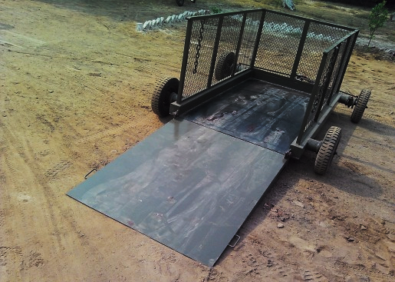  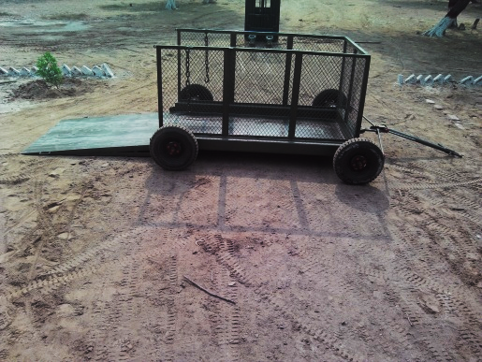  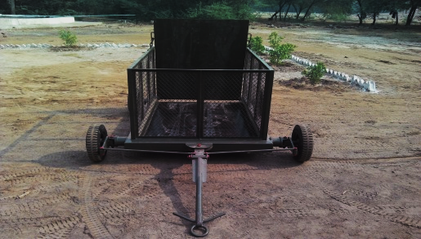  Safety Fence  Tyre with Tube  Handling Hook  Plate Form  Light Weight Single Ramp  Turning Mech  Frame
Maximum Loading Capacity 1 Ton
Height 38” with body
Turning Radius 45⁰
Tyre (4x Nos) 4.00 / 8
Tube (4x Nos) 4.00 / 8
Rim 04x Nos
Foldable Ramp Back Side 01x Nos
Towing Hook
Turning Mechanism
Safety Grill
Single Coat Anti-Corrosion Paint
Double Coat Enamel Paint

Note:

After delivery free services will be provided for six months (i.e. Maintenance and changing of Parts)

