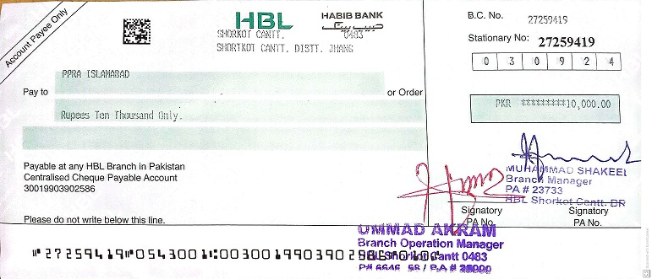

FG Public Middle School
Shorkot Cantt
Tel Civ: 047-5501046
No. Accts/24/347
03 Sep 2024
To
PPRA Islamabad Building, 1st Floor
Federal Bank for Cooperatives, Ataturk
Ave, G-5/2 G-5
Islamabad.

Info: The Regional Director
FGEIs (C/G) Regional Office
Multan Cantt

Subj: Request for Tender Notice for 15 KW Solar System Installation
1

- It is submitted that this institution has received a grant of 2 million PKR for the installation of 15 KW solar system. It is requested PPRA to issue a tender notice for this project by Sep 03, 2024, to invite qualified contractors. Kindly expedite the process to ensure timely implementation, please.

- The tender notice for the advertisement is under:-

TENDER NOTICE
FG Public Middle School Shorkot Cantt invites proposals from the dealers /firms for the following purchase / installation.
Ser | Tender Title | Min Load Required | Projects Address & Contact No.
1 | Supply , Installation & commissioning of solar system panels with inverters and net metering | 15Kws | FG Public Middle School Shorkot Cantt.  0310-6466833  047-5501046

- The interested tenders / contractors should apply in writing for the issue of tender documents alogwith submission of tender document fee Rs 1000/- (Non-Refundable).
- The last date of submission of bids to the undersigned office is 13 Sep 2024 (Monday) and bids will be opened on the same day at 10:00 AM.

Principal
(Muhammad Afzal)

