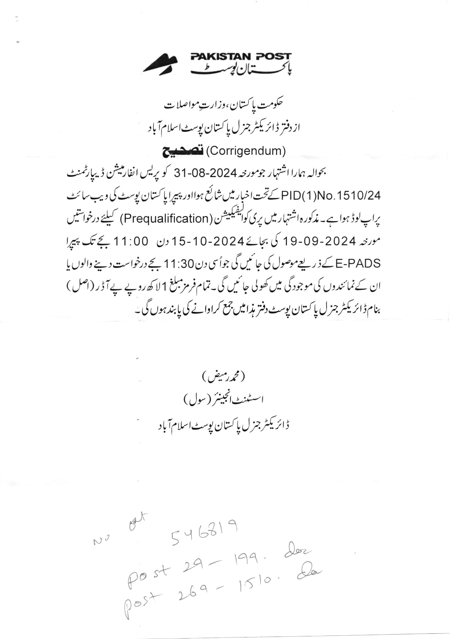


Govt Of Pakistan
Ministry of Communication
OFFICE OF THE DIRECTORATE GENERAL PAKISTAN POST ISLAMABAD
Prequalification Notice For The Year 2024-25.
Director General Pakistan Post Office Department invites contractors/firms for Prequalification for annual repair, petty repair, Electric, Sanitary, Construction, Re-Construction, works in % DGPPO, Postal Staff College/Hostel, BOQ, Officers bungalows and Postal Colony G-8/4 Islamabad for the F.Y 2024-25. Profiles and applications containing following details must reach the undersigned by 19-09-2024 upto 11:00 am and will be opened on the same date at 11:30 AM in presence of the contractors or their representatives. The Updated profiles should consist of following documents: -
- Full name of the firm, Registration, full address of office, telephone, Fax number, and a copy of CNIC of the proprietor.
- Memorandum of article of the association of firms.
- PEC license for the year 2024-25 with the prescribed relevant building code along with appointment of a Civil Engineer. If PEC license is not yet issued, copy of agreement with Civil Engineer and receipt of application submitted to Pakistan Engineering Counsel with bank receipt may be attach.
- Detailed list of technical employees of the firms.
- Detail and documentary proof of project / works completed during the last 03 years.
- List of Project and their cost showing Departments, names and detail of such projects.
- Financial status/ certificates issued by a Scheduled bank of the last three years.
- Income Tax/NTN Certificates for the last 03 years. Proof of filer/ being on active tax payers list.
- List of litigation (If any).
- Latest Bank statement ending last financial year.
- Certificate for Non-Blacklisting of the firm on original Stamp paper @ Rs. 50/-.
- Partnership deed/sole owner on original stamp paper @Rs. 50/-.
- List of Vehicles, tools detail which are on named of firm.
- It should be clearly noted that any statement or document proved fake at later stages
will lead to black listing of the firm and forfeiting of all earnest money/ security deposits/ claims.
- Those firms whose performance is not satisfied with the department, such firms will also not be eligible to participate in pre-qualification process.

To participate in the tendering process, the updated profiles should reach this office on 19-09-2024 upto 11:00 am during. The profiles will be checked by the tender committee and technical committee. Firm’s with completed profiles according to PPRA rules in all respect, will be informed accordingly. Clarification/ Information can be had from the undersigned during office hours.

Muhammad Rameez
Assistant Engineer (Civil)
Tel No. 051-9261012

