TENDER NOTICE

1. Quotations are invited by Equipment Stores Depot Jhelum Cantt for purchase of following items for use of Pakistan Army:-
Nomenclature Accounting Unit
- Cloth for HESCO Bag, Meter
- Material: (Polyester)
- GSM: 270 (+ 10) Gram
- Type: Non-woven Felt (Namda)
- Thickness@300g load: 2.0-2.3mm
- Shade: Near to Mojave Desert Colour-Pantone
  - (for general Visual Appearance)
- Wire Steel Spring 6 SWG for HESCO Bag Kilogram
With no Copper deposit
- Material of wire: Mild Steel
- Gauge of wire: 5 SWG
- Material of spring: Mild Steel
- Gauge of spring: 5-6 SWG
- Coating at wire: Zinc Painted
- Wire Steel Mild Round 4.064 MM Dia (8 SWG) Kilogram
- Wire Steel Mild Round 3.251 MM Dia (10 SWG) Kilogram
- Wrapping Machine Nos

2. The last date for submission of tenders will be at 1030 hours on 08 August 2024.
3. A sum of Rs. 7000/- (Rupees Seven Thousand Only) in the name of COO ESD Jhelum will be deposited through Cross Cheque along with Tender documents which will be non-refundable.
4 Tender documents can be obtained from Equipment Stores Depot Jhelum Cantt (LP Branch).

5. Tenders will be opened at 1100 hours on 08 August 2024 in Local Purchase Officer Office.

6. All those firms who are already registered with Equipment Stores Depot Cantt/ DGDP/ DGP (Army) or willing to get themselves registered can participate

7. Quoted rates will be non-negotiable, inclusive of all taxes and will be valid throughout Pakistan up to 30 June 2025.

8. All firms will provide item samples (non-refundable) alongwith quotations whose inspection report will be carried out by Army Stores inspection Depot / Inspectorate of Army Stores and Clothing concerned. Otherwise quotation will be rejected.

9. Chief Ordnance Officer Equipment Stores Depot Jhelum Cantt reserves the right to reject any tender inquiry / quoted rates (considered contrary to the spirit of tender competition / incomplete / low quality samples or samples not of required army specification) at any stage.

Chief Ordnance Officer
Equipment Stores Depot Jhelum Cantt
Cell # 0335-8020854

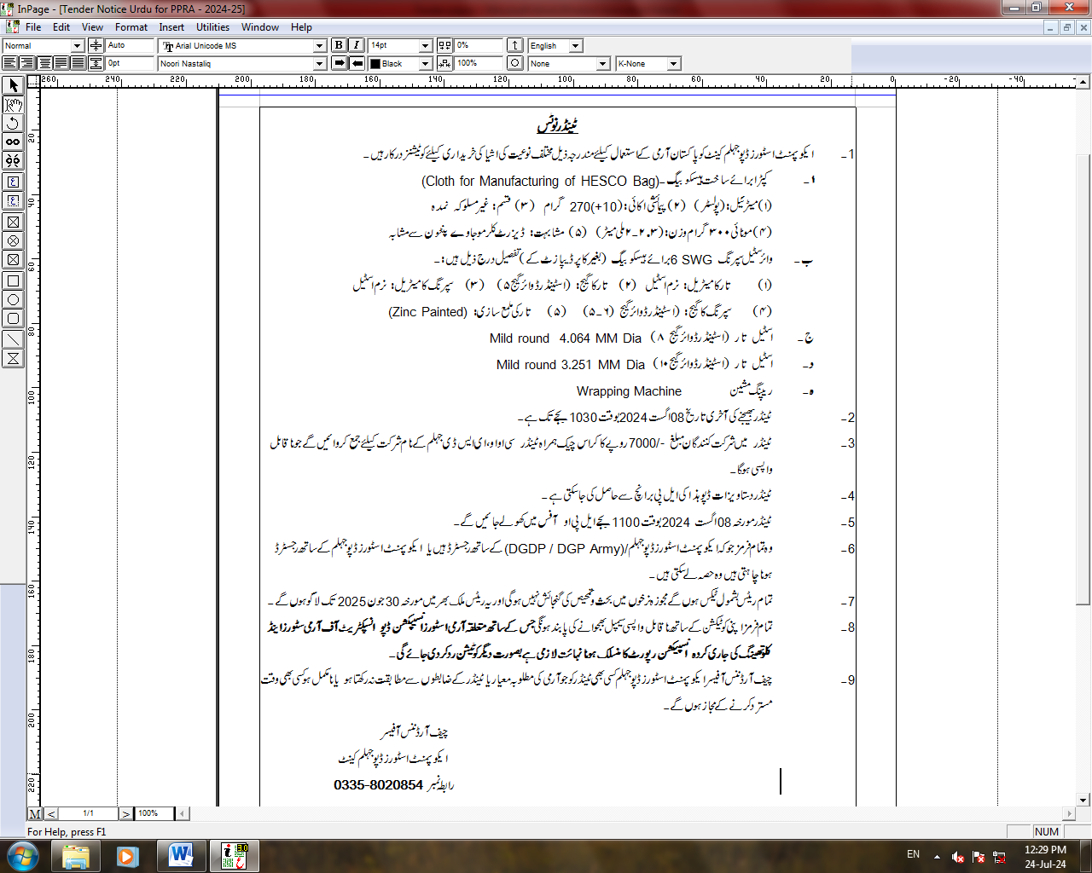

INVITATION TO TENDER

Ser | Part Number | Nomenclature | A/U | Rate
 | KC/PKC-2207 | Cloth of HESCO Bag | Mtr
 | G2/9505-ZO-101-9008 | Wire Steel Spring 6 SWG | Kg
 | G2/9505-ZO-101-3249 | Wire Steel Mild Round 4.064 MM Dia (8 SWG) | Kg
 | G2/9505-ZO-101-3248 | Wire Steel Mild Round 3.251 MM Dia (10 SWG) | Kg
 | W4/PWD-4367/3540-YV-153-5379 | Wrapping Machine | Nos

