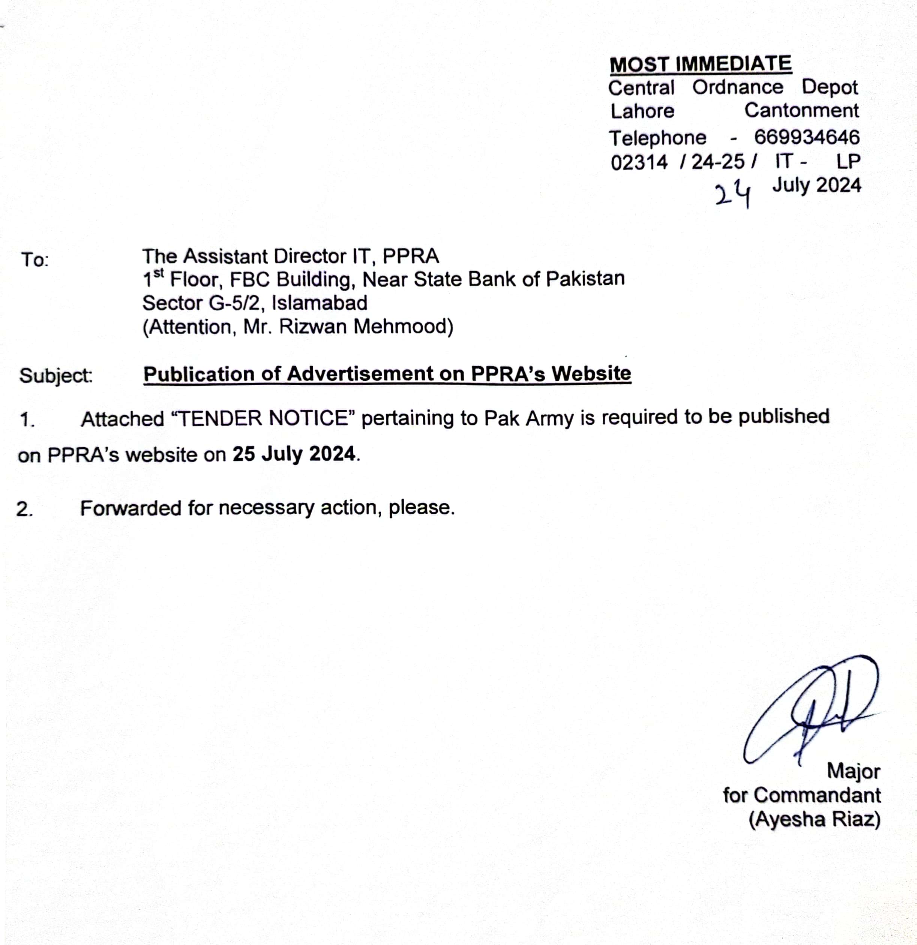

Central Ordnance Depot
Lahore Cantonment
Telephone - 669934646
02314 / 24-25 / IT - LP
24 July 2024
To: M/S ____________________________

________________________________

Subject: Local Purchase of Ordnance Stores Through Central Contract /Central CST during FY2024/25

1. Store mentioned at Annexure ‘A’,’B’&’C’ is urgently required. Please forward your quotation through bearer / by post, so as to reach Commandant Central Ordnance Depot Lahore Cantonment latest by 8 Aug 2024 at 1030 AM which will be opened on 8 Aug 2024 at 1100 AM in the presence of Depot Board of Officers and representatives of the firms, if desired.
2. Accounting Unit and Nomenclature of item will not be amended. Over writing of rates will not be accepted. Your firm will be held responsible for any negative report regarding quality and rates. In this connection render a certificate from your side which depicts complete satisfaction regarding quality / rates.
3. Firm’s stamp, NTN, CNIC, Letter number of the firm and IT letter number must be endorsed on all quotations. Incomplete quotations will not be accepted.
4. Rates must be given as per given designation and should be quoted reasonably for the best quality as per DGP (A) specification which may be checked before quoting.
5. The rates quoted should be as per accounting unit, confirm and final including all taxes/duties. No change in quoted rates will be accepted later on subject to any cause i.e. fluctuation in value of foreign currency or all types of government duties/ taxes.
6. The Stores offered must confirm to the standard specification and will be on firm’s standard One Year warranty / user acceptance.

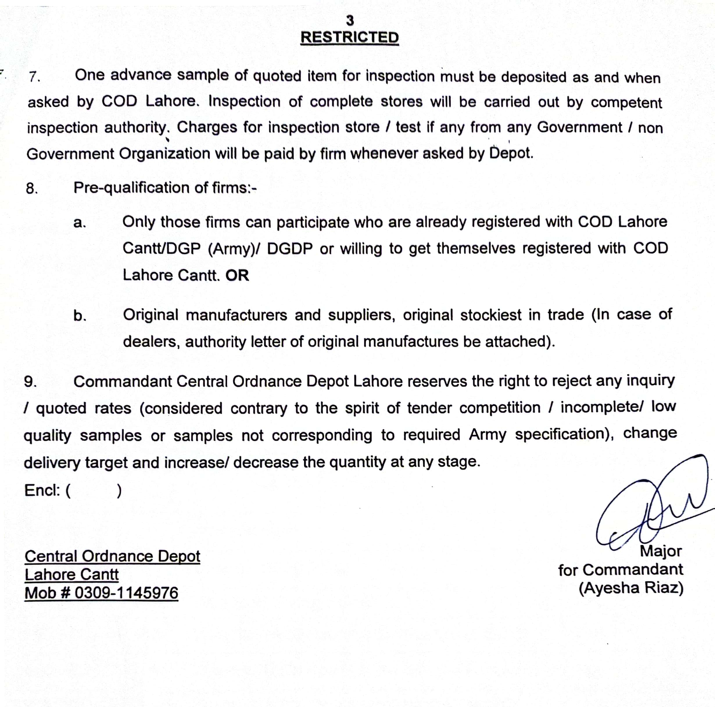

MOST IMMEDIATE
Central Ordnance Depot
Lahore Cantonment
Telephone - 669934646
02314 / 24-25 / IT - LP
24 July 2024

To: The Assistant Director IT, PPRA
1st Floor, FBC Building, Near State Bank of Pakistan
Sector G-5/2, Islamabad
(Attention, Mr. Rizwan Mehmood)

Subject: Publication of Advertisement on PPRA’s Website
1. Attached “TENDER NOTICE” pertaining to Pak Army is required to be published on PPRA’s website on 25 July 2024.
2. Forwarded for necessary action, please.

Major
for Commandant
(Ayesha Riaz)

Central Ordnance Depot
Lahore Cantonment
Telephone - 669934646
02314 / 24-25 / IT - LP
24 Jul 2024
To: M/S ____________________________

________________________________

Subject: Local Purchase of Ordnance Stores Through Central Contract /Central CST during FY2024/25

1. Store mentioned at Annexure ‘A’,’B’&’C’ is urgently required. Please forward your quotation through bearer / by post, so as to reach Commandant Central Ordnance Depot Lahore Cantonment latest by 8 Aug 2024 at 1030 AM which will be opened on 8 Aug 2024 at 1100 AM in the presence of Depot Board of Officers and representatives of the firms, if desired.
2. Accounting Unit and Nomenclature of item will not be amended. Over writing of rates will not be accepted. Your firm will be held responsible for any negative report regarding quality and rates. In this connection render a certificate from your side which depicts complete satisfaction regarding quality / rates.
3. Firm’s stamp, NTN, CNIC, Letter number of the firm and IT letter number must be endorsed on all quotations. Incomplete quotations will not be accepted.
4. Rates must be given as per given designation and should be quoted reasonably for the best quality as per DGP (A) specification which may be checked before quoting.
5. The rates quoted should be as per accounting unit, confirm and final including all taxes/duties. No change in quoted rates will be accepted later on subject to any cause i.e. fluctuation in value of foreign currency or all types of government duties/ taxes.
6. The Stores offered must confirm to the standard specification and will be on firm’s standard One Year warranty / user acceptance.
7. One advance sample of quoted item for inspection must be deposited as and when asked by COD Lahore. Inspection of complete stores will be carried out by competent inspection authority. Charges for inspection store / test if any from any Government / non Government Organization will be paid by firm whenever asked by Depot.
8. Pre-qualification of firms:-
a. Only those firms can participate who are already registered with COD Lahore Cantt/DGP (Army)/ DGDP or willing to get themselves registered with COD Lahore Cantt. OR
b. Original manufacturers and suppliers, original stockiest in trade (In case of dealers, authority letter of original manufactures be attached).
9. Commandant Central Ordnance Depot Lahore reserves the right to reject any inquiry / quoted rates (considered contrary to the spirit of tender competition / incomplete/ low quality samples or samples not corresponding to required Army specification), change delivery target and increase/ decrease the quantity at any stage.
Encl: ( )

Central Ordnance Depot |  | Major
Lahore Cantt |  | for Commandant
Mob # 0309-1145976 |  | (Ayesha Riaz)

Annexure 'A'
Terms & Conditions
1. Items will be procured as per approved Army specifications.
2. Bidders are required to submit lab test reports of all items alongwith quotations. Items where lab test reports are mandatory, quotations not accompanied with lab test reports will not to be entertained.
3. Rates quoted by the firms will be valid for delivery throughout Pakistan till 30 Jun 2025.
4. Firms quoting rates and later refraining from delivery will be straight away Blacklisted.
5. LD (Liquidated Damages) and PR (Price Reduction) if any may be applied by the competent authority.

Local Purchase of Ordnance Stores Through Central Contract /Central CST during FY 2024/25

Ser | Part No | Nomenclature | A/U | Rate
 | KC/PKC-2207 | Cloth for HESCO Bag | Mtr
 | 9505-ZO-101-9008 | Wire Steel Spring 6 SWG | Kgs
 | 9505-ZO-101-3249 | Wire Steel Mild Round 4.064 MM Dia (8 SWG) | Kgs
 | 9505-ZO-101-3248 | Wire Steel Mild Round 3.251 MM Dia (10 SWG) | Kgs
 | W4/PWD-4367 | Wrapping Machine (specification attached) | Nos
 | NIV-GS-691890 | Thread Cotton Un-dyed 10/2  (60% Cotton and 40% Polyester (PC), Count of Yarn-2/60 +/-5 and 2 cord each single construction) | Kgs
 | 8465-ZO-251-0179 | Cloth Nylon Cardura | Mtr
 | PHA-7003 | Lubricant Oil semi fluid for machine Gun | Lit
 | 9150-99-224-1793 | Grease XG-287 | Kg
 | 9150-ZO-250-8072 | Lubricant Oil Pet Compressor Light OM-58 | Lit
 | 9150-ZO-231-2356 | Lubricating Oil preservative Med | Lit
 | 8010-ZO-250-0209 | Thinner Paint | Lit
 | 8010-ZO-250-0215 | Varnish Oil | Lit
 | 8010-ZO-250-0218 | Insulating Varnish Electrical | Lit
 | 8010-ZO-250-7893 | Turpentine | Lit
 | 6830-ZO-250-7896 | Acetylene Technical | CUM
 | 6830-ZO-152-7904 | Oxygen Technical | CUM
 | 3830-ZO-250-7902 | Nitrogen Gas Type-1 Class 1 Oil Free Grade-A | CUM

Ser | Part No | Nomenclature | A/U | Rate | Brand | Country of Origin | Chargeable/  Rechargeable | Sample/  brochure attached
 | 6135-ZO-210-3032 | Battery Dry BA-30 | Nos
 | 6135-ZO-210-3041 | Battery Dry BA-42 | Nos
 | 6135-120-1030 | Battery Dry BA-58 | Nos
 | PZJ/0153/A | Battery Dry BA-58 rechargeable | Nos
 | PZJ/0156/A | Battery Dry BA-30 rechargeable | Nos
 | PZJ/0154/A | Charger for rechargeable Battery BA-30 | Nos
 | PZJ/0155/A | Charger for rechargeable Battery BA-58 | Nos

Annexure 'B'
Terms & Conditions
1. DCP will be procured as per approved Army specifications.
2. Bidders will provide 2 Kg sample of DCP by 8 Aug 2024 alongwith Tech and commercial offers in separate envelopes for inspection by inspection agency.
3. Rates quoted by the firms will be valid for delivery throughout Pakistan till 30 Jun 2025.
4. Firms quoting rates and later refraining from delivery will be straight away Blacklisted.
5. Quotations must be submitted separately as Technical Offer and Commercial Offer, with each offer packed and sealed in separate envelope marked in bold letters and red ink as “TECHNICAL OFFER” and “COMMERCIAL OFFER”.
6. Rates will strictly not be mentioned on paper enclosed in Technical Offer. Only Technical Specifications and Brochures duly filled out will be the part of Technical Offer.
7. Consignor / supplier to ensure deposit of technical proposal on following format:-
Ser | Items | A/U | Brand | Country of Origin | Document (Brochure)

8. Financial proposal be provide as per following format:-

Ser | Items | A/U | Rate | Country of Origin | Delivery Period

9. Initially only the envelope clearly marked as “Technical Proposal” shall be opened.
10. The envelope marked as “Commercial offer” will remain under lock and key and will be opened on receipt of clearance report from inspection agencies.
11. After evaluation and approval of Technical Proposal subject to acceptance of advance sample, the Financial Proposals (of the technically accepted bids only) shall be publicly opened at a given time within the bid validity period and the bid found to be lowest shall be accepted. The financial proposal of bids found technically non-responsive shall be returned (un-opened) to the respective bidders.
12. Acceptance / rejection of Technical Proposal will be communicated to the participants.
13 LD (Liquidated Damages) and PR (Price Reduction) if any may be applied by the competent authority.

Local Purchase of Ordnance Stores Through Central Contract /Central CST during FY 2024/25

Ser | Part No | Nomenclature | A/U | Rate
 | H1(b)/6850-01-317-0730 | Dry Chemical Mixture, Fire Extinguisher Mono Ammonium Phosphate (MAP) NH4H2PO4 | Kgs

Annexure 'C'
Terms & Conditions
1. Paints will be procured as per approved Army specifications.
2. Tech offers of only manufacturing firms will be opened in the first phase (Bids of non-manufacturing firms are not to be entertained) and complete range of paints offered by the firm will be tested from inspection agencies.
3. Rates quoted by the firms will be valid for delivery throughout Pakistan till 30 Jun 2025.
4. Firms quoting rates and later refraining from delivery will be straight away Blacklisted.
5. Quotations must be submitted separately as Technical Offer and Commercial Offer, with each offer packed and sealed in separate envelope marked in bold letters and red ink as “TECHNICAL OFFER” and “COMMERCIAL OFFER”.
6. Rates will strictly not be mentioned on paper enclosed in Technical Offer. Only Technical Specifications and Brochures dully filled out will be the part of Technical Offer.
7. Consignor / supplier to ensure deposit of technical proposal on following format:-
Ser | Items | A/U | Brand | Country of Origin | Document (Brochure)

8. Financial proposal be provide as per following format:-

Ser | Items | A/U | Rate | Country of Origin | Delivery Period

9. Initially only the envelope clearly marked as “Technical Proposal” shall be opened.
10. The envelope marked as “Commercial offer” will remain under lock and key and will be opened on receipt of clearance report from inspection agencies.
11. After evaluation and approval of Technical Proposal subject to acceptance
of advance sample, the Financial Proposals (of the technically accepted
bids only) shall be publicly opened at a given time within the bid validity
period and the bid found to be lowest shall be accepted. The financial proposal of bids found technically non-responsive shall be returned (un-opened) to the respective bidders.
12. Acceptance / rejection of Technical Proposal will be communicated to the participants.
13. LD (Liquidated Damages) and PR (Price Reduction) if any may be applied by the competent authority.

Local Purchase of Ordnance Stores Through Central Contract /Central CST during FY 2024/25

Ser | Part No | Nomenclature | A/U | Rate
 | 8010-ZO-250-0102 | Paint Finishing (Acid &Alkali Resistant) Brushing Black | Lit
 | 8010-ZO-250-0103 | Paint Finishing Brushing Enamel Glass White | Lit
 | 8010-ZO-250-0104 | Paint Finishing Brushing Enamel High Gloss Black | Lit
 | 8010-ZO-250-0105 | Paint Finishing Brushing Enamel High Gloss Azure Blue | Lit
 | 8010-ZO-250-0106 | Paint Finishing Brushing Enamel High Gloss Sky Blue | Lit
 | 8010-ZO-250-0108 | Paint Finishing Brushing Enamel High Gloss Signal Red | Lit
 | 8010-ZO-250-0109 | Paint Finishing Brushing Enamel High Gloss Lemon Yellow | Lit
 | 8010-ZO-250-0110 | Paint Finishing Brushing Enamel High Gloss White | Lit
 | 8010-ZO-250-0111 | Paint Finishing Brushing Enamel High Gloss Golden Yellow | Lit
 | 8010-ZO-250-0112 | Paint Finishing Special MB Green | Lit
 | 8010-ZO-250-0113 | Paint Finishing Cellulose Glossy Black | Lit
 | 8010-ZO-250-0115 | Paint Finishing Baking Enamel White | Lit
 | 8010-ZO-250-0116 | Paint Finishing Matt Light Stone | Lit
 | 8010-ZO-250-0117 | Paint Finishing Semi Glossy MB Green | Lit
 | 8010-ZO-250-0118 | Paint Finishing Matt MB Green | Lit
 | 8010-ZO-250-0119 | Paint Finishing Matt Very Dark Drab | Lit
 | 8010-ZO-250-0120 | Paint Finishing Special Heat Resisting MB Green | Lit
 | 8010-ZO-250-0136 | Paint Finishing Semi Glossy MB Green | Lit
 | 8010-ZO-250-0138 | Paint Finishing MB Green | Lit
 | 8010-ZO-250-0140 | Paint Finishing Brushing Or Spraying aluminum | Lit
 | 8010-ZO-250-0141 | Paint Finishing Brushing General Service Gloss Black | Lit
 | 8010-ZO-250-0143 | Paint Finishing Brushing General Service Gloss Azure Blue | Lit
 | 8010-ZO-250-0144 | Paint Finishing Brushing Gen Service Gloss Light Brunswick Green | Lit
 | 8010-ZO-250-0145 | Paint Finishing Brushing General Service Gloss Dark Admiralty Grey | Lit
 | 8010-ZO-250-0146 | Paint Finishing Brushing General Service Gloss Red Oxide | Lit
 | 8010-ZO-250-0147 | Paint Finishing Brushing General Service Gloss White | Lit
 | 8010-ZO-250-0148 | Paint Finishing Brushing General Service Gloss Light Grey | Lit
 | 8010-ZO-250-0149 | Paint Finishing Spraying General Service Gloss Black | Lit
 | 8010-ZO-250-0150 | Paint Finishing Spraying General Service Gloss Dark Brown | Lit
 | 8010-ZO-250-0151 | Paint Finishing Spraying General Service Gloss Deep Brunswick Green | Lit
 | 8010-ZO-250-0152 | Paint Finishing Spraying General Service Gloss Lemon | Lit
 | 8010-ZO-250-0153 | Paint Finishing Spraying General Service Gloss Post Office Red | Lit
 | 8010-ZO-250-0154 | Paint Finishing Spraying General Service Gloss Port Land Stone | Lit
 | 8010-ZO-250-0157 | Paint Finishing General Service Matt Silver Gray | Lit
 | 8010-ZO-250-0159 | Paint Finishing Brushing General Service Enamel Light Brown | Lit
 | 8010-ZO-250-0163 | Paint Finishing Brushing General Service Enamel Brown | Lit
 | 8010-ZO-250-0170 | Paint Finishing Brushing Cellulose Nitrate White | Lit
 | 8010-ZO-250-0172 | Paint Finishing Brushing Cellulose Nitrate Post Office Red | Lit
 | 8010-ZO-250-0173 | Paint Finishing Brushing Cellulose Nitrate Golden Yellow | Lit
 | 8010-ZO-250-0174 | Paint Finishing Brushing Cellulose Nitrate Azure Blue | Lit
 | 8010-ZO-250-0175 | Paint Finishing Brushing Matt Black | Lit
 | 8010-ZO-250-0182 | Paint Finishing Brushing Black | Lit
 | 8010-ZO-250-0183 | Paint Finishing Brushing Signal Red | Lit
 | 8010-ZO-250-0186 | Paint Finishing Spraying Stoving Red Oxide | Lit
 | 8010-ZO-250-0188 | Paint Marking Brush Stenciling Quick Drying Sig Red | Lit
 | 8010-ZO-250-0189 | Paint Marking Brush Stenciling Quick Drying White | Lit
 | 8010-ZO-250-0190 | Paint Marking Brushing Quick Drying Azure Blue | Lit
 | 8010-ZO-250-0194 | Paint Priming Brushing Red & White Lead | Lit
 | 8010-ZO-250-0201 | Paint Priming Spraying Silver Grey | Lit
 | 8010-ZO-250-2521 | Paint Finishing (Acid & Alkali Resistant) Brushing Signal Red | Lit
 | 8010-ZO-250-3906 | Paint Priming No. 1 | Lit
 | 8010-ZO-250-3907 | Paint Priming No. 2 | Lit
 | 8010-ZO-250-4167 | Paint Finishing Brushing Matt Sand | Lit
 | 8010-ZO-250-4169 | Paint Finishing Spraying Matt Sand | Lit
 | 8010-ZO-250-5800 | Paint Priming Brushing chocolate | Lit
 | 8010-ZO-250-5802 | Paint Finishing Brushing Semi Glossy Olive Drab | Lit
 | 8010-ZO-250-6208 | Paint Finishing War Equipment Spraying Sand | Lit
 | PHA-1171 | Paint Finishing Brushing General Service White Inside | Lit
 | PHA-1172 | Paint Finishing Brushing General Service White Outside | Lit

Page 4A
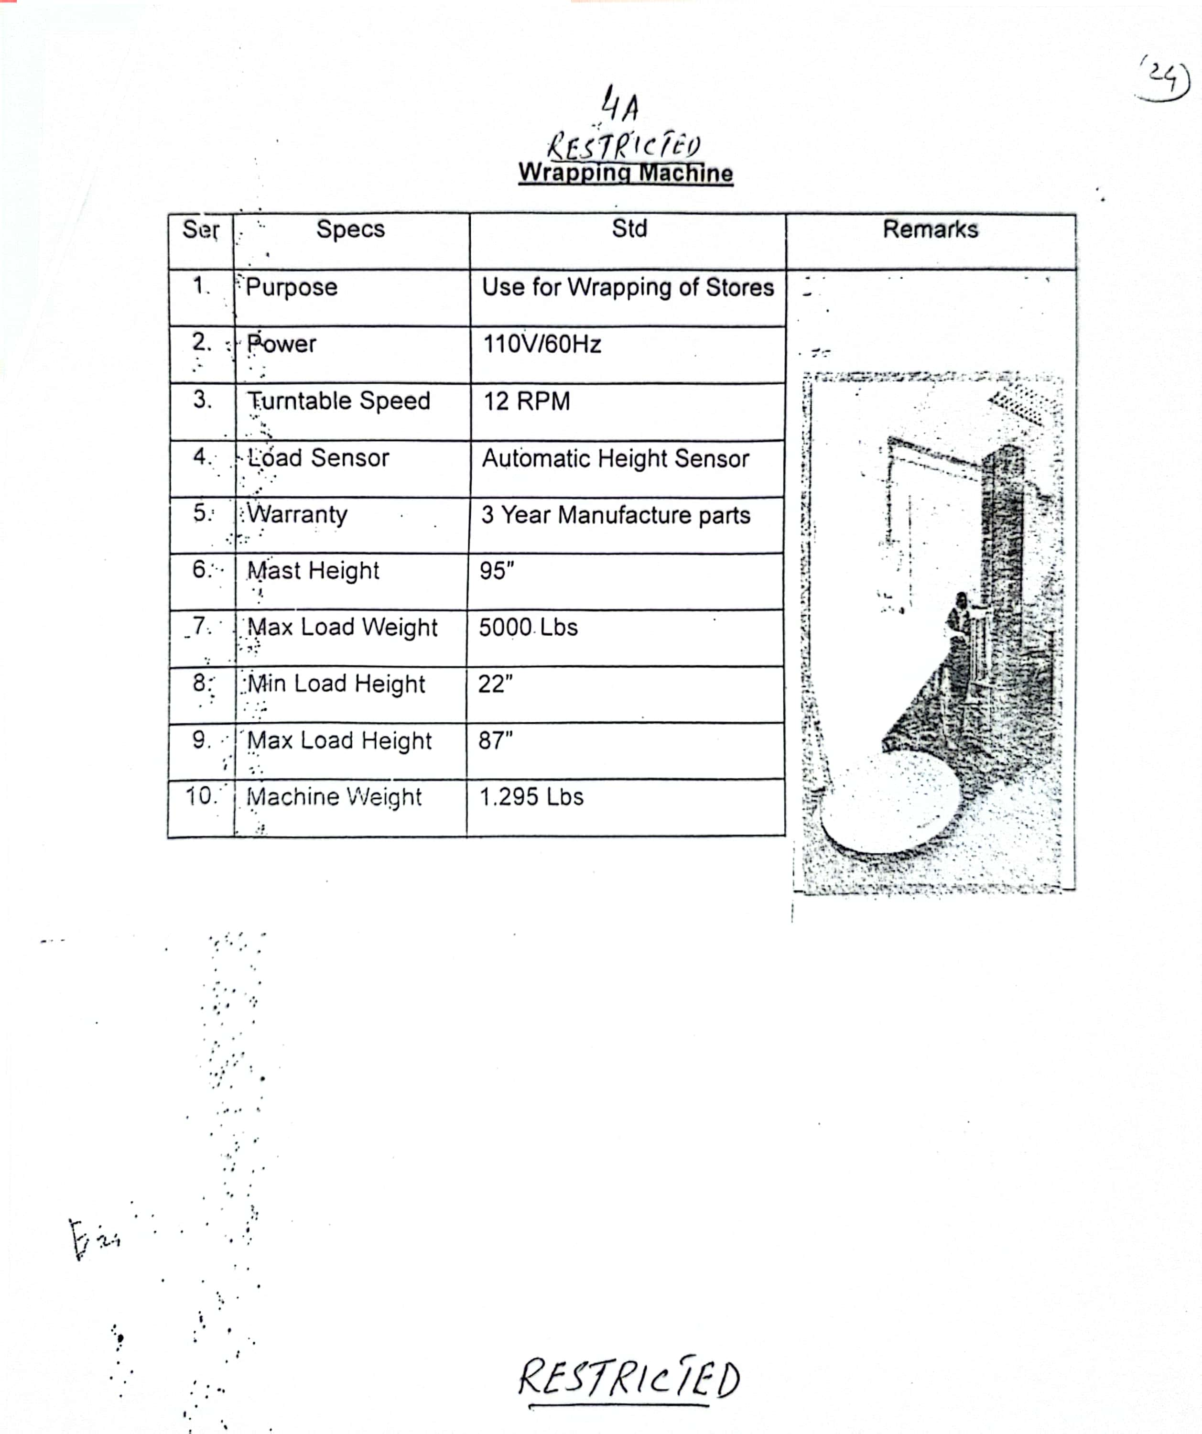
TECHNICAL SPECIFICATIONS OF WRAPPING MACHINE

