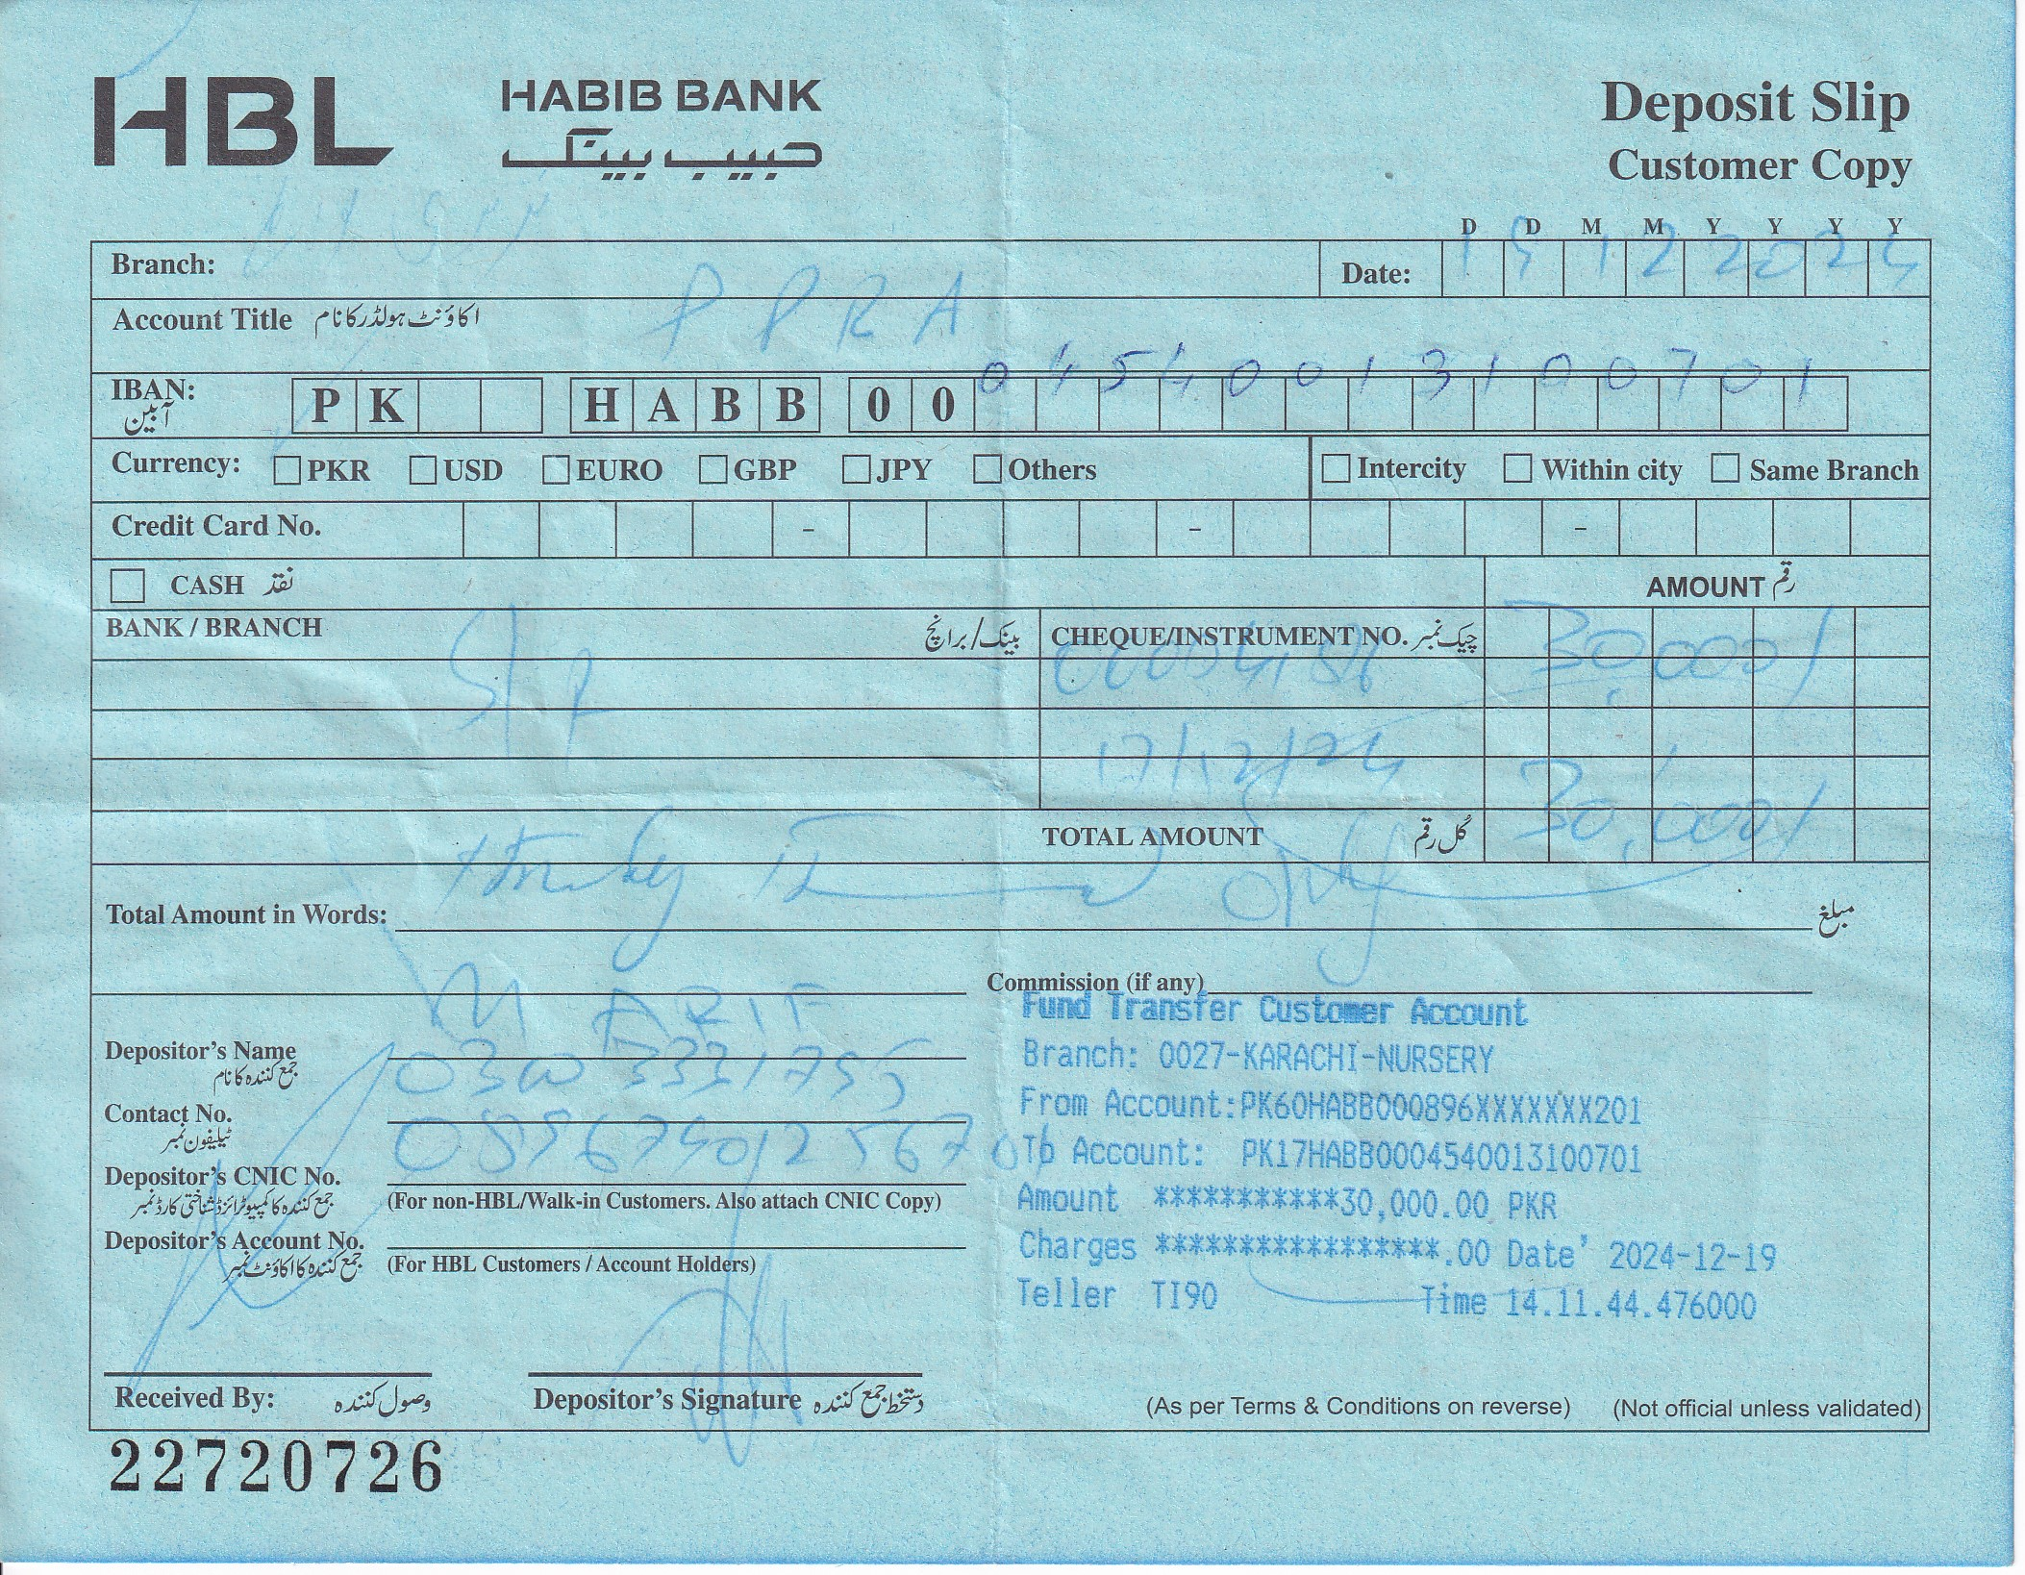



BIDDING NOTICE
PROVISION & INSTALLATION OF OFFICE/CLASSROOM EQUIPMENT AT
NUST - PNEC Karachi

- Bids are invited from reputed GST firms for Provision & Installation of Office/Classroom Equipment.
- Detail Scope of Work is mentioned in Tender Document.
- Firm(s) will provide (i) Firm’s profile (ii) Detail of projects done in last five years (iii) Sales-tax & Income-tax certificates (iv) Where registered / listed. etc.
- Bidding Documents may be purchased by submission of Pay Order / Bank Draft of Rs. 3,000/- (non-refundable) in favor of ‘NUST RECURRING BUDGET ACCOUNT’ during working hours (08am to 2pm) from 24 Dec 2024 from under mentioned address.
- Submit Bid Security / Earnest Money (equal to 3 % of total quoted value) along with bid as pay-order / bank draft in favor of ‘NUST RECURRING BUDGET ACCOUNT’.
- Contract shall be valid as per time specified in bidding document.
- Single stage, two envelope bidding process shall be adopted.
- Both ‘Financial’ & ‘Technical’ Bids into one sealed envelope should reach at under mentioned address latest by 11:00am on
09 Jan 2025. Technical Bids shall be opened on the same day by 11:30 am hours. Financial Bids of successful bidders shall be opened at 11:00am on 16 Jan 2025.

Tender No.NA/402/04/2024-25 dated 20 Dec 24.
PRESIDENT LOCAL PURCHASE
Pakistan Navy Engineering College (NUST)
PNS JAUHAR HABIB REHMATULLAH ROAD, KARACHI
Tel: 021-48503043 – 0332-9300038

