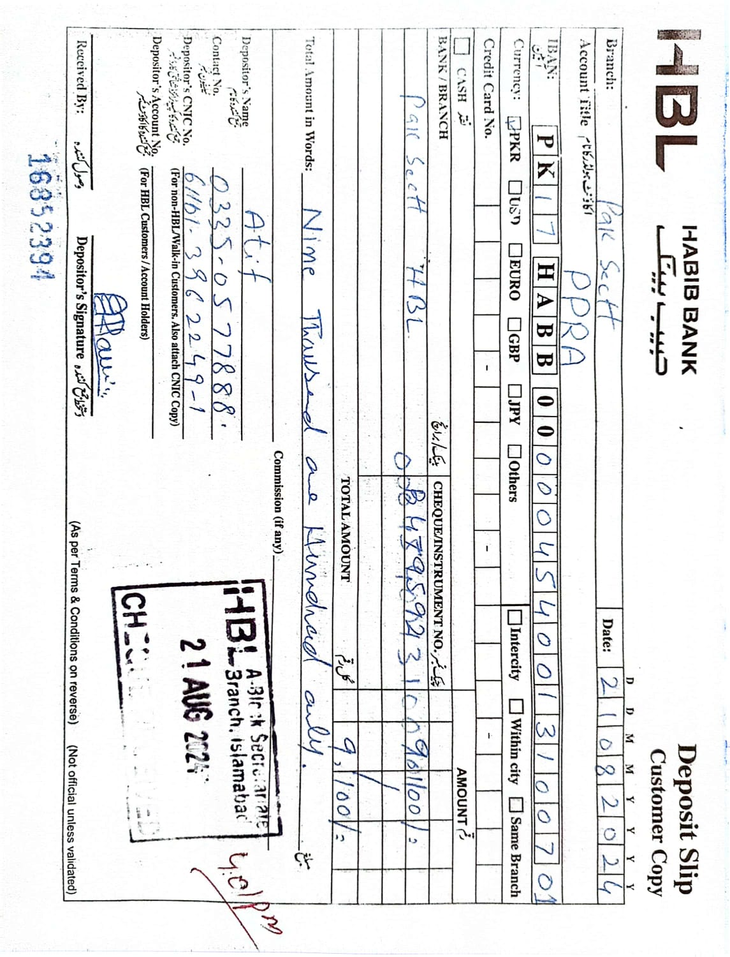

TENDER NOTICE FOR CATERING SERVICES FOR PIPS

The Pakistan Institute for Parliamentary Services invites sealed tenders on Single stage-two envelopes bidding procedure from the reputed firms/ vendors through E-PADS to cater the Parliamentarians, Employees, Media Persons and other visitors in Islamabad for the caterers with financially sound track record from Islamabad Municipal Corporation area only with proper production and distribution facility.

2. Tender documents including list of menu items and draft contract are uploaded on E-PADS and www.ppra.org.pk or www.pips.gov.pk websites.

3. Tenders must be supported with Profile of the Company containing experience in the field, number of staff and their skills & client list. Only those firms will be included in the competitive bidding process that have proven track record/experience in the business of restaurant /catering or high class cafeteria operations and sound financial position etc. will be adopted.

4. An earnest money of Rs. 100, 000/- (refundable) in shape of Bank Draft in favour of PIPS Islamabad must be provided before closing date. No tender will be entertained without earnest money.

5. Tenders must be uploaded on E-PADS by 12th September, 2024 at 11:00 a.m. and would be opened on the same day at 11:30 a.m. by the committee in PIPS Office.

(Habib Khan)

Assistant Director (Admn)
Pakistan Institute for Parliamentary Services,
Ataturk Avenue, F-5/2, Islamabad.

Ph No.051- 9091360/111

PAKISTAN INSTITUTE FOR PARLIAMENTARY SERVICES

Part A:

Subject: INVITATION TO BID AND GENERAL INSTRUCTIONS

You are hereby invited to submit the tender for the provision of catering services in accordance with the description of items at Appendix “A”.

- Prospective Bidders Should Particularly Note That:

- Authorized representative may attend the tender opening, if desired.
- The Purchaser reserves the right to increase or decrease the quantities and accept or reject any or all bids or cancel any or all items at any time as per PPRA Rules.
- Bids against this tender are invited on Single Stage -Two Envelopes Bidding Procedure.
- The tender must be uploaded on or before 12th September, 2024 (up to l1:00 AM).
- Copy of the bidding documents signed on each page by the authorized representative must be uploaded along with the Bid.
- The rates will be valid for a period of two years w.e.f. signing of contract. However, the contract may be extended with mutual consent.
- If the distribution facility is not upto the requirements and standard of the Institute, the caterer will be disqualified.
- The contract will be awarded to the bidder who will win the maximum number of deals given at Annex-I.

Assistant Director (Admn)

Part B:

Instruction To Bidders (ITB):

1. Date and Time for Receipt of Bids.
The bid document must be uploaded on EPADS until 12th September, 2024 at 11:00 a.m.

2. Tender Opening.
Tender will be opened on 12th September, 2024 at 11:30 a.m.
3. Price:
a. The price should be quoted for Islamabad basis only.
b. The price validity period must be at least 02 years from the date of signing of the contract.
c. The rates of the items must be subsidized for PIPS employees and events.
[
4. Taxes:
All prevalent Government Taxes will be applicable.
5. Language of Bidding Document:
The bid must be prepared in English language. If supporting documents and printed literature furnished by the bidder with the bid are not in English language, they must be accompanied by English translation of the relevant passages.

6. One Bid per Bidder:

Each bidder shall submit only one bid either by himself, or as a partner in a joint venture. A bidder who submits or participates in more than one bid (other than alternatives pursuant) will be disqualified.

7. Terms of Payment:
The payment of the events arranged for PIPS will be made on monthly basis after submission of valid invoices by the caterer within 15 working days.

8. Photocopies of relevant Documents:
Photocopies of following documents shall be uploaded with the proposal:-
- Income Tax and Sales Tax Nos. should be mentioned on the proposal.
- Copy of Registration Certificate.
- Active Taxpayer List Status (ATL) issued by Sales Tax Department.
9. Disqualification:
Proposals are liable to be rejected if:-
- Earnest money is not submitted to this Office.
- Multiple rates are quoted against one item.
- Validity of proposal is not mentioned as required.

10. Earnest Money / Bid Security:
Earnest money amounting to Rs. 100,000/- in shape of Bank Draft / Pay Order in favor of PIPS, Islamabad must be received in the Institute before closing.

11. Return of Earnest Money:
Earnest money to the unsuccessful bidders will be returned after award of the contract
to the most adventitious bidder, as per PPRA rules.
12. Rights Reserved:
PIPS reserves the right to accept or reject any or all proposals including the lowest, as per PPRA Rules, as amended from time to time.
13. Extension in Contract:
The contract period may be extended as mutually agreed by both the parties.
Annex-I
Pakistan Institute for Parliamentary Services
Technical Bids Evaluation Criteria:
Marks obtained as per criteria are given below:-
S. # | Grading | Marks
1. | Experience related to the similar assignments  (02 marks for each year after establishment) | 30
2. | Annual Turnover  (01 mark per million) | 20
3. | Job in Hand  (02 marks for each client/ job in hand) | 20
4. | Managerial Capability (Regular Manpower)  (01 Marks for each employee) | 20
5. | Office Setup/ Location  (Proper established office in a building either owned or rented for cater need of PIPS and its Distance from PIPS) | 10
Total Marks |  | 100
Qualifying Marks = 65%

Note:-

Only technically qualified bidders shall be considered for financial bid opening. Bid will be awarded to the bidder who will win the maximum number of the deals given below.

Financial Bid
Menu List for PIPS Catering Services
Sr.# | Description of Item | Rates per person for
Sr.# | Description of Item | Islamabad
Deal 1 (Single serving)
Chicken Fried Rice
Malai Boti (BBQ)
Fried Fish
Mutton Karahi
Naan/Roti
Assorted Salad Bar
Raita/Chatni
Soft Drinks
Sweet Dish
Tea/Coffee
Cookies + Sandwiches
Mineral Water during meeting & meal
Evening Tea/Qehwa if session is more than 04 hours

Deal 2 (Single serving)
Fried Rice
Mutton Karahi
Malai Boti (BBQ)
Naan/Roti
Assorted Salad Bar
Raita/Chatni
Sweet Dish
Tea/Coffee
Cookies + Sandwiches
Mineral Water during meeting & meal
Evening Tea/Qehwa if session is more than 04 hours

Deal 3 (Single serving)
Chicken Pulao
Mutton Karahi
Naan/Roti
Salad
Raita
Sweet Dish
Tea/Coffee
Cookies + Sandwiches
Mineral Water during meeting & meal
Evening Tea/Qehwa if session is more than 04 hours

Deal 4 (Single serving)
Peas Pulao
Chicken Karahi
Salad + Raita
Naan
Sweet DIsh
Tea & Cookies (Afternoon)
Mineral Water during meeting & meal
Evening Tea/Qehwa if session is more than 04 hours

Deal 5 (Single serving)
Chicken Jalfraezi
Daal Handi
Salad + Raita
Naan
Kheer
Tea & Cookies
Mineral Water during meeting & meal
Evening Tea/Qehwa if session is more than 04 hours

Deal 6 (Single serving)
Egg Fried Rice
Fried Kabab
Raita
Roti/Naan
Tea & Cookies
Mineral Water during meeting & meal
Evening Tea/Qehwa if session is more than 04 hours

Deal 7 (Single serving)
Peas Pullao
Chicken Handi
Naan /Roti
Salad
Raita
Sweet
Tea & Cookies
Mineral Water during meeting & meal
Evening Tea/Qehwa if session is more than 04 hours

Deal 8 (Single serving)
Chicken Fried Rice
Chicken Mixed Vegetable
Salad
Sweet
Tea & Cookies
Mineral Water during meeting & meal
Deal 9 (Single serving)
Chicken Fried Rice
Chicken Almond
Mineral Water during meeting & meal
Evening Tea/Qehwa if session is more than 04 hours
Deal 10 (Single serving) /Lunch Box
Chicken Palao
Shami Kabab
Mineral Water during meeting & meal
Evening Tea/Qehwa if session is more than 04 hours

Deal 11 (Single serving)/Lunch Box
Chicken Karahi
Salad
Nan/Roti
Mineral Water during meeting & meal
Evening Tea/Qehwa if session is more than 04 hours

Deal 12 (Single serving)/ Lunch Box
Chicken Tikka
Two Pcs Seekh Kabab
Mint Sauce
Roghni Nan
Mineral Water during meeting & meal
Evening Tea/Qehwa if session is more than 04 hours

Reception Deal 1 (Single serving)
Finger Fish
Shashlik Stick
Sandwich (one bite)
Pastry (one bite)
Tea/Coffee
Mineral Water during meeting
Evening Tea/Qehwa if session is more than 04 hours

Reception Deal 2 (Single serving)
Chicken Patties (One bite)
Cold Sandwich (one bite)
Pastry (one bite)
Finger Fish
Shashlik Stick
Tea/Coffee
Fresh Juice
Mineral Water during meeting
Evening Tea/Qehwa if session is more than 04 hours

Reception Deal 3 (Single serving)
Sandwich (one bite)
Finger Fish
Pastry (one bite)
Tea/Coffee
Mineral Water during meeting
Evening Tea/Qehwa if session is more than 04 hours

Reception Deal 4 (Single serving)
Sandwich (one bite)
Qeema Samosa
Pastry (one bite)
Tea/Coffee
Mineral Water during meeting
Evening Tea/Qehwa if session is more than 04 hours

Reception Deal 5 (Single serving)
Chicken Sandwich
Cookies
Tea/Coffee
Mineral Water during meeting
Evening Tea/Qehwa if session is more than 04 hours

Reception Deal 6 (Single serving)
Sandwich (one bite)
Fruit Cake
Tea/Coffee
Mineral Water during meeting
Evening Tea/Qehwa if session is more than 04 hours

Reception Deal 7 (Single serving)
Qeema Samosa
Cookies
Tea/Coffee
Mineral Water during meeting
Evening Tea/Qehwa if session is more than 04 hours

Reception Deal 8 (Single Serving)
Cookies
Tea/Coffee
Mineral Water during meeting
Evening Tea/Qehwa if session is more than 04 hours

 | Cold/Soft Drink Per head

Note: The above rates should be inclusive of all prevalent Government Taxes.

Contract for Acquiring Catering Services for PIPS

This contract is entered into and executed at Islamabad on this __________________Day of _____, 2024 by & between the Pakistan Institute for Parliamentary Services (PIPS), Government of Pakistan, Ataturk Avenue, Sector F-5/2, Islamabad, (hereinafter referred to as the “PIPS”, which expression shall, where the context so permits, include its successors, legal, representatives and permitted assignees of the one part);
and M/s _______________________, a registered “Caterer”, having its permanent Setup at _________________________________, Islamabad (hereinafter referred to as “Caterer”, which expression shall, where the context so permits, include its successors, legal, representatives and permitted assignees of the other part);
WHEREAS the Bidder is engaged into the business of providing “Catering Services”, who has been qualified and has stood successful in bidding process executed by PIPS, for “Catering Services”, through “Invitation for Bids”, hence PIPS is willing to award “Services” through this agreement; and the Caterer is willing to provide “Services” according to the “Rates” appended with this agreement at “Schedule-I” as integral part of this agreement.
NOW, THEREFORE, in considerations of the mutual representations and covenants hereinafter set forth and for other services consideration the adequacy of which is hereby acknowledged by the parties and the mutual benefits to be derived there from, the representations, covenants, conditions and promises contained herein below and intending to be legally bound the parties agree as follows:

CONDITIONS OF CONTRACT
1. Contract Effectiveness:
1.1. This agreement shall come into effect w.e.f. _____ _____, 2024 to __________,2026. Initially the contract agreement shall be signed for 02 years, which can be extended on satisfactory performance of the Caterer with mutual consent of both parties.
1.2. The Caterer shall, prior to the commencement of the operation of contract, make available to PIPS, the particulars of all the employees who shall be deployed in its premises by the Caterer. Such particulars, inter alia, should include age/date of birth, permanent address and CNIC of the employees. In case of replacement of any employee, the Caterer shall inform PIPS Administration and shall provide the aforementioned particulars immediate to the replacement.

2. Expiry of Contract:
Unless terminated earlier pursuant to Clause 4 hereof, this Contract shall expire after 02 years of the signing of this contract.

3. Extension Upon expiry with Revised Rates:
PIPS reserves the right to extend the contract further with mutual consent. However, the rates may be revised with mutual consent based upon Consumer Price Index (CPI) issued by State Bank of Pakistan/Pakistan Bureau of Statistics.

4. Termination:
4.1 PIPS may, without prejudice to any other remedy for breach of contract, by written notice of default sent to the contractor, terminate this contract provided that:-
a) The contractor fails to perform any obligation under the contract provided that the contractor does not remedy his failure within the time stipulated in default notice.
b) If PIPS terminate the contract it may procure the services upon such terms and conditions as it may deem appropriate and the contractor will be liable to pay the excess cost of the services so procured.
c) If the caterer wants to cancel/terminate the contract before its expiry, a prior notice of one month should be served to PIPS with proper justifications. However, PIPS reserves the right to accept or reject the request in the best interest of the Institute.

5. Assignment:
The Caterer shall not appoint any Sub-caterer or sublet the contract to carry out his obligations under this contract.

6. Services:
6.1 The Caterer shall be responsible for engaging adequate number of manpower for providing quality services in PIPS including their hygienic conditions/manners.
6.2. The prices/rates decided and agreed between the parties for various items as appended in Schedule-I shall not be subject to any variation during currency of the contract until and unless anything approved by PIPS Management in writing.
6.3 The Caterer shall maintain the hygienic environment for preparation of food and shall use products of renowned brands.
6.4 The Caterer shall not undertake any kind of construction including alteration or modification in the premises, including electrical appliances, sanitary fittings and other fitting/equipment, without the permission of PIPS in writing and further he shall have no right to use PIPS’s property for his employee's personal purposes.

7. Prohibition:
Storing & supply/sale and consumption of drugs, alcoholic drinks, cigarettes or any other items of intoxication are strictly prohibited in PIPS premises. Any breach of such restrictions by the Caterer shall attract deterrent action against the Caterer as per statutory norms.

8. Indemnification:
The Caterer shall indemnify PIPS and hold it harmless/ not responsible in respect of all & any expenses arising from any injury or damage to persons or property and also in respect of any claim made in respect of injury or damage under any Acts of Government.

9. Resolution of Disputes:
All questions, disputes, controversies or claims arising directly or indirectly out of or consequent to this agreement shall be settled by mutual negotiations, should such negotiations fail, the matter shall be referred to the Director General (Admn), PIPS whose decision will be final and bindings upon both the parties. However, all the legal forums will also be available to both parties. The parties signing below hereby agree to the terms and conditions of this Contract by so signing below on this ___________, 2024.

10. Subletting:
The Caterer shall not be allowed to sublet the catering services and if found doing so, the contract will be terminated immediately.

This agreement is executed in two counterparts, each of which shall be deemed an original, but both of which together shall constitute one and the same instrument.

FOR AND BEHALF OF FOR AND BEHALF OF

Signature and seal of the Caterer Signature and seal of the PIPS

