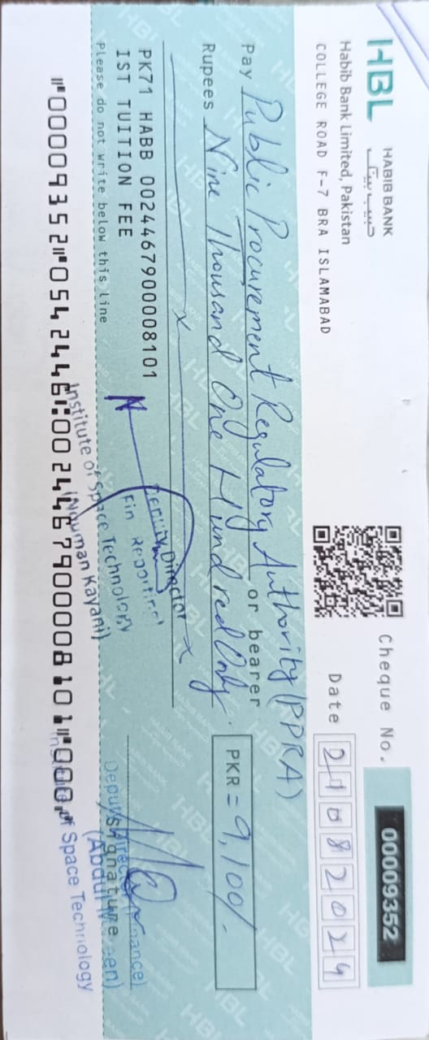

Institute of Space Technology

INVITATION TO BID

1. Institute of Space Technology (IST) is a public sector university established under the Institute of Space Technology Act, 2010 invites sealed bids from the original manufacturers / authoirzed distributors / suppliers / Contractors, registered with Income Tax and Sales Tax Department for supply of the followings:

Sr. | IT Ref No. | Item Name | Quantity | Submission Date | Tender Fee
1 | LIT-2425-Admin-01 | Convocation Services & Catering | N.A | 04 Sep, 2024 | Rs.2,000/-
2 | RFQ-2425-00006-L | GNSS Simulator | 01-No | 05 Sep, 2024 | Rs.2,000/-
3 | RFQ-2425-00007- L | GNSS Receiver & Laser Distance Measuring Tool | 01-Each | 05 Sep, 2024 | Rs.2,000/-
4 | RFQ-2425-00008-L | GNSS Equipment | Misc | 05 Sep, 2024 | Rs.2,000/-
5 | RFQ-2425-00010-L | GPU Workstation | 02-No | 05-Sep-2024 | Rs.2,000/-

2. Bidding documents, containing detailed terms and conditions, method of procurement, procedure for submission of bids, bid security, bid validity, opening of bid, evaluation criteria, clarification / rejection of bids, performance guarantee etc. are available for the interested bidders at Procurement Department Institute of Space Technology, Islamabad at a price of Rs.2000/- in form of demand draft per Bid. Bidding documents can also be downloaded from www.ist.edu.pk.

3. The bids prepared in accordance with the instructions in the bidding documents, must reach at (Institute of Space Technology, Near Rawat Toll Plaza, Main Islamabad Highway, Islamabad on or before above mentioned closing dates by 11:30 hours. Bids will be opened the same day at 12:00 hours respectively. This advertisement is also available on PPRA website at www.ppra.org.pk.



Additional Director (Procurement)
Institute of Space Technology
1, Islamabad Highway, Near CDA Toll Plaza, Islamabad.
Tel No: 051-9075688 , 9075538
Fax No: 051–9275433 email: raees.ahmad@ist.edu.pk

