––––
TENDER DOCUMENTS
Ref: H&AI/HR&ADMIN/PESH/10/2024
Procurement of Office Furniture H&AI Peshawar Office

Sealed technical & financial bids are invited in accordance with PPRA rules, under ‘Single Stage–single Envelope Procedure’, from vendors registered with EPAD /GST/Income Tax Department, own offices and phone/fax numbers, for the purchase Office Furniture
The sealed bids should reach to the office of the under signed on 08-11-24 at 03:00 P.M and bids will be opened on the same day at 03:30 PM in the presence of the bidders or their representatives at Health & Accident Insurance, State Life Building, Mall Road, Peshawar.

Details of ITEMS with Specifications

Sr. | Items | Sample | Qty.
1 | Manager Desk with Right Side Rack | 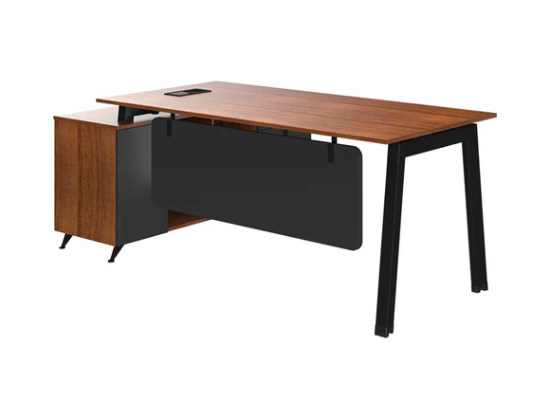 | 2
  Desk Size: 63 W | 31 D | 29.5 H (inches)
  Side Rack Size: 55 W | 18 D | 25 H (inches)
  Carcass: Teak MFC
  Vanity Panel: Charcoal Grey MFC
  Legs: Metallic legs with Black Powder Coat
  Glides: Adjustable Rubber Glides
  Teak MFC top with a charcoal grey vanity panel for a modern look.
  Triangular metallic legs in black powder coat for stability and contemporary flair.
  Rubber glides for smooth movement and adaptability.
  Integrated cable cover for a neat and organized workspace.
  Accompanying side rack with ample storage, open cubby compartments, four drawers and a large cabinet for personalization and storage.
2 | Center Table: | 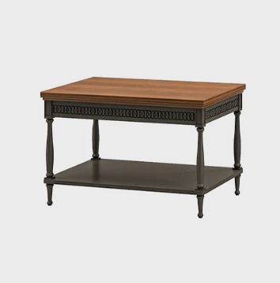 | 4
  - Material: Ash/Oak - Wood/Veneer Polish Finish: Teak, Black High Gloss
  - Size:
  - 41 W x 23 D x 19 H (Inches)
  - 1050 W x 600 D x 500 H (mm)
3 | Center Table | 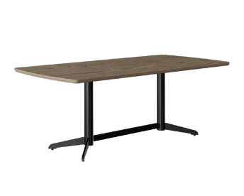 | 4
  - Top Size: 47 W | 24 D | 19 H (inches)
  - Top Material: Silver Apricot Veneer in Natural Finish
  - Metallic Base: MS Pipe
  - Finish: Charcoal Grey Powder Coat
  - Glides: Rubber Glides
4 | Sofa Set 5 Seater: | 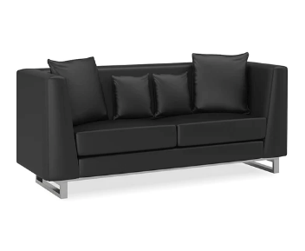 | 2
  1. Size:
  82 W x 32 D x 26 H (Inches)
  2098 W x 838 D x 685 H (mm)
  2. Leatherette Upholstery
  3. Acacia Wood Structure
  4. Stainless Steel Base
  5. Removable Foam Filled Cushions
  6. Foam/cushion guarantee for replacement
5 | Single seater sofa: | 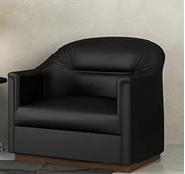 | 6
  1-Seater:35 W x 30 D x 27 H (Inches)
  2. Best Quality Foam
  3. Black Leatherette upholstery
  4. Fixed Foam Cushions
  5. Acacia Wood Structure
  6. Base Acacia Wood with Polish Finish
  7. Foam/cushion guarantee for replacement
6 | Single seater sofa: | 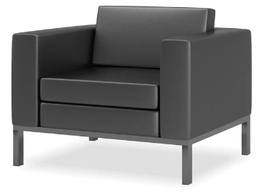 | 6
  1-33 W x 30 D x 26 H (Inches)
  2-Upholstered in Black Leatherette
  3-Metal with Grey Powder Coat
  4-Glides: Rubber
  5-Foam/cushion guarantee for replacement
7 | Manager Chair with Headrest: | 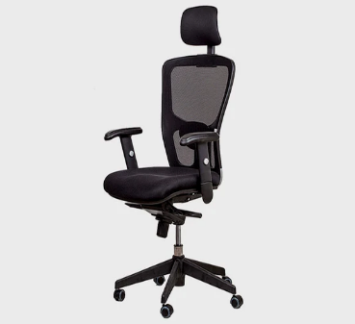 | 25
  Size: 25 W | 25 D | 47 H (Inches)
  Material: Mesh Back and Mesh Padded Seat
  Headrest: Mesh Padded
  Finish: Black
  Base: Nylon Base with Casters
  Mesh back with integrated headrest for superior ergonomic support.
  Mesh-padded seat offers a comfortable and breathable seating experience.
  Adjustable armrest support and lumbar back support for customized comfort.
  Synchronized tilting mechanism with four-level tilt locking for personalized reclining.
  Gas lift feature allows easy height adjustment.
  Nylon base enables 360-degree rotation for seamless mobility.
8 | High Back Computer Chair | 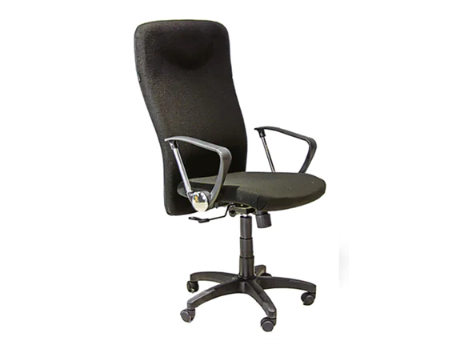 | 10
  Size: 23 W | 19 D | 49 H (Inches)
  Material: Fabric padded seat & back
  Finish: Black
  Base: Nylon
  Comfortable seating with thick-padded back and durable fabric for longevity.
  Height adjustable with gas lift for ideal working height and posture.
  Customizable tilt with multiple levels for the backrest angle.
  360° rotation for easy access to different workspace areas.
  Sturdy nylon base with castor wheels for stability and effortless movement.
9 | Durable Visitors Chairs: | 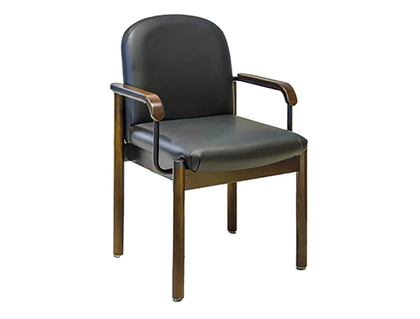 | 30
  Fully upholstered padded seat and back in durable black leatherette for extended comfort.
  Elegant Jacobean polished legs and armrests contrast with black upholstery for warmth and modern elegance.
  Sturdy wooden frame and legs provide lasting stability and support for arms and shoulders.
  Protective floor glides ensure smooth movement without scratching or damaging the floor.
  Specifications:
  Size: 24 W | 23 D | 35 H (Inches)
  Material: Leatherette Padded Seat and Back (Black)
  Armrest: MS Pipe Powder-Coated Armrest
  Frame: Wooden in Jacobean Polish

Conditions
- Bidders shall deliver Bid money before tender closing time to undersigned office, in original form of a Pay Order / Bank Draft for 2% in favor of State Life Insurance Corporation of Pakistan which will be returned immediately after issuance of Supply / Work Order to un- successful bidders and after satisfactory completion of job to successful bidder. however, id security of successful bidder shall be retained by SLIC as performance security and subsequent warranty for guarantee period.
- Bid Security will be send to H&AI Peshawar Officer before closing of bids. Otherwise bid will be rejected.
- No Bid will be accepted without Bid security & other than EPAD Platform, Bidding Advertisement are available on PPRA, EPADS, State Life website.
- Documents can be obtained from office during office timing.
- The bid validity of tender will be 120 days from the date of opening the tender.
- The Most Advantageous Bidder shall be considered. Bidder are required to apply for all items. Tender will be rejected if bidder applied for one item or a few items or left some items blanked.
- The envelope should be marked as bid Money for Tender Notice No: H&AI/ HR&ADMIN/PESH/10/2024
- Income Tax & General Sales Tax as per government rule will be deducted at the source from the payment.
- Supply should be according to tender specifications. Any defective delivery / Material will be taken back by supplier at his own risk & cost.
- Successful bidder will have to provide samples of material (each item), which will be examined by Zonal Procurement Committee, Supply / Work Order shall be issued upon grant of Final approval of sample by committee members. Material will be as it as shown in photo. No compromise on quality. Otherwise bid will be rejected.
- The supplier will be responsible for installation of furniture / fixture at site
- The bidder shall execute work at his own cost and Quality of work shall be inspected before final payment, subsequent bidder shall be responsible to fulfill requirement as per site w/r to committee proposal
- Bidder shall provide 1-year guarantee certificate of its performed work, any repair shall be free of cost including labor & material within guarantee period by bidder
- Supply items shall be brand new & according to tender specification. Photos of furniture are shown and can be discussed with Incharge HR & Admin H&AI.
- Bidders are encouraged to visit office before submission of bid for their ease as Samples are available at office.
- Quotation is acceptable for this tender through EPADS only, other than EPADS platform, quotation shall not be entertained
- Competent Authority reserves the right to reject all bids or proposals at any time prior to acceptance of a bid or proposal. However, State Life on request shall communicate to any supplier or contractor who submitted a bid or proposal, the grounds for its rejections of all bids or proposals.

Undertaking:

We hereby confirm to have read all the terms and conditions carefully mentioned in the tender documents and we agree to abide by all those conditions.

Signature and stamp: __________________________

A:- Verifiable Documentary Proof

- Verifiable documentary proof for all below requirements is mandatory.
- The bidders who have duly complied with the Eligibility / Qualification and Evaluation criteria will be eligible for further processing.

Sr. No. | Eligibility / Evaluation Criteria | Requirement | Supporting Documents to be Attached as | Page No.
1 | Sales Tax Registration (copy of certificate) | Mandatory | Annex-A
2 | Income Tax Registration (copy of certificate) | Mandatory | Annex-B
3 | Experience Certificate for similar work (copy of certificate) | Mandatory | Annex-C
4 | Affidavit/ undertaking that the firm has never been blacklisted by any organization/ government on judicial stamp paper. | Mandatory | Annex-D
5 | Proof of Active Taxpayer List | Mandatory | Annex-E
6 | Bid Security 2% of total tender amount through bank draft/ pay order (To be attached with Financial Proposal) | Mandatory | Must be attached with Financial Proposal only

TECHNICAL EVALUATION
- The technical proposals shall be evaluated by the technical evaluation committee in the light of following evaluation criteria.
- The Bids which do not conform to the technical Specifications or conditional bid from the Bidders without adequate capabilities for supply of Goods/Items/Services will be rejected
 | Eligibility/Evaluation Criteria |  | Supporting Documents to be attached as | Page No
A. | COMPANY PROFILE
 | i. The company established within 1 to 2 years (Proprietorship) = 10 Marks  ii. The company established more than 2 years = 25 Marks  Note: Certificates Required | 15  Marks  Maximum | Annex-F
B. | SIMILAR WORK EXECUTED BY FIRM IN PAST:
 | Contracts completed Less than 4 Lacs for each contract= 5 Marks  Contracts completed Greater than 4 Lacs and Less than 6 Lacs for each contract = 15 Marks  Contracts completed Greater than 6 Lacs for each contract = 25 Marks  Note : Work Order Required | 20 Marks  Maximum | Annex-G
C. | SIMILAR WORK IN PROGRESS/AT PRESENT:
 | 02 Marks per Contract  Minimum executed contracts = 03  Note: Work Order Required | 10 Marks  Maximum | Annex-H
D. | FINANCIAL STATUS :( (Verified by Bank Statement, Annual Tax Return)
 | Annual Turnover  - Between 2- 5 Million = 07 Marks  - 5-10 Million = 14 Marks  - Above 10 Million = 20 Marks (Max) | 20  Marks  Maximum | Annex-I
E. | TECHNICAL STAFF:
 | - Carpantor= 08 Marks  - Installer = 05 Mark  - Labor = 02 Marks  Note: Mention Staff List | 15 Marks  Maximum | Annex-J
F. | ENLISTMENT WITH OTHERS:
 | Enlistment with reputed Govt/National/ Multinational Firms  Minimum requirement = 01 Firms  Note: Contract/Purchase/Work Orders Required | 5  Marks  Maximum | Annex-K
G. | Pre Bid Meeting (is must) otherwise tender documents of that specific vendero will be rejected. Detail discussion regarding material and samples and quality of furniture will be done. | 15 Marks

Total Points = 100
Minimum Qualification = 60

Date: ________________

FINANCIAL PROPOSAL
(For Purchase Furniture F.Y 2024)

S# | Description | Qty. | Unit Price without GST | Amount of GST | Unit Price with GST | Total Cost (No of Units x Unit price including all taxes)
1
2
3

Name of Supplier: ______________________________________________

Signature with Date

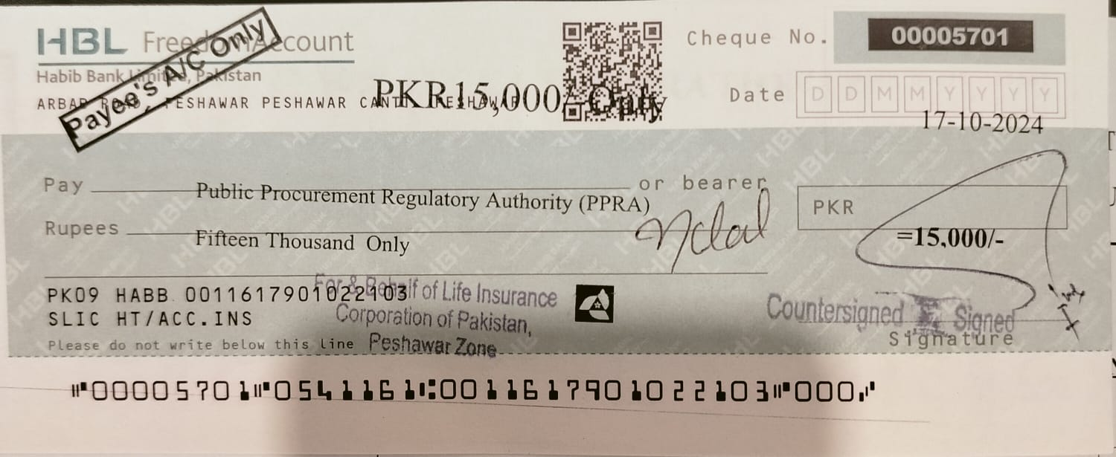

CORRIGENDUM-DATE EXTENSION NOTICE

TENDER NOTICE NO: H&AI/ HR&ADMIN/PESH/10/2024

Procurement of Furniture

For Health & Accident Insurance Peshawar Zone

With reference to the advertisement having PID No. PID(P)258/24 published in Daily “The Nation” and Daily “AWAM-UN-NAS” dated 12th Oct, 2024 for requirements as per subject.

The following amendment / changes in dates to be made in the subject advertisement.

- Last Date & Time for submission of Bids is 08-11-24 at 03:00 pm and opening of Bids at same day at 03:30 pm.
- This advertisement is available on PPRA website www.ppra.org.pk and State Life website www.statelife.com.pk.
- Rest of the contents, terms & conditions will remain same.

Amanullah
Incharge HR&ADMIN,
Health & Accident Insurance Peshawar Zone,
34-The Mall Peshawar Cantt.
Ph. 091-9213949

