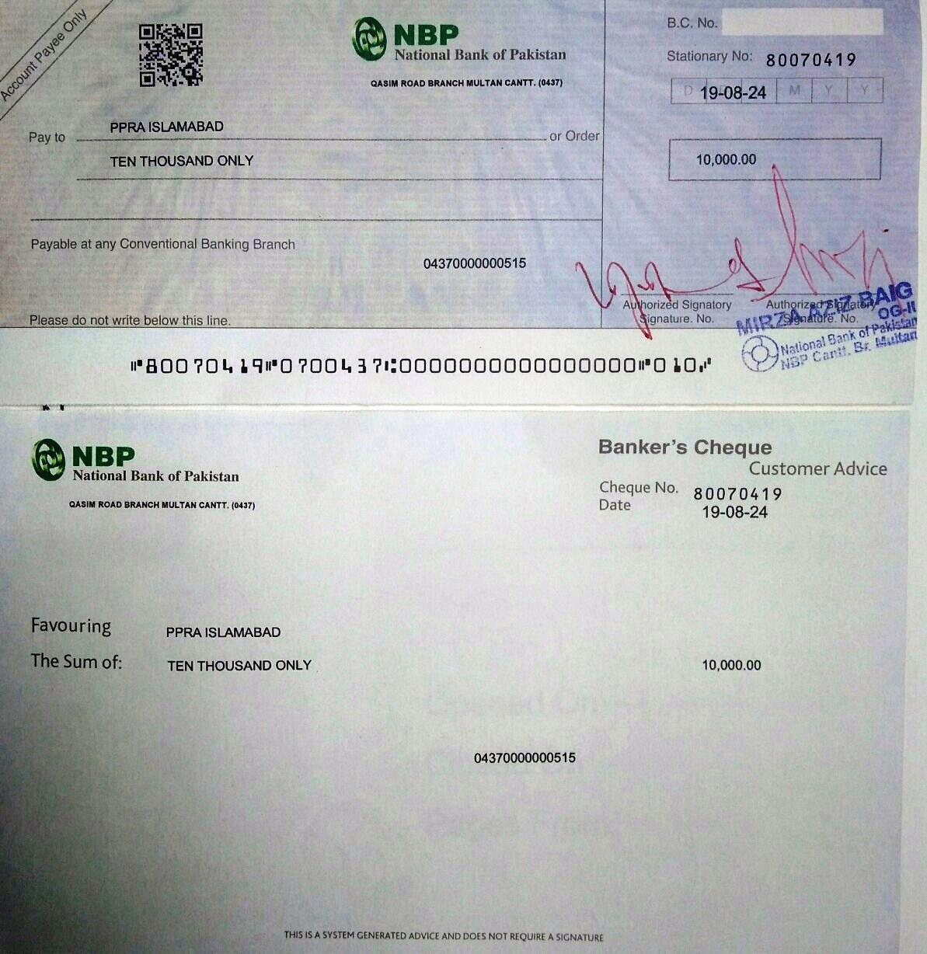

FG Public School No.1 (Boys)
Multan Cantt
Telephone: 061-4504404
No.Accts/04/2024/427
15th Aug 2024

To
PPRA Islamabad Building, 1st Floor
Federal Bank for Cooperatives, Ataturk
Ave, G-5/2 G-5
Islamabad.

Info: The Regional Director FGEIs (C/G) Regional Office Multan Cantt

Subj: Request for Tender Notice for 25 KW Solar System Installation
1

- It is submitted that this institution has received a grant of 2.5 million PKR for the installation of 25 KW solar systems. 25 KW will be segregated like 15 KW in High Block & 10 KW in Middle Block of this school. It is requested PPRA to issue a tender notice for this project by 20th August, 2024, to invite qualified contractors. Kindly expedite the process to ensure timely implementation, please.

- The tender notice for the advertisement is under:-

TENDER NOTICE
FG Public School No.1 (Boys) Multan Cantt invites proposals from the dealers /firms for the following purchase / installation.
Ser | Tender Title | Min Load Required | Projects Address & Contact No.
1 | Supply , Installation & commissioning of solar system panels with inverters and net metering | 25 KW | FG Public School No.1 (Boys) Quaid-E-Azam Road Multan Cantt.  0334-7346571  061-4504404

- The interested tenders / contractors should apply in writing for the issue of tender documents along with submission of tender document fee Rs 1000/- (Non-Refundable).
- The last date of submission of bids to the undersigned office is 29 Aug 2024 (Thursday) and bids will be opened on the same day at 11:00 AM.

Principal
(Ghulam Akbar)

