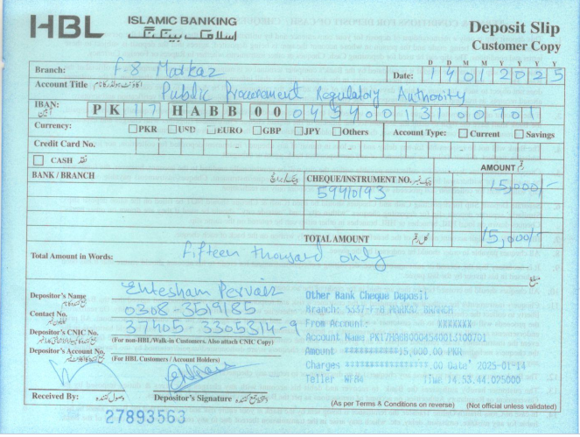

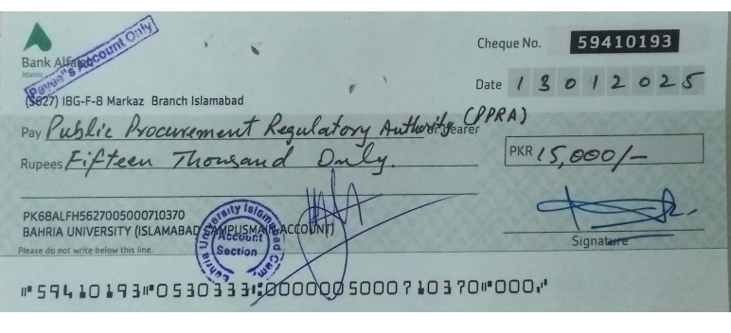

BAHRIA UNIVERSITY
Discovering Knowledge
Islamabad Campus

TENDER NOTICE

No. BUIC/IT/2024/909 Dated: 15 Jan 2025

PROVISION OF NEW CARD PRINTER FOR BAHRIA UNIVERSITY ISLAMABAD CAMPUS

1. The Bahria University Islamabad Campus invites bids from Income tax and Sales tax registered firms for under mentioned items.

2. Interested eligible bidders may download tender documents for the subject work containing detailed terms and conditions from E-PADS or can obtained from Procurement Office Bahria University after uploading/ publication of the Tender Notice during office hours (0900 hours to 1600 hours) except Saturday and Sunday against payment of non-refundable fee in shape of cash of
Rs. 3,000/- (Rupees three thousand only).
S. # | DESCRIPTION | QTY
01 | DNP CX-D80 Dual side card printer (warranty 02 year – new brand) | 01
02 | YMCK colored ribbon (1000 images) | 01
03 | Retransfer film (1000 images) | 01

3. Single stage one envelope methodology shall apply. Bids will only be accepted through
E-PAD. (Hard Copy of uploaded documents and bid security (in original) be deposited in procurement office before 30 Jan 2025). Bid security amounting to Rs. 45,000/- should be submitted in the shape of pay Order / Demand Draft /CDR in favour of Bahria University Islamabad E-8 Campus. Last date of bid submission is 30 Jan 2025 till 1100 hrs. The tenders will be opened on
30 Jan 2025 at 1130 hours in the presence of the bidders/their authorized representatives.

4. The bidders are requested to give their best and final prices including all taxes. The Bahria University may reject all bids or proposals at any time prior to the acceptance of a bid proposal by invoking rule 33 of PPRA – 2004.

5. Further information for any query or technical clarification, if any, may be contacted on phone No. 051-9260002 Extension 1100 from DD (IT & NW) or to visit Procurement Office.

DIRECTOR ADMIN ISLAMABAD
Bahria University, Islamabad Campus
Sector E-8, Shangrila Road, Naval Complex, Islamabad
Tel: 051-9260002 Extension: 1320, FAX: 051- 9260889

