National Highways and Motorway Police


Bidding Documents
TENDER No. 06/MT/S-I/N-55/2024-27,
PREQUALIFICATION OF FIRMS FOR AUTO- WORKSHOPS AND GENERAL ORDER SUPPLIER OF REPAIR OF TRANSPORT AND MISC. ITEMS FOR SECTOR-I N-55 South Zone Through EPADS, For FY 2024-2025, 2025-2026, 2026-2027

Open Framework Agreements

Last Date of Submission: (04-09-2024) at (1100 hrs) Opening at (1130 hrs) on (04-09-2024)
Note:
- The tender documents must be signed & stamped and attached with Technical Bid otherwise bid will be rejected.

All potential bidders are requested to upload their bids on EPADS on or before (04-09-2024) (at 1100 hrs) and submitted bidding documents at the office of the Sector Commander Sector-I N-55 Sehwan. The bids will be opened as per scheduled date & time i.e. at (1130 hrs) on (04-09-2024).

Chairman Purchase Committee
Sector Commander, Sector-I N-55 Sehwan
sspofficesehwanshareef@gmail.com
Contact#: 025-4620097

Prequalification Document (Through Open Framework Agreement)
PART 1 – PREQUALIFICATION PROCESS
Section I - | Instructions to Applicants (ITAs)  This Section contains detailed information for preparing and submitting the Applications for Prequalification, in addition to information on opening and evaluation of the Applications.
Section II - | Prequalification Data Sheet (PDS)  This Section contains provisions that supplement the ITA (in Section-I), and are specific to respective Prequalification Proceedings.
Section III - | Qualification Criteria and Requirements

This Section prescribes the methodology, criteria, and requirements to be used to determine the capacity and capability of the Applicants for the supply of goods and related services in accordance with the requirements of the Procuring Agency, with an objective to prequalify them for Invitation to Bid(s), and sign the open framework agreement(s) with the selected bidder(s).

Section IV – Application Forms

This Section contains Application Submission Form and other allied forms required to be submitted with the Application.

Section V - Eligible Countries

This Section contains information regarding eligible countries in accordance with the Policy of the Federal Government.

PART 2 – SUPPLY REQUIREMENTS

Section VI – Schedule of Requirements
Invitation for Prequalification
OFFICE OF THE
SENIOR SUPERINTENDENT OF POLICE NATIONAL HIGHWAYS MOTORWAY POLICE SECTOR-I, N-55 SEHWAN

PROPOSAL FOR PREQUALIFICATION
National Highways & Motorway Police (NHMP) invites Bids from the firms/vendors based at Hyderabad/Karachi/Sukkur/Larkana and nearby cities who are well reputed, registered with Income Tax, Sales Tax Department and Sindh Revenue Board and are on Active Taxpayers List of the Federal Board of Revenue for Prequalification of Auto Workshops & Vendors for repair of vehicles, wheel alignment/balancing, purchase of spare parts, tyres, batteries and other parts for the vehicles of Sector-I N-55 Sehwan South Zone through EPDAS Open Framework Agreement for a period of three (03) years (FY 2024-2025, 2025-2026, 2026-2027)
TERMS & CONDITIONS FOR BIDDERS

a. | Prequalification Documents containing detailed terms and conditions are available on EPADS and in the office of The Sector Commander Sector-I N-55 Sehwan, main Indus highway road Sehwan city, which can be obtained upon the payment of Rs.500/- non-refundable. Prequalification Documents can also be downloaded from the websites of NHMP at www.nhmp.gov.pk & PPRA website at www.ppra.org.pk and through EPADS at eprocure.gov.pk free of cost.
b. | Tender should be accompanied by bid money as mentioned in the Prequalification Documents as earnest money (refundable) in the name of D.D.O NHMP, Sector-I, N-55, Sehwan in the form of pay order/CDRs. Cheque will not be acceptable.
c. | The NHMP reserves the right to reject any/all bids at any time prior to acceptance of a bid in accordance with PPRA’s Rules.
d. | In case opening date(s) is declared as a Public Holiday by the Government, the next working day shall be deemed to be the date for submission and opening of tender(s) at the same time and place.
e. | Proposals, prepared in accordance with the instructions given in the Prequalification Documents should be uploaded on EPADS by 1100 hours on (04-09-2024) and will be opened on the same  day at (1130) hours at the Office of Sector Commander, Sector-I, N-55 Sehwan.

Chairman Purchase Committee
Sector Commander Sector-I N-55 Sehwan
Ph: 025-4620097
  - Contents
PART 1 – Prequalification 5
Section I - Instructions to Applicants 5
- General. 5
- Contents of the Prequalification Documents 8
- Preparation of Applications 10
- Submission of Applications 12
- Procedures for Evaluation of Applications 13
- Evaluation of Applications 14
Section II - Prequalification Data Sheet (PDS) 19
- General. 19
- Contents of the Prequalification Document. 19
- Preparation of Applications 20
- Submission of Applications 20
- Procedures for Evaluation of Applications 21
Section III – Eligibility Criteria and Requirements 22
Section IV - Application Forms 24
Application Submission Letter 24
Form ELI -1.1 26
Applicant Information Form 27
Form ELI -1.1 (continued) 27
Applicant Information Form 27
Form FIN – 1 29
Financial Situation and Performance 29
Section V - Eligible Countries 30
Section VI – Evaluation Criteria and Requirement 31
Section VII – Specification and Scope of Work 33

PART 1
Prequalification of Automobile Workshops and General Order Supplier of M.T Items

Section I - Instructions to Applicants
A. General
1. Scope of Application | 1.1 In connection with the “Invitation for Prequalification”, the Procuring Agency, as defined in Section II (Prequalification Data Sheet abbreviated as PDS), issues this set of Prequalification Documents (PD) to prospective applicants (also hereinafter referred as Applicants) interested in submitting applications (also hereinafter referred as Applications) to determine the capacity and capability of the Applicant(s) for supply of Goods and Related Services incidental there to as specified in Section VI (Schedule of Requirements).
2. Source of Funds | 2.1 Source of funds is regular budget for Prequalification.
3. Fraud and Corruption | The Procuring Agency requires that the Applicants /Bidders/ Suppliers/Contractors under Government financed contracts, observe the highest standard of ethics during the procurement and execution of such agreements and contracts.  The Applicants/Bidders shall permit and shall cause their agents (whether declared or not), sub-contractors, sub-consultants, service providers, suppliers, and their personnel, to permit the Procuring Agency to inspect all accounts, records and other documents relating to any, Application/Bid submission, Primary Procurement process, Framework Agreement performance, Secondary Procurement process, and/or Call-off Contract performance (in the case of award of a Call- off Contract), and to have them audited by auditors appointed by the Procuring Agency.  Any communications between the Applicant and the Procuring Agency related to matters of alleged corrupt and fraudulent practices must be made in writing or in electronic forms that provide record of the content of communication.

Procuring Agency will reject an application or bid or proposal, if it is established that the Applicant or the Bidder or Prosper was engaged in corrupt and fraudulent practices in competing for the contract.

Procuring Agency will also declare the Applicant as blacklisted in accordance with Public Procurement Rule 19 and predefined standard mechanism.
4. Eligible Applicants | 4.1 An Applicant may be a private entity, a state-owned enterprise or institution subject to ITB 4.6, or any combination of such entities in the form of a joint venture (JV) under an existing JV agreement or with the intent to enter into such an agreement supported by a letter of intent.  In case of single (private or state-owned entity), it shall be liable for execution of all the provisions of the Framework Agreement (if signed b/w the Procuring Agency and the entity), the execution of any Call-off Contract(s) awarded (to the entity) under the Framework Agreement in accordance with the Call-off Contract conditions that apply.  In the case of a joint venture, all members shall be jointly and severally liable for the execution of all the provisions of the Framework Agreement (if signed b/w the Procuring Agency and the JV), the execution of any Call-off Contract(s) awarded (to the JV) under the Framework Agreement in accordance with the Call off Contract conditions that apply.  The JV shall nominate a Representative who shall have the authority to conduct all business for and on behalf of any and all the members of the JV during the Prequalification process, Bidding process (in the event the prequalified JV submits a Bid) and during the period of framework agreement and contract execution (in the event the JV is awarded the Contract). Unless specified in the PDS, there is no limit on the number of members in a JV.

An Applicant may apply for Prequalification both individually, and as part of a joint venture, or participate as a subcontractor. If prequalified as a JV only, it will not be permitted to bid for the same contract as an individual entity. Bids submitted in violation of this provision will be rejected.

An Applicant and any of its affiliates (that directly or indirectly control, are controlled by or are under common control with that entity) may submit its Application for Prequalification either individually, as joint venture or as a sub-contractor among them for the same contract. However, if prequalified only one prequalified Applicant will be allowed to bid for the same contract.
All Bids submitted in violation of this provision will be rejected.
4.4 Applicants shall be considered to have a conflict of interest, if they participated as a consultant in the preparation of the design or technical specifications or have been hired or proposed to be hired by the Procuring Agency for execution of subsequent Framework
Agreement(s) or Call off Contract(s). In addition, Applicants may
be considered to have a conflict of interest if they have a close business or family relationship with such professional staff of the Procuring Agency (or a recipient of a part of the funds) who:

- are directly or indirectly involved in the preparation of the Prequalification Documents or Bidding Documents or specifications of the Framework Agreement or Call-off Contract and/or the Prequalification or Bid evaluation process of such Contract; or
- would be involved in the implementation or supervision of such Framework Agreement or Call-off Contract, unless the conflict stemming from such relationship has been resolved throughout the Procurement Process, Bidding process during the execution of the Framework Agreement and/or Call-off Contract.
 | 4.5 An Applicant that has been declared debarred or blacklisted shall be ineligible to be prequalified to bid or enter into any Framework Agreement or Call-off Contract for such period of time and for such type of procurement for which he has been declared debarred or blacklisted. The list of debarred firms and individuals is available at PPRA’s website.
 | 4.6 An Applicant shall provide such documentary evidence for determining the eligibility of the Applicant to the reasonable satisfaction of the Procuring Agency.
5. Eligibility  (in terms of Nationality) | 5.1 Applicants may be ineligible if they are nationals of ineligible countries as indicated in Section V.

B. Contents of the Prequalification Documents
6. Sections of Prequalification Documents | 6.1 This set of Prequalification Documents consists of Part 1 which comprise all the sections indicated below, and which should be read in conjunction with any Addendum issued in accordance with ITA 8.
PART 1 Prequalification Procedures

- Section I - Instructions to Applicants (ITA)
- Section II - Prequalification Data Sheet (PDS)
- Section III - Qualification Criteria and Requirements
- Section IV - Application Forms
- Section V - Eligible Countries
- Section VI – Schedule of Requirements (assessment criteria)
 | 6.2 Unless obtained directly from the Procuring Agency or downloaded directly from the website link referred in the Invitation for Prequalification, the Procuring Agency accepts no responsibility for the completeness of the Prequalification documents, responses to
 | requests for clarification, the minutes of the pre-Application meeting (if any), or Addenda to the Prequalification documents in accordance with ITA 8. In case of any discrepancies, documents issued directly by the Procuring Agency or downloaded from the website link shall prevail.
 | 6.3 The Applicant is expected to examine all instructions, forms, and terms in the Prequalification Documents and to furnish with its Application all information or documentation as is required by the Prequalification Documents.

7. Clarification of  Prequalification Documents and Pre-Application Meeting | An Applicant requiring any clarification of the Prequalification Documents shall contact the Procuring Agency in writing at the Procuring Agency’s address indicated in the PDS. The Procuring Agency will respond in writing to any request for clarification provided that such request is received no later than three (03) days prior to the deadline for submission of the Applications. The Procuring Agency shall forward a copy of its response to all prospective Applicants who have obtained the Prequalification Documents directly from the Procuring Agency (or through its website link), including a description of the inquiry but without identifying its source. If so indicated in the PDS, the Procuring Agency shall also promptly publish its response at the web page identified in the PDS. Should the Procuring Agency deem it necessary to amend the Prequalification Documents as a result of a clarification, it shall do so following the procedure under ITA 8 and in accordance with the provisions of ITA 17.2.  If indicated in the PDS, the Applicant’s designated representative is invited at the Applicant’s cost to attend a pre-Application meeting at the place, date and time mentioned in the PDS. During this Pre- Application meeting, prospective Applicants may request clarification of the schedule of requirement, the qualification criteria or any other aspects of the Prequalification Documents.  Minutes of the Pre-Application meeting, if applicable, including the text of the questions asked by Applicants, including those during the meeting (without identifying the source) and the responses given, together with any responses prepared after the meeting will be transmitted promptly to all prospective Applicants who have obtained the Prequalification Documents. Any modification to the Prequalification Documents that may become necessary as a result of the pre-Application meeting shall be made by the Procuring Agency exclusively through the use of an Addendum pursuant to ITA 8. Non- attendance at the pre-Application meeting will not be a cause for disqualification of an Applicant.

8.Amendment of Prequalification Documents | 8.1 At any time prior to the deadline for submission of Applications, the Procuring Agency may amend the Prequalification Documents by issuing an Addendum.

8.2 Any Addendum issued shall be part of the Prequalification Document and shall be communicated in writing to all Applicants who have obtained the Prequalification Documents from the Procuring Agency. The Procuring Agency shall promptly publish the Addendum at the Procuring Agency’s web page identified in the PDS:
Provided that an Applicant who had either already submitted their Applications or handed over the applications to the courier prior to the issuance of any such addendum shall have the right to withdraw his already filed Application and submit the revised Application prior to the original or extended Application submission deadline.
8.3 To give Applicants reasonable time to take an Addendum into account in preparing their Applications, the Procuring Agency may at its discretion, extend the deadline for the submission of Applications in accordance with ITA 17.2:

Provided that the Procuring Agency shall extend the deadline for submission of Applications, if such an addendum is issued within last three (03) days of the Application submission deadline.
C. Preparation of Applications
9. Cost of Applications | 9.1 The Applicant shall bear all costs associated with the preparation and submission of its Application. The Procuring Agency will in no case be responsible or liable for those costs, regardless of the conduct or outcome of the Prequalification process.
10. Language of Application | 10.1 The Application as well as all correspondence and documents relating to the Prequalification exchanged by the Applicant and the Procuring Agency, shall be written in the language specified in the PDS. Supporting documents and printed literature that are part of the Application may be in another language, provided they are accompanied by an accurate translation of the relevant passages in the language specified in the PDS, in which case, for purposes of interpretation of the Application, the translation shall govern.
11. Documents Comprising the Application | The Application shall comprise the following:  - Application Submission Letter, in accordance with ITA 12.1;  - Eligibility: documentary evidence establishing the Applicant’s eligibility, in accordance with ITA 13.1;

- Qualifications: documentary evidence establishing the Applicant’s qualifications, in accordance with ITA 14; and
- any other document required as specified in the PDS.
12. Application Submission Letter | 12.1 The Applicant shall complete an Application Submission Letter as provided in Section IV (Application Forms). This Form must be completed without any alteration to its format.
13. Documents Establishing the Eligibility of the Applicant | 13.1 To establish its eligibility in accordance with ITA 4, the Applicant shall complete the eligibility declarations in the Application Submission Letter and Form ELI-1.1 (eligibility), included in Section IV (Application Forms).
14. Documents Establishing the Qualifications of the Applicant | 14.1 To establish its qualifications to perform the contract(s) in accordance with Section III (Qualification Criteria and Requirements), the Applicant shall provide the information requested in the corresponding Information Sheets included in Section IV (Application Forms).
 | 14.2 Wherever an Application Form requires an Applicant to state a monetary amount, Applicants should indicate the Pak Rupee equivalent using the rate of exchange determined as follows:
 | (a) for turnover or financial data required for each year - Exchange rate prevailing on the last day of the respective calendar year (in which the amounts for that year is to be converted).
 | (b) value of single contract - Exchange rate prevailing on the date of the contract.
 | 14.3 Exchange rates shall be taken from the publicly available source identified in the PDS. Any error in determining the exchange rates in the Application may be corrected by the Procuring Agency.
 | 14.4 The documentary evidence of the Applicant’s qualifications to conclude a Framework Agreement, and/or to perform any Call-off Contract(s) if awarded, shall establish to the Procuring Agency’s satisfaction:
 | (a) that, if required in the BDS, an Applicant that does not manufacture or produce the Goods it offers to supply shall submit the Manufacturer’s Authorization using the form included in Section IV A (Bidding Forms) to demonstrate that it has been duly authorized by the manufacturer or producer of the Goods to supply these Goods in the Procuring Agency’s Country;
 | (b) that, if required in the BDS, in case of an Applicant not doing business within Islamic Republic of Pakistan (or the country

 | where the procurement is being made), the Applicant is, or will be, (if awarded the call off contract) represented by an Agent in the country, equipped and able to carry out the Supplier’s maintenance, repair, and spare parts stocking obligations in respect of the Goods.
15. Signing of the Application and Number of Copies | The Applicant shall prepare one set of the original documents comprising the Application as described in ITA 11 and clearly mark it “ORIGINAL”. The original set of the Application shall be typed or written in indelible ink and shall be signed by a person duly authorized to sign on behalf of the Applicant. In case the Applicant is a JV, the Application shall be signed by an authorized representative of the JV on behalf of the JV and so as to be legally binding on all the members as evidenced by a power of attorney signed by their legally authorized signatories.  The Applicant shall submit copies of the signed original Application, in the number specified in the PDS, and clearly mark them “COPY”. In the event of any discrepancy between the original and the copies, the original shall prevail.  When the Applications are submitted electronically, if permitted pursuant to ITA 17.1, The Applicant shall submit ORIGINAL and COPIES in accordance with the procedures specified in the PDS.
D. Submission of Applications
16. Sealing and Identification of Applications | The Applicant shall enclose the original and the copies of the Application in a sealed envelope that shall:  - bear the name and address of the Applicant;  - be addressed to the Procuring Agency, in accordance with ITA  17.1; and  (c) bear the specific identification of this Prequalification process indicated in the PDS reference ITA 1.1.  When the Applications are submitted electronically, if permitted pursuant to ITA 17.1, The Applicant shall seal the original and the copies in accordance with the procedures specified in the PDS.  The Procuring Agency will accept no responsibility for not  processing any envelope that was not identified as required in ITA 16.1 above.

17. Deadline for Submission of Applications | 17.1 Applicants may either submit their Applications by mail, by courier or by hand. Applications shall be received by the Procuring Agency at the address and no later than the deadline indicated in the PDS. When so specified in the PDS, Applicants have the option of  submitting their Applications electronically, in accordance with electronic Application submission procedures specified in the PDS.
If required in accordance with the provisions of ITA 8.3, the Procuring Agency will extend the deadline for the submission of Applications, in which case all rights and obligations of the Procuring Agency and the Applicants subject to the previous deadline shall thereafter be subject to the deadline as extended.
The deadline will be extended in the same manner as that of original Invitation for Prequalification (or the advertisement).
18. Late Applications | 18.1 The Procuring Agency reserves the right to accept Applications received after the time for submission of Applications, however subject to the condition that the same is received within the date specified as last date for submission of applications but before the time for opening of the Applications.
19. Opening of Applications | The Procuring Agency shall open all Applications at the date, time and place specified in the PDS. Late Applications shall be treated in accordance with ITA 18.1.  Applications submitted electronically, if permitted pursuant to ITA 17.1, shall be opened in accordance with the procedures specified in the PDS.  The Procuring Agency shall prepare a record of the opening of Applications to include, as a minimum, the name of the Applicants. A copy of the record shall be distributed to all Applicants.
E. Procedures for Evaluation of Applications
20. Confidentiality | 20.1 Information relating to the Applications, their evaluation and results of the Prequalification shall not be disclosed to Applicants or any other persons not officially concerned with the Prequalification process until the notification of Prequalification results is made to all Applicants in accordance with ITA 28.
 | 20.2 From the deadline for submission of Applications to the time of notification of the results of the Prequalification in accordance with ITA 28, any Applicant that wishes to contact the Procuring Agency on any matter related to the Prequalification process may do so only in writing.

21.  Clarification of Applications | 21.1 To assist in the evaluation of Applications, the Procuring Agency may, ask an Applicant for a clarification (including missing documents) of its Application, to be submitted within a stated reasonable period of time. Any request for clarification from the  Procuring Agency and all clarifications from the Applicant shall be in writing.
 | 21.2 If an Applicant does not provide clarifications and/or documents requested by the date and time set in the Procuring Agency’s request for clarification, its Application shall be evaluated based on the information and documents available at the time of evaluation of the Application.
22. Responsive- ness of Applications | 22.1 The Procuring Agency may reject any Application which is not responsive to the requirements of the Prequalification Documents. In case the information furnished by the Applicant is incomplete or otherwise requires clarification as per ITA 21.1, and the Applicant fails to provide satisfactory clarification and/or missing information within prescribed time, it may result in disqualification of the Applicant.
23. Margin of Preference | 23.1 Unless otherwise specified in the PDS, a margin of preference shall not apply in the Bidding process resulting from this Prequalification.
24. Sub- contractors | 24.1 Subcontractors’ qualification and experience will not be considered for evaluation of the Applicant. The Applicant on its own (without taking into account the qualification and experience of the Subcontractor) should meet the qualification criteria.
F. Evaluation of Applications and Prequalification of Applicants
25. Evaluation of Applications | 25.1 The Procuring Agency shall use the factors, methods, criteria, and requirements defined in Section III, Qualification Criteria and Requirements, to evaluate the qualifications of the Applicants, and no other methods, criteria, or requirements shall be used. The Procuring Agency reserves the right to waive minor deviations from the qualification criteria if they do not materially affect the technical capability and financial resources of an Applicant to perform the contract, however subject to the provisions of ITA 27.
 | 25.2 Subcontractors proposed by the Applicant shall be fully qualified for their parts of the Scope of Supply of the Goods and Allied Services.

25.3 In case of multiple contracts, Applicants should indicate in their Applications the individual contract or combination of contracts in which they are interested. The Procuring Agency shall prequalify each Applicant for the maximum combination of contracts for which the Applicant has thereby indicated its interest and for which the Applicant meets the appropriate aggregate requirements. The Qualification Criteria and Requirements are
mentioned in Section III.
 | 25.4 Only the qualifications of the Applicant shall be considered. The qualifications of other related entities such as the Applicant’s subsidiaries, parent entities, affiliates, subcontractors or any other firm(s) different from the Applicant shall not be taken into consideration in determining the qualifications of the Applicant.
26. Procuring Agency’s Right to Accept or Reject Applications | 26.1 The Procuring Agency reserves the right to accept or reject all the Applications, and to annul the Prequalification process at any time, without thereby incurring any liability to the Applicants.
27.Prequalification of Applicants | All Applicants whose Applications substantially meet or exceed the specified qualification requirements will be prequalified by the Procuring Agency.  An Applicant may be “conditionally prequalified,” that is, qualified subject to the Applicant submitting or correcting certain specified nonmaterial documents or deficiencies to the satisfaction of the Procuring Agency.  Applicants that are conditionally prequalified will be so informed along with the statement of the condition(s) which must be met to the satisfaction of the Procuring Agency before or at the time of submitting their Bids.
28.Notification of Prequalification | The Procuring Agency shall notify all Applicants in writing of the names of those Applicants who have been prequalified or conditionally prequalified. In addition, those Applicants who have been disqualified will be informed separately.  The procuring agency shall communicate to those suppliers or contractors who have not been pre-qualified the reasons for not pre-qualifying them.
29. Request for Bids | 29.1 Promptly after the notification of the results of the Prequalification, the Procuring Agency will invite the Bids from all the Applicants that have been prequalified.

30. Changes in Qualifications of Applicants | Any change in the structure or formation of an Applicant after being prequalified in accordance with ITA 27 and invited to bid (including, in the case of a JV, any change in the structure or formation of any member thereto) shall be subject to the written approval of the Procuring Agency prior to the deadline for submission of Bids. Such approval shall be denied if:  - a prequalified Applicant proposes to associate with a disqualified Applicant or in case of a disqualified joint venture, any of its members;  - as a consequence of the change, the Applicant no longer substantially meets the qualification criteria set forth in Section III, Qualification Criteria and Requirements; or  - in the opinion of the Procuring Agency, the change may result in a substantial reduction in competition.  Any such change should be submitted to the Procuring Agency before the date of “Invitation to Bids”.
31. Constitution of Grievance Redressal | Procuring agency shall constitute a Grievance Redressal Committee (GRC) comprising of odd number of person with proper power and authorization to address the complaint. The GRC shall not have any of the members of Procurement Evaluation Committee. The committee must have one subject specialist depending the nature of the procurement.  Any party or applicant can file its written complaint against the eligibility parameters or any other terms and conditions prescribed in the prequalification or bidding documents found contrary to provision of Procurement Regulatory Framework, and the same shall be addressed by the GRC well before the application/proposal submission deadline.  Any Bidder feeling aggrieved by any act of the procuring agency after the submission of his bid may lodge a written complaint concerning his grievances not later than seven of the announcement of technical evaluation report and five days after issuance of final evaluation report.  In case, the complaint is filed against the technical evaluation report, the GRC shall suspend the procurement proceedings.  In case, the complaint is filed after the issuance of the final evaluation report, the complainant cannot raise any objection on technical evaluation of the report:  Provided that the complainant may raise the objection on any part of the final evaluation report in case where single stage one envelop bidding procedure is adopted.  The GRC shall investigate and decide upon the complaint within

ten days of its receipt.
31.7. Any bidder or the procuring agency not satisfied with the decision of the GRC may file Appeal before the Appellate Committee of the Public Procurement Regulatory Authority (PPRA) on prescribed format after depositing the fee as prescribed in “Redressal of Grievance Regulations, 2021”.
The Committee, upon receipt of the Appeal against the decision of the GRC complete in all respect shall serve notices in writing upon all the parties to Appeal.
The committee shall call the record from the concerned procuring agency or the GRC as the case may be, and the same shall be provided within prescribed time.
The committee may after examination of the relevant record and hearing all the concerned parties, shall decide the complaint within fifteen (15) days of receipt of the Appeal.
The decision of the Committee shall be in writing and shall be signed by the Head and each Member of the Committee. The decision of the committee shall be final.
32. Mechanism of Blacklisting | The Procuring Agency shall bar for not more than the time prescribed in Rule-19 of the Public Procurement Rules, 2004, from participating in their respective procurement proceedings, bidder or contractor who either:  - Involved in corrupt and fraudulent practices as defined in Rule-2 of Public Procurement Rules; ii. Fails  to perform his contractual obligations; and  iii. Fails to abide by the id securing declaration;  The show cause notice shall contain: (a) precise allegation, against the bidder or contractor; (b) the maximum period for which the Procuring Agency proposes to debar the bidder or contractor from participating in any public procurement of the Procuring Agency; and (c) the statement, if needed, about the intention of the Procuring Agency to make a request to the Authority for debarring the bidder or contractor from participating in public procurements of all the procuring agencies.  The procuring agency shall give minimum of seven days to the bidder or contractor for submission of written reply of the show cause notice.  In case, the bidder or contractor fails to submit written reply within the requisite time, the Procuring Agency may issue notice for personal hearing to the bidder or contractor/ authorize representative of the bidder or contractor and the procuring agency shall decide the matter on the basis of available record and personal hearing, if availed.  In case the bidder or contractor submits written reply of the show  cause notice, the Procuring Agency may decide to file the matter

or direct issuance of a notice to the bidder or contractor for personal hearing.
The Procuring Agency shall give minimum of seven days to the bidder or contractor for appearance before the specified officer of the Procuring Agency for personal hearing. The specified officer shall decide the matter on the basis of the available record and personal hearing of the bidder or contractor, if availed
The procuring Agency shall decide the matter within fifteen days from the date of personal hearing unless the personal hearing is adjourned to a next date and in such an eventuality, the period of personal hearing shall be reckoned from the last date of personal hearing.
The Procuring Agency shall communicate to the bidder or contractor the order of debarring the bidder or contractor from participating in any public procurement with a statement that the bidder or contractor may, within thirty days, prefer a representation against the order before the Authority.
Such blacklisting or barring action shall be communicated by the procuring agency to the Authority and respective bidder or bidders in the form of decision containing the grounds for such action. The same shall be publicized by the Authority after examining the record whether the procedure defined in blacklisting and debarment mechanism has been adhered to by the procuring agency.
The bidder may file the review petition before the Review Petition Committee Authority within thirty days of communication of such blacklisting or barring action after depositing the prescribed fee and in accordance with “Procedure of filing and disposal of review petition under Rule-19(3) Regulations, 2021”. The Committee shall evaluate the case and decide within ninety days of filing of review petition
The committee shall serve a notice in writing upon all respondent of the review petition. The notices shall be accompanied by the copies of review petition and all attached documents of the review petition including the decision of the procuring agency. The parties may file written statements along with essential documents in support of their contentions. The Committee may pass such order on the representation may deem fit.
The Authority on the basis of decision made by the committee either may debar a bidder or contractor from participating in any public procurement process of all or some of the procuring agencies for such period as the deemed appropriate or acquit the bidder from the allegations. The decision of the Authority shall be final.

Section II - Prequalification Data Sheet (PDS)
A. General
ITA 1.1 | The identification number of the Invitation for Prequalification is:  TENDER No. 06/MT/S-I/N-55/2024-27,  Address of the Procuring Agency is :  Office of the Sector Commander, Sector-I, N-55 Sehwan, National Highways & Motorway Police (NHMP),  Ministry of Communications  The list of contracts is: repair & maintenance of official vehicles of Sector-I N-55 Sehwan and Procurement of Misc. MT Items (including Tyres, Batteries, filters and spare parts and other parts of Vehicles).
ITA 2.1 | The name of the Procuring Agency is: Sector-I, N-55 Sehwan, National Highways & Motorway Police (NHMP),
ITA 4.2 | Maximum number of members in the JV shall be: “Joint Venture Not Allowed”
ITA 4.7 | A list of debarred firms and individuals is available on the PPRA’s website: http://www.ppra.org.pk
B. Contents of the Prequalification Document
ITA 7.1 | For clarification purposes, the Procuring Agency’s address is: [ “same as in ITA1.1 above” ]  Address: Office of the Sector Commander, Sector-I, N-55 Sehwan, South Zone National Highways Motorway Police (NHMP),  City: Sehwan Shareef  ZIP Code: --------  Country: Pakistan Telephone: 025-4620097  Electronic mail address: sspofficesehwanshareef@gmail.com
ITA 7.1 & 8.2 | Web page: www.nhmp.gov.pk & www.ppra.org.pk & https://eprocure.gov.pk/
ITA 7.2 | Pre-Application Meeting will be held: No

C. Preparation of Applications
ITA 10.1 | This Prequalification document has been issued in the “English”
ITA 11.1 (d)  1 | The Applicant shall submit with its Application, the following requirements:  Bidder must provide an Affidavit on Non-judicial stamp paper of Rs. 100/stating that the bidder is not-blacklisted by any public sector organization in Pakistan.
2 | Bidder must provide an Affidavit on Non-judicial stamp paper that bidder has never been Blacklisted for offence related to fraud, under- invoicing, tax evasion, concealment, money laundering etc. (Bids from any bidder who is found or purported to be engaged in these offenses shall be rejected without assigning any reason).
ITA 14.2 | The source for determining exchange rates is: https://www.nbp.com.pk/RateSheet/index.aspx
ITA 15.2 | In addition to the original, the number of copies to be submitted with the Application is: 1 copy
D. Submission of Applications
ITA 17.1 | The deadline for Application submission is:  Date: (04-09-2024)  Time: (1100 hours)  For Application submission purposes only, the Procuring Agency’s address is:  Procuring Agency’s address  Address: Office Sector Commander, NHMP Sector-I, N-55 Sehwan, Main Indus Highway Road Sehwan City.  City: Sehwan Shareef  ZIP Code: -------  Country: Pakistan Telephone: 025-4620097  Electronic mail address:  Applicants shall be able to submit their bids online through EPADS.

ITA 19.1 | The opening of the Applications shall be at (1130) on (04-09-2024) at the following address:  Office Sector Commander, NHMP Sector-I, N-55 Sehwan, Main Indus Highway Road Sehwan City.
ITA 19.2 | Shall be EPADS.
E. Procedures for Evaluation of Applications
ITA 23.1 | A margin of domestic preference shall not apply
ITA 31.1 | If an Applicant wishes to make a Prequalification Related Complaint, the Applicant should submit its complaint, in writing (by the quickest means available, that is either by email or fax or directly submitting the written complain documents to the Office of the Sector Commander, Motorway South Zone, National Highways & Motorway Police, Sehwan to:  For the attention: Grievances and redressal committee Zonal Office, N-5 south Zone Karachi.  Procuring Agency: Sector-I N-55 Sehwan, Main Indus Highway Road, South Zone National Highways & Motorway Police (NHMP),  In summary, at this stage, a Prequalification related Complaint may challenge any of the following:  the terms of the Prequalification Documents; and the Procuring Agency’s decision not to prequalify an Applicant.

Section III – Eligibility Criteria and Requirements
This Section contains the methods, criteria, and requirements that the Procuring Agency shall use to evaluate Applications. The information to be provided in relation to each requirement and the definitions of the corresponding terms are included in the respective Application Forms.

 | Eligibility and Qualification Criteria |  | Compliance Requirements | Document
No. | Subject | Requirement | Single Entity | Submission Requirements
1. Eligibility
1.1 | Nationality | Nationality in accordance with ITA 5.1 | Must meet requirement | Forms ELI – 1.1 with attachments
1.2 | Conflict of Interest | No conflicts of interest in accordance with ITA 4.4 | Must meet requirement | Application Submission Letter
1.3 | Eligibility | Not having been declared ineligible as described in ITA  4.5 and 5.1 | Must meet requirement | Application Submission Letter
1.4 | State-owned enterprise | Meet conditions of ITA 4.1 | Must meet requirement | Forms ELI – 1.1 with attachments
2. Historical Contract Non-Performance
2.1 | History of Non- Performing Contracts | Not debarred due to any Nonperformance of contract or deviation from Bid Securing Declaration in accordance with the provision of Rule-19 of PP Rules or the period of debarment has been over. | Must requirement meet | Form PER-1
2.2 | Pending Litigation | Applicant’s financial position and prospective long term profitability still sound according to criteria established in 3.1 below and assuming that all pending litigation will be resolved against the Applicant | Must meet  requirement | Form PER-1

Eligibility and Qualification Criteria Compliance Requirements Documentation
No. | Subject | Requirement | Single Entity | Submission Requirements
3. Financial Situation and Performance
3.1 | Financial Capabilities | Applicant’s financial position and indicate its prospective long-term profitability. | Must meet requirement | Form FIN – 1
3.2 | Average Annual Turnover | Average annual turnover (Average Annual Sales Revenue) from supply of Goods of PKR [5 Million], calculated as total certified payments received for contracts in progress and/or completed during the last three years. | Must meet requirement | Form FIN – 2
3.3 | Current Contractual Commitments | The Applicant shall also demonstrate, to the satisfaction of the Procuring Agency, that it has adequate sources of finance to meet the cash flow requirements on contracts currently in progress and for future contract commitments. |  | Form CON -1

 | Eligibility and Qualification Criteria |  | Compliance Requirements | Documentation
No. | Subject | Requirement | Single Entity | Submission Requirements
4. Experience
4.1 | General Experience | Experience in supply of MT Items and Repair of Vehicles at least the last Two (2) years | Must meet requirement | Form EXP –1

Section IV - Application Forms

Application Submission Letter

Date: [ ]

To: The Chairman Purchase Committee, Sector Commander Sector-I, N-55 Sehwan.

We, the undersigned, apply to be prequalified for the referenced IFP and declare that:
- No reservations: We have examined and have no reservations to the Prequalification Document, including Addendum(s) No(s), issued in accordance with Instructions to
Applicants (ITA) 8: (insert the number and issuing date of each addendum]).
- No conflict of interest: We have no conflict of interest in accordance with ITA 4.6;
- Eligibility: We (and our subcontractors) meet the eligibility requirements as stated ITA 4.1, we have not been suspended by the Procuring Agency based on execution of a Bid/Proposal Securing Declaration in accordance with ITA 4.9;
- State-owned enterprise or institution:
[select the appropriate option and delete the other] [We are not a state-owned enterprise or institution] / [We are a state-owned enterprise or institution];
- Not bound to accept: We understand that you may cancel the Prequalification process at any time without incurring any liability to the Applicants, in accordance with ITA 26.1. Only suppliers or contractors who have been pre-qualified shall be entitled to participate further in the procurement proceedings
- True and correct: All information, statements and description contained in the Application are in all respect true, correct and complete to the best of our knowledge and belief.

Signed: [insert signature(s) of an authorized representative(s) of the Applicant]
Name: [insert full name of person signing the Application]
In the capacity of: [insert capacity of person signing the Application]
Duly authorized to sign the Application for and on behalf of: ------------------------------------
[insert full name of the Applicant or the name of the JV] Address:

[insert street number/town or city/country address]

Dated:

[insert date the document is signed i.e. day number] day of [insert month], [insert year]
[For a joint venture, either all members shall sign or only the authorized representative, in which case the power of attorney to sign on behalf of all members shall be attached]

Form ELI -1.1
Applicant Information Form

Date: [ ]

Applicant's name along with nationality [insert full name]
In case of Joint Venture (JV), name of each member along with nationality: [insert full name of each member in JV]
Applicant's actual or intended country of registration: [indicate country of Constitution]
Applicant's actual or intended year of incorporation: [indicate year of Constitution]
Applicant's legal address [in country of registration]: [insert street/ number/ town or city/ country]
Applicant's authorized representative information Name: [insert full name]
Address: [insert street/ number/ town or city/ country]
Telephone/Fax numbers: [insert telephone/fax numbers, including country and city codes] E-mail address: [indicate e-mail address]
1. Attached are copies of original documents of
 Articles of Incorporation (or equivalent documents of constitution or association), and/or documents of registration of the legal entity named above, in accordance with ITA 4.5.
In case of JV, letter of intent to form JV or JV agreement, in accordance with ITA 4.2.
2. Included are the organizational chart, a list of Board of Directors, and the beneficial ownership.

Form ELI -1.1 (continued) Applicant Information Form
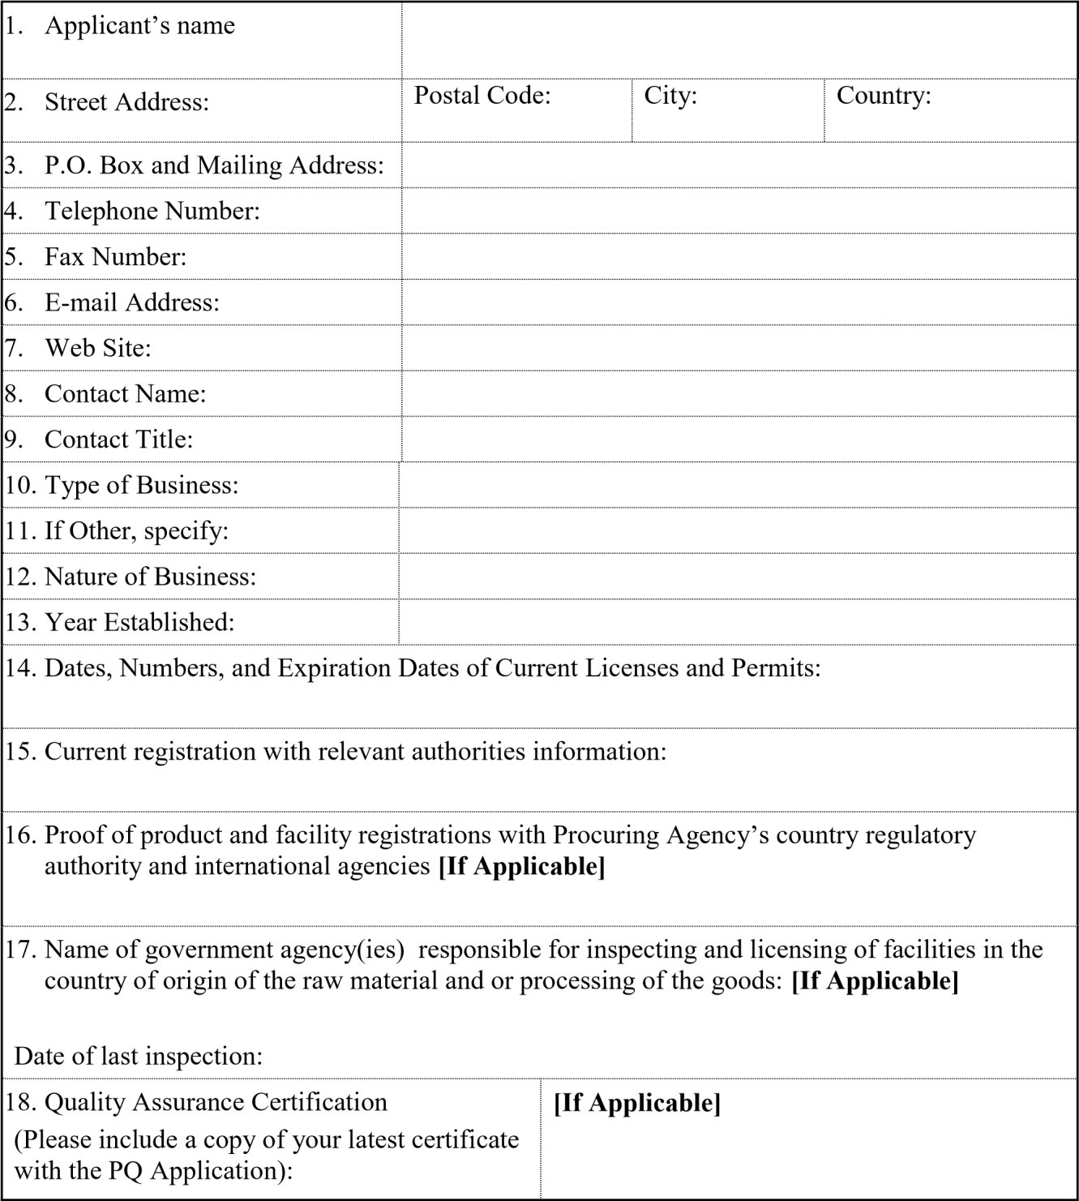
Date: [ ]
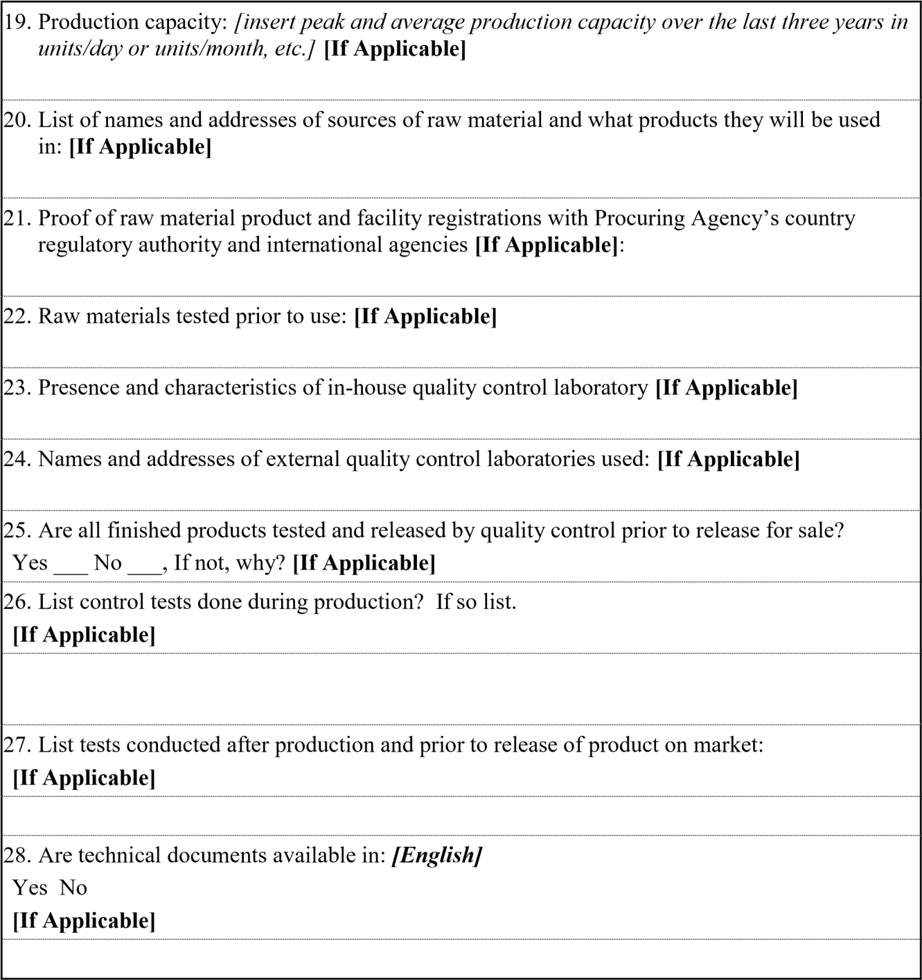

Form FIN – 1
Financial Situation and Performance

1. Financial data
Applicant’s Name: [ ]
Date: [ ]

Type of Financial information in (currency) | Historic information for previous _[insert number] years,  [insert in words]  (amount in currency, currency, exchange rate*, PKR equivalent)
 | Year 1 | Year 2
Statement of Financial Position (Information from Balance Sheet)
Total Assets (TA)
Total Liabilities (TL)
Total Equity/Net Worth (NW)
Current Assets (CA)
Current Liabilities (CL)
Working Capital (WC)
Information from Income Statement
Total Revenue (TR)
Profits Before Taxes (PBT)
Cash Flow Information
Cash Flow from Operating Activities
* Refer ITA 14 for the exchange rate
- Financial documents

  - be independently audited or certified in accordance with local legislation.

  - be complete, including all notes to the financial statements.

  - correspond to accounting periods already completed and audited.
  - of financial statements¹ for the [2] years required above; and complying with the requirements.

Section V - Eligible Countries

Eligibility for the Provision of M.T Items (tyres, batteries, vehicles spare parts and repair of vehicles)
In reference to ITA 5.1, for the information of the Applicants, at the present time, Automobiles workshops and vendors, supply of spare parts of vehicles and repair of vehicles from the following countries are excluded from this Prequalification process:

All the bidders are allowed to participate in the subject procurement without regard to nationality, except bidders of some nationality, prohibited in accordance with policy of the Federal Government.

Following countries are ineligible to participate in the procurement process:
- India
- Israel

Ministry of Interior, Government of Pakistan has notified List of Business Friendly Countries (BVL), information can be accessed through following link:

http://www.dgip.gov.pk/Files/Visa%20Categories.aspx#L
Section VI –
Evaluation Criteria and Requirements

National Highways & Motorway Police, Sector Sector-I N-55 Sehwan, South Zone.

PREQUALIFICATION OF FIRMS OF AUTO- WORKSHOPS AND GENERAL ORDER SUPPLIER OF REPAIR OF TRANSPORT ITEMS FOR SECTOR-I N-55 South Zone THROUGH EPADS, For FY 2024-2025, 2025-2026, 2026-2027

Tender Document for | Pre-qualification of Workshops/Vendors of Sector-I N-55 Sehwan, South Zone.
Tender Document No. | TENDER No. 06/MT/S-I/N-55/2024-27,

National Highways & Motorway Police
Sector Sector-I, N-55 Sehwan.

PROPOSAL FOR PREQUALIFICATION
GENERAL INFORMATION AND PERFORMA FOR AUTOMOBILES/ VENDORS PREQUALIFICATION
- INTRODUCATION
National Highways & Motorway Police Headquarters intends to introduce the process of Pre- Qualification of Automobile Workshops and General Order supplier of MT items for its fleet of more than 30 vehicles (Toyota, Honda, Hino etc) through EPADS in order to streamline its Procurement procedures for maintenance services.
All reputable and well established Auto workshops and vendors for vehicles spare parts, tyres and batteries and other items are invited to apply for the Pre-qualification by submitting the Pre- Qualification proposal on EPADS.
NHMP LHQ Sector-I N-55, Sehwan will process all the procurements in accordance with the policy defined and specified under PPRA Rules by the Government of Pakistan.
- DOCUMENTS NEEDED
Selection for prequalification will be based on information provided in these documents and information Performa.
  - Sales Tax Registration Certificate.
  - NTN Certificate
  - Dealership Certificate (if any)
  - Last six months bank statement of firm / workshop.
  - Certificate for being not black listed ever.
  - Details of employees of the firm (Permanent, Temporary, Technical and non- Technical) with designation and contract numbers.
  - Annual Turnover supported by Income Tax returns.
  - Previous detail of works with documentary proof.
  - Bid money Rs. 10,000 in shape of pay orders CDRs Bank Draft in the name of Drawing and Disbursing Officer, NHMP Sector-I, N-55 Sehwan.
  - The committee may also visit the workshops to assess the capabilities of the firm and verify the submitted information.
  - Separate agreements will be entered into with successfully prequalified firms after approval of competent authority.
SECTION VII
National Highways & Motorway Police
Sector-I, N-55 Sehwan.

SPECIFICATION AND SCOPE OF WORK
(Also mention any other specific repair work like A/C system, wheel alignment/balancing, seat cover etc)

Managerial Capability
- Technical:
(No. of Auto Mechanics, Auto Electricians, AC technicians etc.)
- Non- Technical (Support Staff): Attach as separate Annexure (if necessary)
Type & No. of
Machinery / Tools / Equipment & Plant (Mention page no. if detail available in profile
attached)
Dealership Certificate
(Copy of certificate of authorization from manufacturer, if any)

The information given above is true to the best of my knowledge, I undertake to inform NHMP LHQ Sector-I, N-55 Sehwan of any changes that may take place later in the status of workshop, business, agency or the management etc.

The terms and conditions attached below have also been read and certificate signed.

Authorized Signature Name:
Designation:
Date:
National Highways & Motorway Police
Sector-I, N-55 Sehwan.

FOR VEHICLES SPARE PARTS, TYRES & BATTERIES, REPAIR WORK
Type of:
Sr. | Items Name | Specification
1 | Air Filters | Genuine/ OR Equivalent
2 | Fuel Filters | Genuine/ OR Equivalent
3 | AC Filters | Genuine/ OR Equivalent
4 | Oil Filters | Genuine/ OR Equivalent
5 | Spark Plugs | Genuine/ OR Equivalent
6 | Disk Pads/ Brake Shoe | Genuine/ OR Equivalent
7 | Batteries:-  NS-85 (13 Plates),  110 L (15 Plates) | Exide, Volta, AGS, Osaka and Equivalent
8 | Tyres:-  195/65 R-15 (Car)  195 R-15C (Van/ Single Cabin),  265/60 R-18 (Revo),  265/60 R-18 (fortuner),  9.00 R20 (Hino Truck)  7.50-16LT (Truck Recovery) | Dunlop (Japan), Bridgestone, Yokohama, Speed Symbol = 11 Minimum, Temperature A,  Tread Wear 450 or above,  Manufacturing date within 01 year from order of supply.
Dealership Certificate:
Copy of Certificate of Authorization from Manufacturer, if any)

The information given above is true to the best of my knowledge, I undertake to inform NHMP Zonal Office of any changes that may take place later in the status of business agency or the management etc.

The terms and conditions attached below have also been read and certificate signed.

Authorized Signature:
Name:
Designation:
Date:
National Highways & Motorway Police
Sector-I, N-55 Sehwan.
ASSESSMENT CRITERIA FOR AUTOMOBILE WORKSHOPS
The Pre-qualification proposal / application will be evaluated as per the following criteria;

S.# | Assessment Criteria | Marks | Marks Obtained
01 | Experience related to engine overhauling  >=10 =25  >=05 <10 =20  >=03 <05 =15  >=01 <03 =10
 |  | 25
02 | Machinery / Tools / Equipment  Latest Machinery / Tools / Equipment =25  5 years Old Machinery / Tools / Equipment =15 More than 10 years old Machinery / Tools / Equipment =10 | 25
03 | Managerial & Technical Staff Capability  10 Years Experienced Diploma holder Mechanics =25 05 Years Experienced Diploma holder Mechanics =20  Experienced mechanics without Diploma =10 | 25
04 | Comparison of services  All services under one roof =15  Only mechanical services =10  Only body shop services =05 | 15
05 | Major assignments in Hand  >=10 =10  <10 =05 | 10
TOTAL |  | 100

2 - The committee may also visit the workshop to assess above capabilities and verify the submitted information.
3- The workshop / vendor who will obtain more than 50% marks will be qualified for pre-qualification and workshop/vendor will obtain less than 50 marks will disqualify.

