Tender Document
Supply of Computer Chairs


COMSATS University Islamabad
Park Road, Islamabad

Table of Contents

1. Tender Notice 3
2. Key Points 4
Table # 1 4
3. Technical Evaluation Criteria: 4
Table # 2: Mandatory Requirements: 4
4. FINANCIAL PROPOSAL 6
5. Technical Compliance Performa 8
6. General Terms & Conditions of the Tender 10
7. Contact person and Submission of Bids: 10
8. Validity of Bids: 10
9. Price of the Bid: 10
10. Bid Currencies & Bid Security: 11
11. Clarification of Bidding Document: 11
12. Opening of Bids: 12
13. Influencing the evaluation process: 12
14. Qualification & Evaluation of Bids: 12
15. Notification of Evaluation Reports: 13
16. Corrupt or Fraudulent Practices & Blacklisting: 13
17. Right to Accept or Reject Bids: 14
18. Award of Contract: 14
19. Notification of Award: 14
20. Delivery Information: 14
21. Legal Document 15
22. Declaration Form 16

- Tender Notice
COMSATS University Islamabad
CUI-Proc/(TN-545/09/2024

Supply of Computer Chairs
- COMSATS University Islamabad (CUI), a Public Sector University invites Bids through e-Pak Acquisition & Disposal System (EPADS) https://eprocure.gov.pk on “Single-Stage Two-Envelope” method from Income Tax & GST registered Firms/Companies who are on the Active Taxpayer List (ATL) for General Sales Tax and Income Tax of FBR.
- The Bid Security for the Bid is Rs.25,000/- in the form of Call Deposit/Bank Draft (refundable) drawn in favor of “COMSATS University Islamabad” (FTN/NTN: 9013701-9); scanned copy of which is required to be uploaded through EPADS and hard copy must be submitted physically along with hard-copy of sealed bidding document on the closing date & time of the tender to COMSATS University Islamabad on the address given below.
- The complete Tendering process shall be carried out through EPADS.
- Interested bidders are requested to register themselves on the EPADS https://eprocure.gov.pk and submit their tender documents on EPADS.
- For registration and guidance/training on EPADS, you may contact EPADS UAN: 051-111-137-237.
- Closing date of submission is September 30, 2024. by 1100 hours. The bids shall be opened half hour after the closing time in the presence of the bidders who wish to be present, in Room No. G-6/G-8, Ground Floor, Faculty Block-I, COMSATS University Islamabad.
- As per PPRA Rule 33, CUI may reject all bids or proposals at any time prior to the acceptance of a bid or proposal.

Contact Person and Submission


In-Charge Procurement
COMSATS University Islamabad
2nd Floor, Faculty Block-II, Park Road, Tarlai Kalan, Islamabad,
Tel: 0336-5524334, 051-90495242, 051-9049-5154, 051-9049-5122
Email: wajidkamran@comsats.edu.pk

- Key Points

Table # 1
S.N | Detail | Specification
 | Validity of Bid | 60 Days from the date of Closing of Bids
 | Award of Contract / W.O | Items Wise Basis
 | Supply/work completion | 25 Days from the date of issuance of W.O
 | Method | Single Stage Two Envelope
 | Closing Date & Time | September 30, 2024, by 1100 hours
 | Opening Date & Time | Half Hour after the Closing Time on the same day
 | Bid Security Amount  (Under Rule 25 of PPRA Rules 2004) | Rs.25,000 /- (Refundable)
 | Delivery Location  (Arrangement of Labor included in the cost) | Store Section entry through Gate 1, behind Main Library Building. The Store (Mr. Noor Wali 051-9049-6035)

- Technical Evaluation Criteria:

Table # 2: Mandatory Requirements:
 | Detail | Criteria | Envelope
 | Financial Bid / Quotation (Strictly as per CUI pattern)  Any alteration/addition/deletion shall dis-qualify the bidder from the bidding process | Mandatory | Financial Bid
 | Draft of Bid Security  (To be Physically Submitted to Purchase Section on the Closing Date) | Mandatory | Technical Bid
 | Declaration Form | Mandatory | Technical Bid
 | Active Taxpayer List (ATL) of FBR  Status as “Active” in I.T and Compliance Level is 100% in GST | Mandatory | Technical Bid
 | Certificate of non-blacklisting:  Affidavit on legal paper of appropriate value (duly attested from notary public) OR letterhead that the firm/company is neither blacklisted nor in litigation with any public sector client | Mandatory | Technical Bid
 | Compliance with CUI requirement/Specification  Blank technical sheet shall be treated as non-compliance and may result rejection of tender / bid | Mandatory | Technical Bid
 | Professional Experience  List of 3 executed/ similar contracts of over Rs.500,000/-each for Different Clients in the last 5 Year (attached proof is mandatory). | Mandatory
 | Sample required  Samples is mandatory against items quoted (Samples shall be checked for quality against specification given in the BOQ of the tender document) Bidders MUST submit their sample to the Procurement Office at the time of submission of bid. In case of non-compliance the bidder will be disqualified from the bidding process. | Mandatory
 | Submission of Tender document through EPADS as well as one hard copy (Technical Bid Envelope, Financial Bid Envelope, Bid Security as per prescribed time in the tender notice). | Mandatory

- Failing in any of the mandatory requirement shall disqualify the bidder from the bidding process.
- After evaluation of bidders in technical evaluation process, financial bids of technically qualified bidders shall be only opened later on prior notice.

- DO NOT attach any information or portfolio which is not requested. Only provide the demanded information.

- FINANCIAL PROPOSAL
(On Company’s Letterhead)
Ref No: |  | NTN:
Date: |  | GST:

Supply of Computer Chairs
SN | Specification | Qty | Unit Price (GST Excl) | GST Amount  (If any) | Unit Price (GST Incl) | Total Cost  (GST Incl)
 | Providing Ergonomic office chair (Adjustable) High back Mesh steel Chair base, high quality wheels Breathable materials approx. Size Length 20" Width 19".5 Height 42" (Approx) as per picture attached across  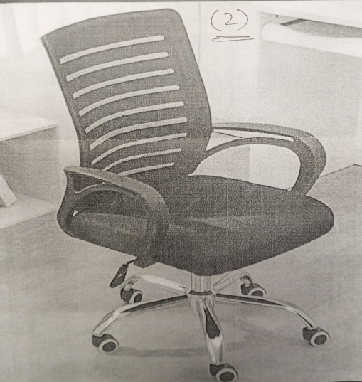 | 08 Nos
 | Chair Brand: SAAB or equivalent  Model: S-514 Relax back mesh chair manufactured with Polypropylene plastic mesh foam polyester fabric hydraulic jack, Nilon imported wheels sample relax back computer chair  Back length 21”, Width 18”  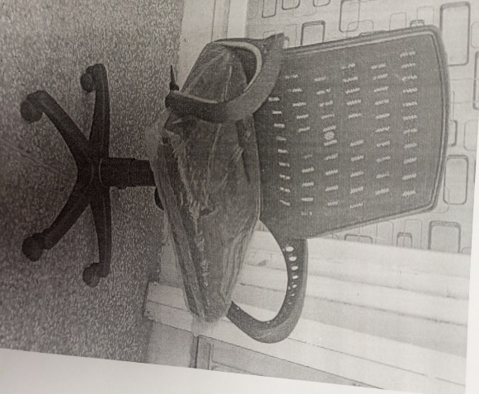 | 50 Nos
Total Cost (Inclusive of GST)
- The bid is submitted without any conditions.
- All the terms and conditions set forth by COMSATS University Islamabad in this tender are acceptable unconditionally, including bid validity, delivery time.
Note: Interested bidder may visit during office hours (9 AM to 5 PM) for Physical check of chair sample. In case of any query may contact the local person, namely Mr. Zia-ur-Rehman, contact no, 03456979567 & 0333-5130297.

Name of Authorized Person:
Date:
Signature
Official Company Seal:

- Technical Compliance Performa
(On Company’s Letterhead)
Ref No: |  | NTN:
Date: |  | GST:

Supply of Computer Chairs
SN | Specification | Brand Name being offered if any | Compliance | Non-Compliance | Higher if any
1 | Providing Ergonomic office chair (Adjustable) High back Mesh steel Chair base, high quality wheels Breathable materials approx. Size Length 20" Width 19".5 Height 42" (Approx) as per picture attached across  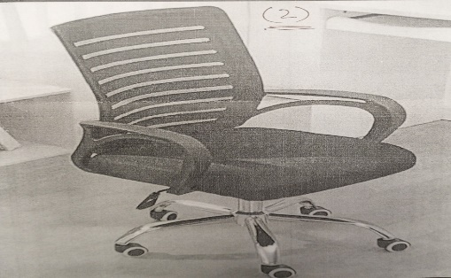
2 | Chair Brand: SAAB or equivalent  Model: S-514 Relax back mesh chair manufactured with Polypropylene plastic mesh foam polyester fabric hydraulic jack, Nilon imported wheels sample relax back computer chair  Back length 21”, Width 18”

- The bid is submitted without any conditions.
- All the terms and conditions set forth by COMSATS University Islamabad are acceptable unconditionally, including bid validity, delivery time.
- I understand that blank technical sheet / non-mentioning of Brand and Model shall make my bid non-responsive and may result rejection of my bid.
- Note: Interested bidder may visit during office hours (9 AM to 5 PM) for Physical check of chair sample. In case of any query may contact the local person, namely Mr. Zia-ur-Rehman, contact no, 03456979567 & 0333-5130297.

Name of Authorized Person:
Date:
Signature
Official Company Seal:

- General Terms & Conditions of the Tender
- No tender/bid shall be considered if: ‐
- Not uploaded through EPADS.
- Received without required documentation or deficiency in required documentation.
- Received without bid security.
- In contradiction with the specification given by the CUI.
- Received with any condition.
- The bidder is in litigation with CUI or is blacklisted by any organization or is notified as
blacklisted on PPRA website.

- Contact person and Submission of Bids:
- Contact Person for all inquiries, clarifications and bid submission shall be:

In-Charge Procurement
COMSATS University Islamabad
2nd Floor, Faculty Block-II, Park Road, Tarlai Kalan, Islamabad,
Tel: 0336-5524334, 051-90495242, 051-9049-5154, 051-9049-5122
Email: wajidkamran@comsats.edu.pk

- Validity of Bids:
- The Bid shall remain valid as mentioned in Table 1 of the tender document.
- Any bidder/firm/ company which refuses to accept the Work Order based on market price escalation shall result in forfeiting the bid security. CUI may also impose a ban from business with it for a period of 6 months.
- Price of the Bid:
- Prices quoted by the Bidder shall be fixed during the period of the contract and not subject to variation on any account.
- Applicable Income tax and GST shall be deducted at source and as per rules. In case of exemption, please mention and attach proper documentation duly verified from the concerned tax authorities. However, CUI may accept the exemption certificate. In case of non-acceptance, CUI shall deduct all applicable taxes as per tax rate. CUI shall provide a certificate of tax deduction and the vendor may claim refunds from Tax Authorities/FBR.
- In the case of tie in rates of the bidders, award of contract shall be decided through balloting in the presence of the of the bidders.
- Unit price shall be taken up to 1 decimal point. The total cost shall be round-up to zero decimal.
- In case of any conflict in the price/cost quoted by the bidder, the unit cost (Exclusive of GST) quoted by the bidder shall be considered for calculation.
- In case GST is not mentioned, the prices shall be considered as inclusive of GST.

- Bid Currencies & Bid Security:
- Bid prices shall be quoted in Pak Rupees.
- The currency of the bid security shall also be in Pak Rupees.
- The Bidder shall furnish, as part of its bid, bid security as specified in Table 1 of the tender document. The bid security is required to protect CUI against the risk of Bidder’s default which would warrant the security’s forfeiture.
- The bid security shall be in favor of COMSATS University Islamabad (FTN/NTN: 9013701-9), in any of the following form:

- Bank Draft
- Pay Order

- A scanned copy of bid security is required to be uploaded through EPADS and hard copy must be submitted physically on the closing date of the tender to COMSATS University Islamabad on the address given in the tender notice.
- No personal cheques shall be acceptable at any cost. Also, any previous bid security shall not be considered or carried forward.
- The bid security found deficient of the required amount shall not be considered.
- Unsuccessful bidders’ bid security shall be released and returned promptly as the successful bidder gives consent to the work order or signs the contract agreement, whichever is applicable.
- The bid security of the bidder shall be forfeited if the bidder:
    - Requests for withdrawal of his bid during the evaluation process.
    - Does not accept the correction of arithmetic errors in its bid.
- The bid security of the successful bidder shall be forfeited if the bidder:
- Fails to accept the work order/sign the contract agreement after announced as successful Bidder.
- Fails to comply with the requirement of the bid and contract.

- Clarification of Bidding Document:
- During evaluation of the bid(s), CUI may, at its discretion, ask the Bidder for a clarification of its bid and such information imperative for evaluation. The request for clarification and the response shall be in writing, and no change in the prices or substance of the bid shall be sought, offered, or permitted. In case the bidder fails to respond within given deadline, the bidder shall be considered as non-responsive and shall be disqualified from the bidding process.

- Opening of Bids:
- CUI shall open all bids through EPADS at the time, date, and place specified in tender notice, in presence of bidders’ representatives who wish to attend the meeting and shall sign an attendance sheet as evidence of their presence.

- Influencing the evaluation process:
- No Bidder shall contact CUI on any matter relating to evaluation of its bid, from the time of bid opening to the time evaluation report is made public. If the Bidder wishes to bring additional information or has a grievance to submit, it should do so through EPADS.
- Any effort by a Bidder to influence CUI during bid evaluation may result in disqualification of the bid.

- Qualification & Evaluation of Bids:
- CUI shall determine whether the Bidder is qualified to perform the Contract satisfactorily, in accordance with the criteria & qualification specified in the tender document.
- The qualification shall be based upon an examination of the documentary evidence submitted by the Bidder, as well as such other information as CUI deem necessary and appropriate.
- CUI shall technically evaluate and compare the bids which have been determined to be substantially responsive, as per evaluation criteria given in the tender document.
- The bidder’s financial evaluation of a bid shall be based on the lowest evaluated bid inclusive of all prevailing taxes and duties.
- CUI shall examine the bids as whether:
- They are complete in all respect;
- Any computational errors have been made;
- Required financial sureties have been furnished;
- The documents have been properly signed.

- Arithmetical errors shall be rectified on the following basis:
  - If there is a discrepancy between the unit price and the total price that is obtained by multiplying the unit price and quantity, the unit price (exclusive of tax) shall prevail, and the total price shall be corrected. If the Contractor does not accept the correction of the errors, the bid shall be rejected, and the bid security shall be forfeited.
  - If there is a discrepancy between words and figures, the amount in words shall prevail.
- CUI may waive any minor non-conformity, in a bid which does not constitute a material deviation, provided such waiver does not prejudice or affect the relative ranking of any Bidder.
- Explanation: A minor non-conformity is one that is merely a matter of form and not of substance. It also pertains to some immaterial deficiency in a Bid or variation of a bid from the exact requirements of the tender document that can be corrected or waived without being prejudicial to other bidders. The deficiency is immaterial when the affect on quantity, quality, or delivery is negligible when contrasted with the total cost or scope of the supplies or services being acquired. CUI shall either give the bidder an opportunity to correct any deficiency in a bid or waive the deficiency, whichever is advantageous to CUI.
- Prior to the detailed evaluation, CUI shall determine the substantial responsiveness of each bid to the bidding documents. For the purposes of these clauses, a substantially responsive bid is one which conforms to all the terms and conditions of the bidding documents without material deviations.
- Deficiency in bid security, Applicable Law and Taxes and Duties shall be deemed to be a material deviation. The CUI ’s determination of a bid’s responsiveness is to be based on the contents of the bid itself without recourse to extrinsic evidence.
- If a bid is not substantially responsive, it shall be rejected and may not subsequently be made responsive by the Bidder by correction of the non-conformity.

- Notification of Evaluation Reports:
- The evaluation report shall be notified through EPADS.

- Corrupt or Fraudulent Practices & Blacklisting:
- The bidders shall be required to observe the highest standard of ethics during the procurement and execution of contracts. For the purpose of this provision, the terms set forth below are defined as under:
- “Corrupt practice” means the offering, giving, receiving or soliciting of anything of value to influence the action of a public official in the procurement process or in contract execution;
- “Fraudulent practice” means a misrepresentation of facts to influence a procurement process or the execution of a contract to the detriment of CUI;
- “Collusive practice” is an arrangement among bidders (prior to or after bid submission) designed to establish bid prices at artificial, non-competitive levels for any wrongful gains, and to deprive CUI of the benefits of free and open competition.
- CUI shall have the right to reject a proposal for award if it determines that the bidder had been engaged in corrupt or fraudulent practices in the past with any organization.
- Any bidder/firm/company which is blacklisted by any organization and/or notified as blacklisted by PPRA shall be considered disqualified from the bidding process unless and until it is de-notified on PPRA website.
- If it at any time, CUI determines that the firm has engaged in corrupt, fraudulent, or collusive practices in competing for, or in executing the contract, it shall sanction/ban a bidder/firm/company, in accordance with prevailing Blacklisting procedures under Federal Public Procurement Rules.

- Right to Accept or Reject Bids:
- Under PPRA Rule 33(1), CUI may reject bids or proposals at any time prior to the acceptance of a bid or proposal, without incurring any liability to the bidder(s).

- Award of Contract:
- After scrutiny of all bidding documents, the final evaluation report shall be uploaded to EPADS, and the work order/purchase order shall be issued on the basis of most advantageous bid as mentioned in Table 1 of the tender document.
- The successful bidder shall immediately sign a contract agreement / give consent to the Work Order/Purchase Order. The bidder shall bear all the stamp duties and expenses for the purpose of contract agreement/Work Order/Purchase Order, if any.

- Notification of Award:
- The notification of award shall constitute the formation of the Agreement/Work Order/Purchase Order.
- Upon the successful bidder’s signing the contract agreement/acceptance/consent to the Work Order/Purchase Order, CUI will promptly notify the unsuccessful bidder(s) and will release its bids security.
- Quantity may increase/Decrease as per CUI requirements subject of availability of funds.

- Delivery Information:
- The supply shall be made to CUI as mentioned in Table 1 of the tender document.
- In case of delay in delivery and installation the vendor may submit a written request for extension in delivery time, giving valid justification with proof.
- CUI may extend the delivery time and installation according to the reason of delay with the condition of deductions in percentage (0% to 10%) from the total bill as penalty. The decision shall be communicated to the vendor for extension along with [percentage of deduction, if any]. In case of non-responsiveness/non-acceptance by the vendor, the work order shall automatically be cancelled, the bid security shall be forfeited. CUI may also impose a ban from business with it for a period of six months.
- CUI may reject the request for extension, in which case, the work order shall be cancelled, the bid security shall be forfeited. CUI may also impose a ban from business with CUI for a period of six months.
- The bills along with delivery challan (duly signed by authorized official of CUI) shall be submitted to the Procurement Office for further necessary payment process. Any deficiency in bill/supporting documentation shall be removed by the vendor.
- Any defective item(s) shall be replaced by the vendor during the warranty period, free of cost, within one-week is time. In case of failure to supply the specific item, CUI shall purchase the item on risk and cost of the supplier, to be deducted from the bidder’s bid security or performance guarantee.
- Payment shall be made as per actual quantity delivered & accepted to CUI.
- Samples are mandatory where specifically demanded and bid without samples shall be considered non-responsive. No sample(s) shall be accepted after the closing date of the tender. Sample(s) other than the demanded item(s) shall not be considered.
- After technical evaluation of bids, sample(s) provided by bidders may be picked up from the procurement section within 30 days from the date of technical bid evaluation announcement. Failure on the part of the bidder(s) to collect his samples within the stipulated time shall allow CUI to dispose of the samples.
- In cases lowest evaluated bidder refuses or fails to supply the item(s)/execute the work within the deadline(s), the Work Order may be offered to the next lowest bidder provided that the difference between the 1st lowest bidder and 2nd lowest bidder (2nd-1st) is less than or equal to the earnest money (General Economic Principle). Same principle for 3rd, 4th lowest bidders and so on.

- Legal Document
- The Tender document and Contract agreement/Work Order/Purchase Order altogether shall have legal binding on all bidders.

- Declaration Form
(THIS FORM IS TO BE PROVIDED WITH THE BID)
All the terms & conditions have been carefully read and understood and are hereby unconditionally accepted and it is declared that:
- I understand that by inserting any condition in my bid consciously or unconsciously shall automatically disqualify me from the bidding process.
- By altering/adding/deleting any point, clause, condition in the documents provided shall automatically disqualify me from the bidding process.
- All the information furnished by me here-in is correct.
- I have no objection if enquiries are made about the work listed by me/us in the accompanying sheets /annexure.
- I agree that the decision of CUI in selection shall be final and binding to me.
- I have read the instructions appended to the proforma and I understand that if any false information in the document is noticed at a later stage, CUI is at liberty to act in a manner in accordance with the applicable rules and terms & conditions of the tender, which may include Penalty AND/OR forfeiting of bid security AND/OR blacklisting for future tendering with CUI AND/OR bar from business with CUI for a period of six months.

Tender Title
Name of Firm/ Company
Year of Establishment in this business
Name of Authorized agent
Office Address
GST No.
NTN.
Valid Cell No.
Valid E-mail (For all official correspondence)
Signature & Stamp
(Authorized Representative)

