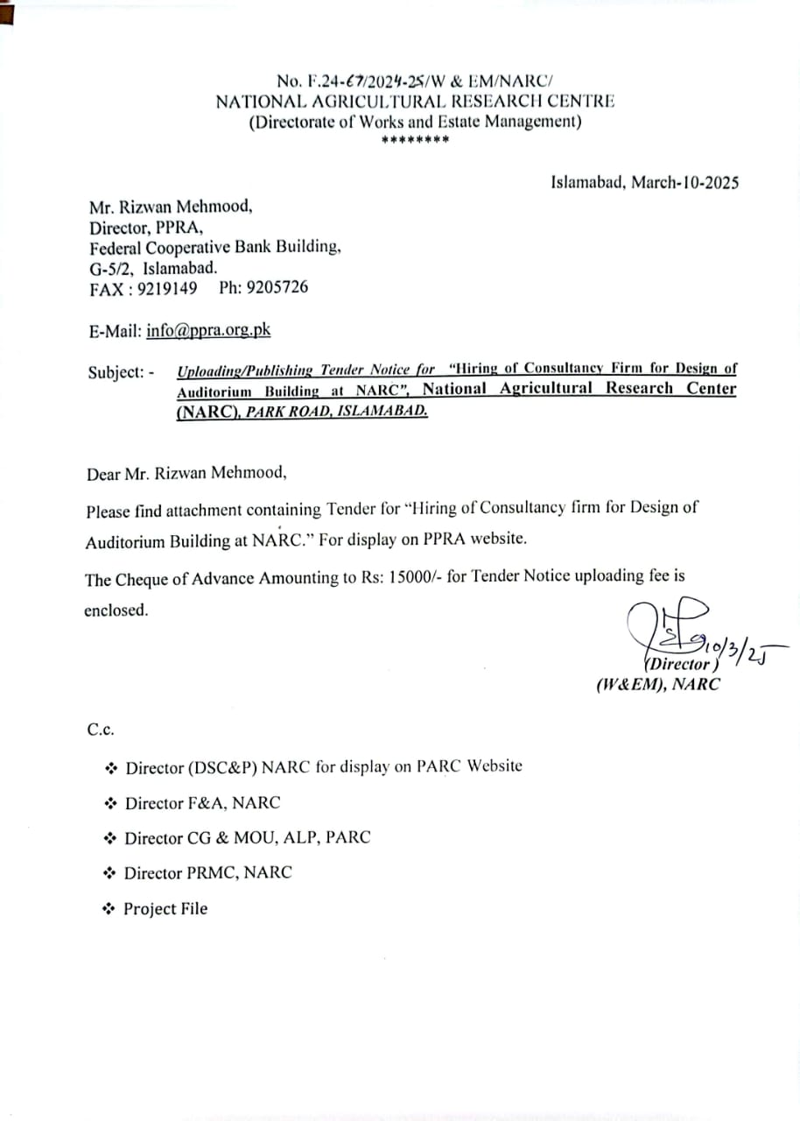

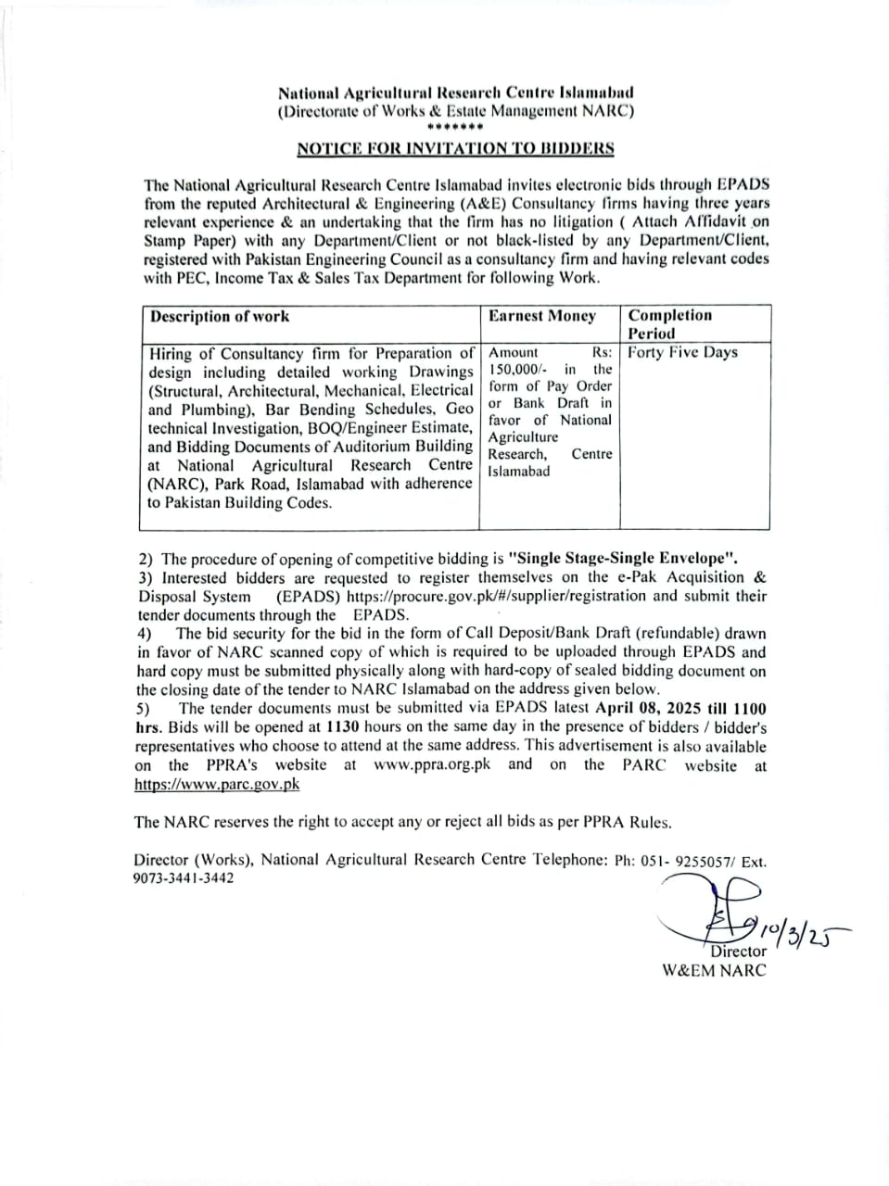

National Agricultural Research Centre Islamabad
(Directorate of Works & Estate Management NARC)
*******
NOTICE FOR INVITATION TO BIDDERS

The National Agricultural Research Centre Islamabad invites electronic bids through EPADS from the reputed Architectural & Engineering (A&E) Consultancy firms having three years relevant experience & an undertaking that the firm has no litigation ( Attach Affidavit on Stamp Paper) with any Department/Client or not black-listed by any Department/Client, registered with Pakistan Engineering Council as a consultancy firm and having relevant codes with PEC, Income Tax & Sales Tax Department for following Work.

Description of work | Earnest Money | Completion Period
Hiring of Consultancy firm for Preparation of design including detailed working Drawings (Structural, Architectural, Mechanical, Electrical and Plumbing), Bar Bending Schedules, Geo technical Investigation, BOQ/Engineer Estimate, and Bidding Documents of Auditorium Building at National Agricultural Research Centre (NARC), Park Road, Islamabad with adherence to Pakistan Building Codes. | Amount Rs: 150,000/- in the form of Pay Order or Bank Draft in favor of National Agriculture Research, Centre Islamabad | Forty Five Days

2) The procedure of opening of competitive bidding is "Single Stage-Single Envelope".
3) Interested bidders are requested to register themselves on the e-Pak Acquisition & Disposal System (EPADS) https://procure.gov.pk/#/supplier/registration and submit their tender documents through the EPADS.
4) The bid security for the bid in the form of Call Deposit/Bank Draft (refundable) drawn in favor of NARC scanned copy of which is required to be uploaded through EPADS and hard copy must be submitted physically along with hard-copy of sealed bidding document on the closing date of the tender to NARC Islamabad on the address given below.
5) The tender documents must be submitted via EPADS latest April 08, 2025 till 1100 hrs. Bids will be opened at 1130 hours on the same day in the presence of bidders / bidder's representatives who choose to attend at the same address. This advertisement is also available on the PPRA's website at www.ppra.org.pk and on the PARC website at https://www.parc.gov.pk

The NARC reserves the right to accept any or reject all bids as per PPRA Rules.

Director (Works), National Agricultural Research Centre Telephone: Ph: 051- 9255057/ Ext. 9073-3441-3442

Director
W&EM NARC

