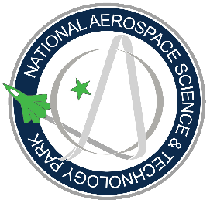
Tender No. NASTP SILICON VALLEY/ 001/2024/House Keeping Services

NATIONAL AEROSPACE SCIENCE AND TECHNOLOGY PARK
NASTP SILICON VALLEY
____
TENDER NOTICE

INVITATION OF BID FOR HIRING OF HOUSE KEEPING & JANITORIAL SERVICES AT NASTP SILICON VALLEY KARACHI

1. NASTP Silicon Valley, Karachi invites sealed bids from the Firms/Companies
(registered with Income Tax and Sales Tax Departments and who are on Active Tax payers) for delivering Housekeeping & Janitorial Services at NASTP Silicon Valley Karachi.
2. Interested firms may collect bidding documents containing "Pre-qualification / Technical Evaluation Criteria" from the given below address on any working day during 1000 Hrs to 1700 Hrs after submitting bank draft / pay order of Rs 5000/- (non-refundable) in favour of "GWALPHA Tech (Private) Ltd." The bidding procedure is "Single Stage-Two Envelope".

3. The (Technical and Commercial Proposal) must be prepared in accordance with the instructions of bidding documents and must reach at below address on or before 27 December, 2024 latest by 1000 Hours. Technical bids will be opened the same day at 1400 Hours in the presence of bidders.

4. NASTP Silicon Valley reserves the right to accept or reject any / all bids which are not compliance to PPRA Rules and instructions mentioned in bidding documents.

Director Support
NASTP Silicon Valley, near PAF Museum
Shahra-e-Faisal, Karachi
Phone No: - 021-33412190
Cell No-0300-5244430

