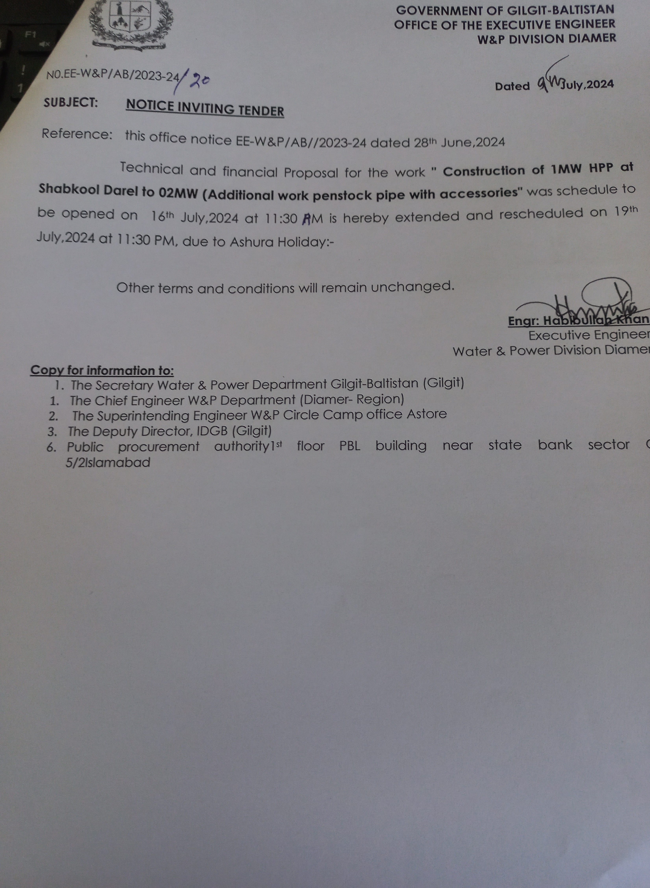

’ | GOVERNMENT OF GILGIT-BALTISTAN  OFFICE OF THE EXECUTIVE ENGINEER  W&P DIVISION DIAMER
N0.EE-W&P/AB/2023-24 |  | Dated 27th June,2024
NOTICE INVITING TENDER:

Sealed tender is hereby invited from the approved Government Contractor/Firms of W&P Department for below mentioned Work of W&P Division Diamer.

S.# | Name of HPP | Estimated Cost | 2% Earnest Money | Cost of Tender From | Date/Time of Issue of Bidding Documents | Date/ Time of Submission of Bid | Date/Time of Opening of Bid
1. | Construction of 1MW HPP at Shabkool Darel to 02 MW (Additional work penstock pipe with accessories) | 55.271 | 1. 105 | 0.006 | 15.07.2024  10:00 AM | 16-07-2024  11:00 AM | 16-07-2024  11:30 AM

2. Terms and conditions

i. Registration with Pakistan Engineering Council in relevant Category/code "ME-07" duly renewed for the year, 2023-24 (Mandatory).
ii. Receipt of renewal fee for the year, 2024-25 in W&P department (Mandatory).
iii. Detail of Similar work executed during the last 05 years i.e with documentary proof (Mandatory).
iv. Detail of plants/machinery available with the firm /contractors "with proof of ownership" (duly attested by 1st class magistrate).
v. Financial status of the firms/contractor of schedule bank with a minimum balance of 80% of estimated Cost (1st January, 2024 to 7th July, 2024) duly verified by the bank manger (in original)
vi. Contractor/Firm should provide difference amount in the shape f extra call deposit in any schedule Bank of Pakistan.

3. The bidders may obtain the bidding documents by submitting a written application with copy of CNIC on Cash payment of Rs.6000/-non refundable" from the office of the undersigned on due date and time.

Engr: Habibullah Khan
Executive Engineer
Water & Power Division Diamer
Copy for information to:
1. The Secretary Water & Power Department Gilgit-Baltistan (Gilgit)
- The Chief Engineer W&P Department (Diamer- Region)
- The Superintending Engineer W&P Circle Camp office Astore
- The Deputy Director, IDGB (Gilgit)
6. Public procurement authority1st floor PBL building near state bank sector G- 5/2Islamabad

