ATTACHMENT – I
(See regulation 2)

PUBLIC PROCUREMENT REGULATORY AUTHORITY (PPRA)

CONTRACT AWARD PROFORMA – I

To Be Filled And Uploaded on PPRA Website In Respect of All Public Contracts of Works, Services and Goods Worth Fifty Million or More

- NAME OF THE ORGANIZATION/DEPTT. Pakistan State Oil (PSO)
- FEDERAL / PROVINCIAL GOVT. Federal Autonomous Body
    - TITLE OF CONTRACT Supply of Price Display Units for Monolith Towers at Central Store KTB.
    - TENDER NUMBER RC-17649-FI
    - BRIEF DESCRIPTION OF CONTRACT Price Display unit for PSO Retail outlets
- TENDER VALUE Rs. 119,685,600/-
- ENGINEER’S ESTIMATE Not Applicable

  - ESTIMATED COMPLETION PERIOD July 10, 2024
- WHETHER THE PROCUREMENT WAS INCLUDED IN ANNUAL PROCUREMENT PLAN?
Yes | √ | No | -

- ADVERTISEMENT :
N/A | TS526637E  30-Nov-2023

- PPRA Website (Federal Agencies)
(If yes give date and PPRA’s tender #)
N/A | Express & The News 29-Nov-2023

- News Papers
(If yes give names of newspapers and dates)

- TENDER OPENED ON (DATE & TIME) 18.12.2023
- NATURE OF PURCHASE
Local | √ | International | -

- EXTENSION IN DUE DATE (If any)
Yes | - | No | √

-: 2 :-
- NUMBER OF TENDER DOCUMENTS SOLD 04
(Attach list of Buyers)

- WHETHER QUALIFICATION CRITERIA WAS INCLUDED IN BIDDING/TENDER DOCUMENTS
Yes | - | No | √

(If yes enclose a copy).

- WHETHER BID EVALUATION CRITERIA WAS INCLUDED IN BIDDING/TENDER DOCUMENTS
Yes | √ | No | -

(If yes enclose a copy).

- WHICH METHOD OF PROCUREMENT WAS USED: - (Tick one)

- SINGLE STAGE – ONE ENVELOPE PROCEDURE
N/A

- SINGLE STAGE - TWO ENVELOPE PROCEDURE.
√

- TWO STAGE BIDDING PROCEDURE.
N/A

- TWO STAGE – TWO ENVELOPE BIDDING PROCEDURE.
N/A

PLEASE SPECIFY IF ANY OTHER METHOD OF PROCUREMENT WAS ADOPTED WITH BRIEF REASONS (i.e. EMERGENCY, DIRECT CONTRACTING, NEGOTIATED TENDERING ETC.):

- WHO IS THE APPROVING AUTHORITY Procurement Committee of PSO

- WHETHER APPROVAL OF COMPETENT AUTHORITY WAS OBTAINED FOR USING A METHOD OTHER THAN OPEN COMPETITIVE BIDDING.
Yes | - | NO | √

- NUMBER OF BIDS RECEIVED 02
- WHETHER THE SUCCESSFUL BIDDER WAS LOWEST BIDDER
Yes | √ | No | -

- WHETHER INTEGRITY PACT WAS SIGNED
Yes | √ | No | -

ATTACHMENT – II
(See regulation 2)

PUBLIC PROCUREMENT REGULATORY AUTHORITY (PPRA)

CONTRACT AWARD PROFORMA – II

To Be Filled And Uploaded on PPRA Website In Respect of All Public Contracts of Works, Services & Goods Worth Fifty Million Rupees or More

- NUMBER OF BIDDERS PRESENT AT THE TIME OF OPENING OF BID 02

- NAME AND ADDRESS OF THE SUCCESSFUL M/s. CONCEPT ELLERS
- A-89-91 ,SHAH HOUSE. DHANI BUX GOTH.OFF SUPER HIGHWAY
- AHSANABAD LINK ROAD.NEAR ADMORE PETROL KARACHI PAKISTAN
- RANKING OF SUCCESSFUL BIDDER IN EVALUATION REPORT (i.e. 1st, 2nd, 3rd EVALUATED BID). 01
NEED ANALYSIS:
(Why the procurement was necessary?) Price Display unit installed at PSO Retail outlets for display of rates.
- IN CASE EXTENSION WAS MADE IN RESPONSE TIME, WHAT WERE THE REASONS (Briefly describe)
Yes | - | No | √

- WHETHER NAMES OF THE BIDDERS AND THEIR PRICES WERE READ OUT AT THE TIME OF OPENING OF BIDS
Yes | √ | No | -

- DATE OF CONTRACT SIGNING (Attach a copy of agreement) 14/02/2024

  - CONTRACT AWARD PRICE Rs. 127,001,862.69

- WHETHER COPY OF EVALUATION REPORT GIVEN TO ALL BIDDERS
Yes | √ | No | -

Bid Evaluation Report was uploaded on PSO websites

- ANY COMPLAINTS RECEIVED (If yes result thereof)
Yes | - | No | √

- ANY DEVIATION FROM SPECIFICATIONS GIVEN IN THE TENDER NOTICE/DOCUMENTS
Yes | - | No | √

(If yes give details)

- DEVIATION FROM QUALIFICATION CRITERIA (If yes give details)
Yes | - | No | √

- SPECIAL CONDITIONS, IF Any (Give Brief Description)
Yes | - | No | √

[F.No.2/1/2008PPRA-RA.III]

Attach list of Buyers:
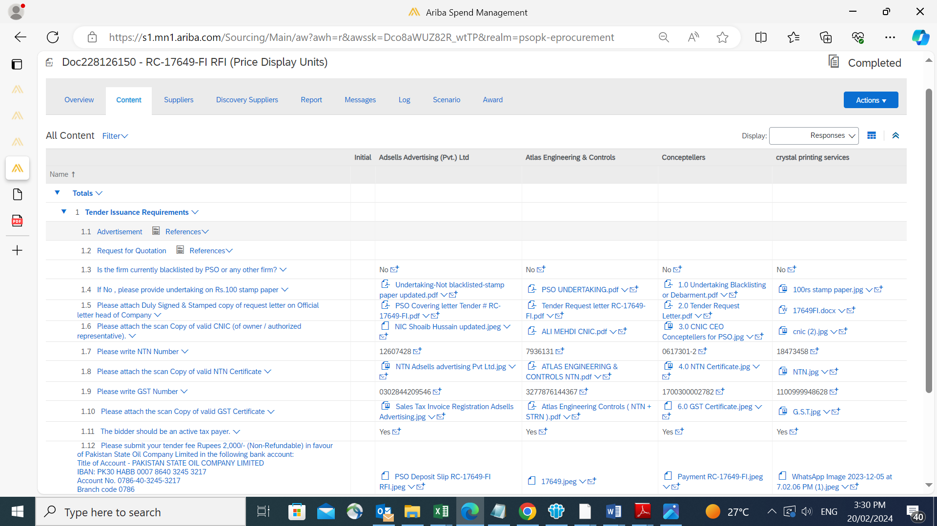

BID EVALUATION CRITERIA:

Technical Evaluation Criteria (Total Marks: 100)
- Bidders failing Mandatory Requirements will not be qualified.
- Minimum 70% Marks are required for Technical Qualification in overall and in each section (1.2 to 1.5).
Mandatory Requirements
Is your firm currently blacklisted by PSO or any other firm?
If Yes, please provide details.
If no, please provide signed and stamped undertaking on the Company’s Letterhead that your company is not black listed by PSO or any other firm further that your company is not in litigation with PSO or any other firm).
Whether any director / partner of your company / Firm (as the case may be) is / was the Director or partner in any other company or firm which is currently blacklisted either by PSO or any other person/entity?
If your answer is no, please provide a duly signed and stamped undertaking to this effect on your company's / Firm’s letterhead.
If yes, you shall not be qualified in this tender .
Fatal accident taken place during the performance of any contract in the last 05 years.
If no, please provide signed and stamped undertaking on the Company’s Letterhead.
If yes, you shall not be qualified in this tender .
Firm should not have been defaulted in any financial liability or been subject to any material proceedings in bankruptcy or liquidation or have any outstanding judgments against it which are material to its ability to execute the project as envisaged herein
Please provide undertaking on Company’s letterhead, signed & stamped.
Quoted product must be 100% compliant or better than PSO Specifications. Compliance Sheet attached for reference.
Please attach duly filled and signed & stamped compliance sheet by vendor/supplier.
Please attach technical data sheets, operation & installation manuals and any necessary technical details of the offered equipment.
PDU’s shall be demonstrated by the supplier in compliance with PSO specifications at PSO Head Office within 10 days after technical bid opening.
Please provide undertaking on Company’s letterhead, signed & stamped.
Firm’s Status & Financials (Marks: 30)
Avg. Annual Turnover of Supplier in the last 3 years (Marks: 10)
Equal and above 120 million PKR (100%)
Equal and above 100 and Below 120 Million PKR (90%)
Equal and above 80 and Below 100 million PKR (80%)
Equal and above 60 and Below 80 million PKR (70%)
Equal and above 50 and Below 60 million PKR (50%)
Below 50 million PKR (0%)
Please provide audited financial reports / tax statements of last three years.
Net Assets (Total Assets – Total Liabilities) of supplier in the last year (Marks : 10)
Equal and above 60 million PKR (100%)
Equal and above 50 and Below 60 Million PKR (90%)
Equal and above 30 and Below 50 million PKR (80%)
Equal and above 20 and Below 30 million PKR (70%)
Equal and above 15 and Below 20 million PKR (50%)
Below 15 million PKR (0%)
Please provide audited financial reports / tax statements of last year.
Highest Value of the Work Order (in last five years) of Supplier (10 Marks)
Equal and above 35 million PKR (100%)
Equal and above 30 and Below 35 Million PKR (90%)
Equal and above 20 and Below 30 million PKR (80%)
Equal and above 10 and Below 20 million PKR (70%)
Equal and above 08 and Below 10 million PKR (50%)
Below 08 million PKR (0%)
Please provide the copies of work order as an evidence.
Clientele, Experience & References (Marks: 30)
No. of years of Experience (Marks : 10)
More than 05 years (100%)
More than 04 and less than or equal to 05 years (80%)
More than 03 and less than or equal to 04 years (70%)
More than 02 and less than or equal to 03 years (50%)
less than or equal to 02 years (0%)
Please provide copies of oldest work orders and other related documents.
Number of Clienteles of Supplier/Manufacturer (Marks : 10)
More than 10 clients (100%)
From 7 - 10 clients (80%)
From 4 - 6 clients (70%)
From 2 - 3 clients (50%)
Less than 2 clients (0%)
Please attach list of clients on official letterhead
Number of Digital Signage projects done by Supplier (Marks : 10)
More than 50 Projects (100%)
More than 40 and less than or equal to 50 Projects (90%)
More than 30 and less than or equal to 40 Projects (80%)
More than 20 and less than or equal to 30 Projects (70%)
More than 10 and less than or equal to 20 Projects (50%)
less than or equal to 10 Projects (0%)
Please attach relevant documents for experience e.g. completion certificates, work orders etc.
Note: 1 project = 1 site which include digital signage of sites with minimium value of work order is Rs 250,000/-
Capabilities / Human Resource Details (Marks: 20)
Offices/Service centers in Major Cities - Karachi, Lahore and Islamabad. (Marks : 10)
Offices in all 3 locations (100%)
Office in any 2 of the above mentioned locations (80%)
Office in any 1 of the above mentioned location (70%)
No Office/Service Center in mentioned location (0%)
Please provide details of all locations on company letterhead.
Number of Technical/ Skilled staff (Marks : 10)
10 or above (100)
8-9 (90)
6-7 (80)
4-5 (70)
2-3 (50)
Less than 2 (0)
Please provide list of Skilled/Technical staff on company’s letterhead duly signed by company official.
Note: Skilled/Technical Staff should have minimum 3 years of relevant experience
HSE (Marks: 20)
HSE Policy & Procedures (08 Marks)
HSE Policy/Procedures Available
1. Lifting Operations
2. Electrical Safety
3. Manual Handling & Use of PPEs
4. Hand & Power Tools Safety / Welding, Cutting & Grazing
5. Painting Works
6. Risk Assessment / JHA
7. Incident Reporting System
8. Emergency Response
All 8 Polices/Procedures available (100%)
Any 6 to 7 Polices/Procedures available (90%)
Any 3 to 5 Policy/Procedure available (80%)
Any 1 to 2 Policy/Procedure available (70%)
No Policy/Procedure available (00%)
Please provide signed and stamped HSE policy by CEO.
Personal Protective Equipment (PPE) (04 Marks)
1. Guideline / Procedure for PPE
2. Inventory list of PPEs (Helmets, Safety Shoes, Full Body Harness, Masks, and Gloves etc.)
Please provide signed and stamped HSE policy by CEO.
HSE Training (08 Marks)
Does company arrange regular training sessions for its staff of critical HSE topics? If Yes, share recent training records?
1. Lifting Operations
2. Electrical Safety
3. Manual Handling & Use of PPEs
4. Hand & Power Tools Safety
5. Painting Works
6. Risk Assessment / JHA
7. Incident Reporting System
8. Emergency Response
All 8 Trainings (100%)
Any 5 - 7 Trainings (90%)
Any 3 - 4 Trainings (80%)
Any 1 - 2 Trainings (70%)
No Training (00%)
Please provide copy of Attendance sheet/ certificate/ presentations/ pictures etc.

